# Sumido hasta las rodillas en ZScript

¡Una guía para escribir tu primer proyecto ZScript para GZDoom!

<https://www.youtube.com/watch?v=Ri62c7Z6hsk&list=PL-36gm0W-VKl89pw9lUfF36TJ28bjrNUn&index=5&ab_channel=DavidXNewton>

<https://doom.teamouse.net/zstutorial/>

## ¿Por qué debería utilizar ZScript?

Ésta es una gran pregunta que creo que muchas guías de ZScript no abordan: ¿por qué necesita cambiar a ZScript?

La verdad es que, si ya puedes hacer todo lo que quieres en GZDoom con ACS y DECORATE, ¡realmente no necesitas cambiar! DECORATE sigue siendo una característica útil del motor y no va a desaparecer: para crear cosas como escenarios y monstruos, sigue funcionando bien. Pero una vez que te vuelvas un poco más ambicioso, comenzarás a encontrarte con sus limitaciones: tal vez necesites realizar un seguimiento de algunas variables en un monstruo para darle un comportamiento más complejo de lo normal. Es posible que tengas que asignar un TID específico al jugador al comienzo del nivel para poder hacer referencia a ellos desde un script ACS más tarde, o escribir y compilar una biblioteca ACS porque un objeto de recolección necesita hacer una llamada para obtener algo que no está disponible para él en DECORATE.

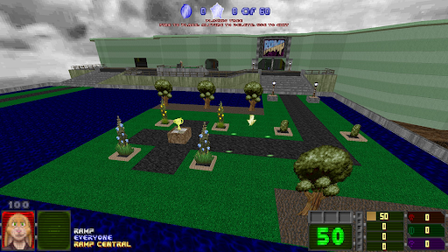

Es posible evitar todos estos problemas en los antiguos entornos DECORATE/ACS. Para el primer RAMP de 2021, escribí un minijuego completo de construcción de jardines con ellos, pero era complicado y requería pensar mucho en los obstáculos, hacer un seguimiento de los TID y, en general, engañar a la computadora para que lo hiciera. ZScript te permite adentrarte mucho más en los detalles de GZDoom que los antiguos lenguajes de programación: puedes reaccionar a una variedad mucho mayor de cosas que suceden en el juego, manipular elementos del juego como linedefs y sectores sin tener que hacerlos específicamente direccionables con etiquetas y crear clases que no solo existen en el mundo del juego como Cosas, sino que también pueden interactuar con datos detrás de escena.

No es fácil adentrarse en ZScript: este mayor alcance en el juego se produce a costa de una pronunciada curva de aprendizaje, una abrumadora cantidad de posibilidades y una variedad mucho mayor de oportunidades de producir fallos. Sin embargo, una vez que te acostumbras a su funcionamiento, empiezas a darte cuenta de cuánto más control tienes sobre el entorno del juego, y explorar sus posibilidades se vuelve tan adictivo como cualquier otro aspecto del mapeo de Doom.

### Cómo funciona ZScript

Al igual que DECORATE, ZScript se escribe como uno o más bloques de formato de texto y se utiliza para definir objetos y su comportamiento. Comparte gran parte de su concepto y sintaxis con otros lenguajes de programación orientados a objetos, como Java y C#. Repasarlos es un gran trabajo e intentaré explicar los conceptos de programación orientada a objetos que necesitarás conocer a medida que surjan, pero antes de sumergirte realmente en ZScript, puede resultar útil seguir un tutorial para principiantes sobre cualquiera de ellos. Tener una comprensión de conceptos como la herencia de objetos y las funciones virtuales/anuladas ayudará a comprender lo que sucede en ZScript, pero espero poder dar una introducción lo suficientemente buena a ellos aquí para que sean comprensibles.

ZScript sufre un poco por la falta de documentación, ya que hay mucho que documentar: se han escrito varios tutoriales y referencias sobre lo que hacen todos los componentes, y [https://zdoom-docs.github.io/staging/](https://www.google.com/url?q=https://zdoom-docs.github.io/staging/&sa=D&source=editors&ust=1677034908407660&usg=AOvVaw3I5dM4XWzlPTwymd-cY1kw)  de Alison G. Watson y Fira Watson es actualmente mi referencia preferida. Sin embargo, creo que muchas de las posibilidades de ZScript se pueden resumir con solo analizar dos conceptos.

### Las dos superestrellas de ZScript

Antes de empezar a usar ZScript, lo que más me desanimaba era no saber por dónde empezar. Empecé con ACS y DECORATE diciendo "Me gustaría que este interruptor hiciera algo que no está en las acciones especiales estándar" o "Me gustaría hacer un nuevo tipo de pastilla". No tenía un objetivo equivalente que solo pudiera lograrse en el mundo de ZScript. Solo después de comprender las dos ideas siguientes me di cuenta de lo que ZScript me permitiría hacer:

#### Pensadores

Un Pensador es un objeto que puede realizar acciones. En el mundo de DECORATE, siempre estás trabajando con Actores, que están presentes como entidades físicas en el juego: duendes, destinos de teletransporte o cabezas en palos. Pero los Pensadores existen un lugar por encima de ellos en la jerarquía de objetos, como objetos que no necesariamente tienen una presencia y que pueden funcionar silenciosamente en segundo plano. En lugar de decirle qué hacer definiendo una lista de estados como lo harías para un actor de DECORATE, puedes definir el comportamiento de un Pensador escribiendo un método Tick() para él; este se llamará automáticamente en cada tick del juego.

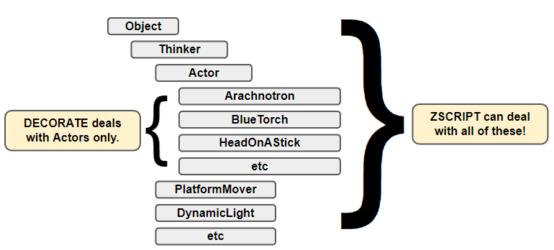

Un Actor es ahora sólo uno de los muchos tipos de Pensadores que puedes usar: los actores usan su método Tick() para avanzar a través de su lista de estados y llamar a las funciones definidas en ella, pero otros Pensadores pueden funcionar de manera muy diferente.

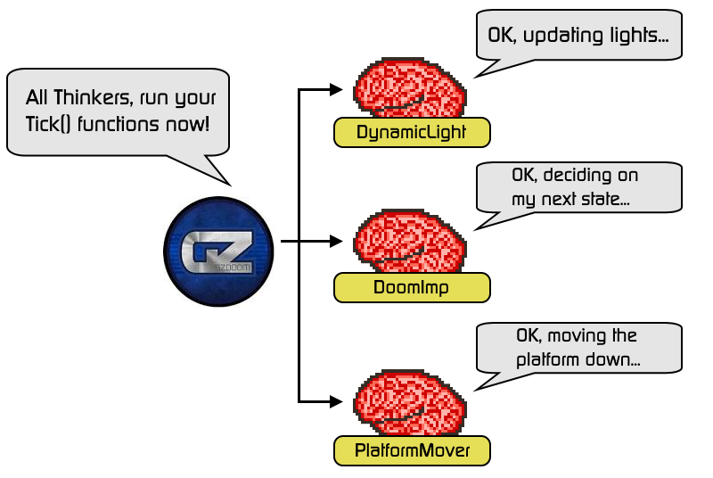

#### Controladores de eventos

Los controladores de eventos te permiten reaccionar a las cosas que suceden en el mundo del juego, sin la torpeza de tener que asignar etiquetas a los objetos y realizar llamadas a través de ACS. Cuando agregas un controlador de eventos al juego, este recibirá una notificación cada vez que suceda algo que esté configurado para escuchar. Puedes pensar en ellos de una manera similar a los scripts especiales de ACS: puedes tener código en un controlador de eventos para un mapa que se está cargando o un jugador que ingresa o sale de él.

Sin embargo, la gran diferencia aquí es que los controladores de eventos también pueden reaccionar a cosas mucho más detalladas: un monstruo que recibe daño, una línea que se activa e incluso el jugador que realiza pulsaciones de teclas. Consulta [https://zdoom.org/wiki/Events\_and\_handlers](https://www.google.com/url?q=https://zdoom.org/wiki/Events_and_handlers&sa=D&source=editors&ust=1677034908409855&usg=AOvVaw3mgj1Hzw8XP-spOAmMsFL4)  para obtener una lista de eventos que pueden detectar estos controladores: las posibilidades son amplias.

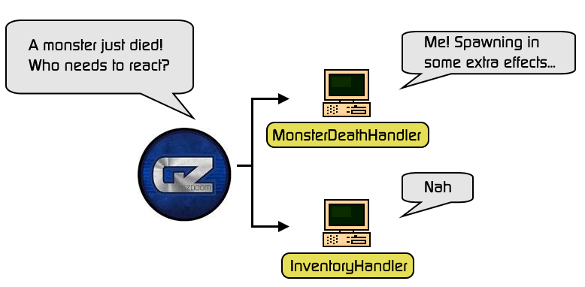

Gran parte del poder de ZScript proviene de un comportamiento común a ambos objetos: proporcionan funciones que puedes anular en tus subclases personalizadas para insertar tu propia lógica. Cualquier cosa que extienda la clase Thinker tendrá su método Tick() llamado 35 veces por segundo, y un EventHandler ejecutará funciones para cualquier evento que esté configurado para escuchar. Al usar estos elementos juntos, más el acceso que ZScript te da a los elementos internos del mundo del juego, es posible crear cosas muy interesantes.

## El proyecto

En este tutorial, vamos a usar ZScript para hacer algo que Doom nunca pidió: agregar un poco de ahorro para que el jugador pueda comprar salud y mejoras. También vamos a recompensar al jugador por su velocidad al matar engendros del infierno y aprenderemos a usar ZScript para agregar un widget al HUD para mostrar el estado de todo. Para hacer todo esto, usaremos tanto pensadores como controladores de eventos para alterar el nivel, manejar la entrada y reaccionar a los eventos, dibujar en la pantalla e incluso leer desde otra parte del WAD.

Una de las cosas más difíciles para mí al iniciar ZScript fue saber dónde encontrar información; por lo tanto, a lo largo de este tutorial no solo hablaré sobre cómo construir el proyecto, sino también dónde está documentada la funcionalidad que estoy usando y cómo descubrir más sobre ella por ti mismo.

### Configuración

Puedes descargar los recursos para este proyecto desde [https://doom.teamouse.net/zstutorial/zstutorial-start.zip](https://www.google.com/url?q=https://doom.teamouse.net/zstutorial/zstutorial-start.zip&sa=D&source=editors&ust=1677034908411595&usg=AOvVaw1BhnkWEmDkScJECiojh2xa)  :  contiene un par de sprites y extras a los que haremos referencia en nuestro ZScript, pero eres bienvenido a crear tu propia versión de cualquiera de estos activos.

Gran parte de este tutorial consistirá en explicaciones de lo que estamos haciendo y cómo funcionan. Las acciones que debes realizar se resaltarán en un recuadro con el ícono de la calavera de Doom. Aquí tienes la primera:

|  |
| --- |
| IMG_260**Descargue el ZIP de recursos y descomprímalo en una nueva carpeta.** |

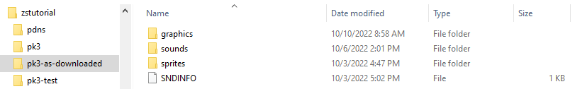

Esta será nuestra carpeta PK3. El contenido de esta carpeta se puede comprimir en un archivo PK3 para crear un mod empaquetado para GZDoom. Para probarlo, puedes arrastrar la carpeta a GZDoom.exe sin comprimirla. Como alternativa, prefiero usar la línea de comandos, pasando .  como archivo para indicar el directorio actual:

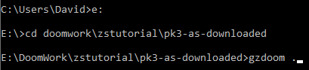

(Sí, tengo mi carpeta gzdoom en mi RUTA de Windows; la gente más normal tendría que ingresar la ruta completa a gzdoom aquí)

A partir de aquí, este tutorial te guiará en la incorporación de algunos elementos de ZScript. ¡Buena suerte!

## Parte 1. El trabajo preliminar

### Orbes de la perdición

#### Creación de una clase de actor de ZScript

Empecemos con el elemento más básico de nuestro mod y vayamos avanzando a partir de ahí: vamos a necesitar un objeto que el jugador pueda recoger para obtener puntos. La apariencia y el nombre de este pueden depender de ti, pero yo voy a seguir el ejemplo de Devil May Cry y convertirlos en orbes rojos. Un objeto básico que se pueda recoger y que amplíe el inventario se vería así en DECORATE:

|  |
| --- |
| Ejemplo de DECORAR de un objeto básico de DoomOrb |
| Actor DoomOrb: Inventario {      Inventario.Cantidad máxima 999999      Inventario.Cantidad 1      Inventario.RecogerSonido "orbes/inventario/arriba"      +BRILLANTE      estados {        Desovar:          DORB A 5          DORMITORIO B 5          Bucle      }  } |

El equivalente de esto en ZScript no tiene nada demasiado sorprendente: hay una guía sobre las diferencias entre DECORATE y ZScript en la wiki de ZDoom en [https://zdoom.org/wiki/Converting\_DECORATE\_code\_to\_ZScript](https://www.google.com/url?q=https://zdoom.org/wiki/Converting_DECORATE_code_to_ZScript&sa=D&source=editors&ust=1677034908417150&usg=AOvVaw1dIn2HQR_ZVSqV732SkJlf)  que entra en algunos detalles, pero en nuestro caso solo necesitamos saber algunas cosas:

* Ahora estamos definiendo una clase que resulta ser un actor, no definiendo un actor directamente.
* Las líneas de código, declaraciones de estado, propiedades, etc. ahora terminan consistentemente con un punto y coma.
* Las propiedades que simplemente estaban en la definición de Actor en DECORATE ahora van a un bloque de código llamado "predeterminado".

|  |
| --- |
| IMG_263**Crea un archivo llamado ZSCRIPT en tu carpeta PK3 y agrégale esta clase DoomOrb.** |

|  |
| --- |
| Script Z |
| **versión "4.10.0"**  **clase DoomOrb : Inventario {**  **por defecto {**  **Inventario.MaxAmount 999999;**  **Inventario.Cantidad 1;**  **Inventario.PickupMessage "Recogí un orbe";**  **Inventario.PickupSound "orbes/inventario/arriba";**  **+BRILLANTE;**  **}**  **estados {**  **Desovar:**  **DORB A 5;**  **DORB B 5;**  **Bucle;**  **}**  **}** |

ZSCRIPT debe comenzar con una declaración de versión para que GZDoom sepa cómo interpretarla: al momento de escribir esto, 4.10.0 es la última versión de ZSCRIPT, y el proyecto que estamos construyendo debería funcionar en esa versión de GZDoom o superior.

El resto del archivo es muy similar al ejemplo DECORATE anterior, y eso es todo lo que se necesita para crear nuestra primera clase ZScript. Si cargas este proyecto en GZDoom, ingresas al primer nivel y bajas la consola con la tecla de acento grave (`), puedes escribir el comando de invocación de doomorb  para crear uno frente al jugador. Parpadeará felizmente hasta que camines sobre él para recogerlo.

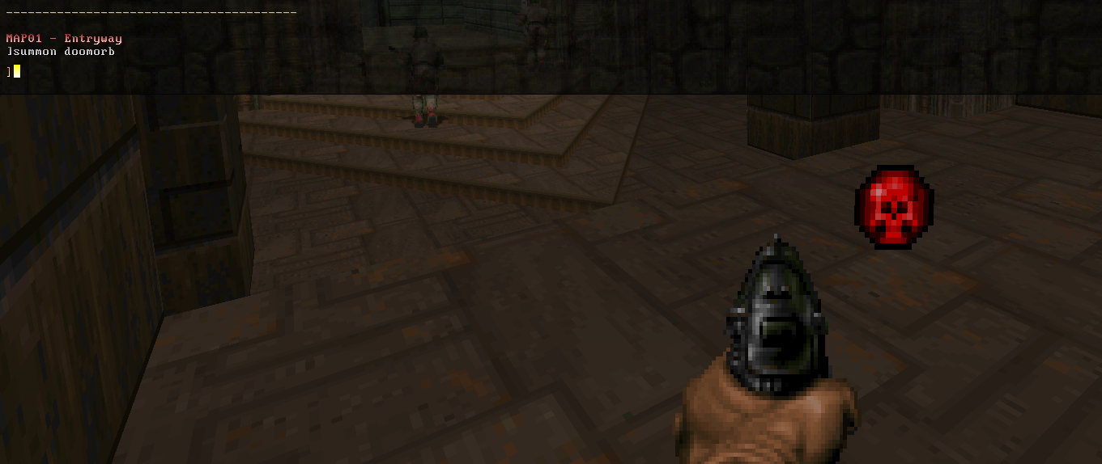

Si aún no estás familiarizado con el ecosistema de GZDoom, vale la pena mencionar que "Inventario" aquí significa algo ligeramente diferente de lo que significa en la mayoría de los juegos con motor Doom. En juegos como Heretic y Hexen, los elementos del inventario son específicamente cosas que puedes recoger, recorrer y luego usar más tarde, por ejemplo, los famosos Tomes of Power u otros elementos mágicos que puedes llevar contigo. En GZDoom, "inventario" se refiere a todo lo que posee el jugador: aquí se incluyen armas, municiones y elementos de inventario utilizables. Estos elementos no aparecerán en un inventario al estilo Hexen, son solo fichas que se colocan en el inventario del jugador detrás de escena.

Así que ese es un objeto de inventario simple al estilo de DECORATE que acabamos de trasladar directamente a ZScript, pero ahora llegamos a la parte interesante, donde podemos usar ZScript para alterar su lógica de maneras que estaban fuera de nuestro alcance en DECORATE. No queremos que estos orbes se queden ahí para siempre: si no se los recoge en un tiempo determinado, haremos que desaparezcan.

En DECORATE, puedes hacer esto intentando construir un bucle limitado de estados recordando las distintas reglas que debes respetar con las variables de usuario y cómo manipularlas en funciones anónimas; o si eres como yo, simplemente abandona eso y escribe un montón de ABABABAB una y otra vez para crear suficientes estados para que duren el tiempo que quiero. ZScript nos permite una forma mucho más elegante de hacer esto: escribir una función Tick() para el objeto.

#### Agregar una función Tick()

La función Tick() es el corazón de la lógica de una clase ZScript: cada vez que el juego se actualiza, es decir, "en cada tick", se llamará a esta función en todos los objetos para que puedan decidir qué deben hacer en este cuadro. La función Tick() existe en la clase padre Thinker y, para los actores, se encarga de todas las cosas estándar, como mover el objeto a través de su lista de estados, etc. En nuestro DoomOrb, queremos hacer eso y luego agregar algo de lógica propia.

Escribir esta parte es exactamente lo mismo que escribir una función para un objeto en C# o Java: queremos agregar una variable que cada instancia de esta clase pueda usar para realizar un seguimiento de cuánto tiempo ha existido y luego incrementarla en cada tic hasta que sea el momento de eliminarla.

|  |
| --- |
| IMG_265**Agregue una variable de instancia y una función Tick() a nuestro DoomOrb:** |

|  |
| --- |
| Script Z |
| clase DoomOrb : Inventario {  **int edad;**      por defecto {...}      estados {...}  **anular void Tick() {**  **super.Tick();**  **edad++;**  **si (edad > 350) {**  **auto.Destruir();**  **}**  **}**  } |

La lógica aquí es bastante simple: agrega 1 a la variable de instancia 'age' en cada tick y, si ahora supera los 350, elimina el objeto del juego llamando a su función Destroy(). Hay 35 ticks por segundo en el mundo de GZDoom, por lo que este objeto debería durar diez segundos antes de desaparecer.

La palabra clave "self" se utiliza aquí para referirse al objeto que está ejecutando este código, de la misma manera que C# y Java utilizarían "this" - [https://zdoom.org/wiki/ZScript\_special\_words](https://www.google.com/url?q=https://zdoom.org/wiki/ZScript_special_words&sa=D&source=editors&ust=1677034908426308&usg=AOvVaw23p7UTaBOukUdSHqfvc2uV)  muestra una lista de palabras clave como esta. La función Destroy() existe para todos los objetos ZScript y marca el objeto para su eliminación - está definida en la clase Object en la parte superior de la jerarquía. [https://zdoom-docs.github.io/staging/Api/Base/Object.html#instance-methods](https://www.google.com/url?q=https://zdoom-docs.github.io/staging/Api/Base/Object.html%23instance-methods&sa=D&source=editors&ust=1677034908426701&usg=AOvVaw2UqxlvgoJNaSp_Xr0c3MI8)

Otra cosa que es diferente de otros lenguajes orientados a objetos es que ZScript no permite especificar un valor predeterminado para las variables de instancia. Esto puede causarle cierta preocupación si viene de C++, donde esto daría como resultado obtener simplemente lo que esté en la memoria en ese momento, pero no se preocupe: un int siempre se inicializará a 0.

Por último, la llamada a super.Tick() en la parte superior es muy importante: llamará a la función Tick() en la clase padre Actor para que el actor ejecute la lógica que está allí, así como todo lo que agregamos. Sin esta llamada, el objeto quedará congelado en el tiempo de forma extraña; intenta eliminarla si quieres y verás que el objeto no se ve afectado por la gravedad y no se anima porque no avanza a través de sus estados.

Intenta abrir este proyecto en GZDoom nuevamente, y esta vez (siempre que la llamada a super.Tick() esté intacta) cuando ingreses el comando invocar doomorb , deberías verlo desaparecer después de diez segundos.

#### Depuración de la función Tick()

Intenta invocar algunos de estos objetos y recogerlos. Si bajas la consola y escribes printinv  después, deberías verlos en tu inventario... pero ¿qué sucede? Después de unos segundos, es posible que no tengas tantos en tu inventario como creías que habías recogido.

Podemos aclarar lo que está sucediendo agregando algún registro a nuestra función. Es posible que esté familiarizado con Log() y A\_Log(); en ZScript, podemos imprimir un mensaje en la consola mediante la función console.printf().

|  |
| --- |
| IMG_266**Añade una línea para registrar cuando un DoomOrb haya envejecido lo suficiente como para ser destruido.** |

|  |
| --- |
| Script Z |
| …      anular void Tick() {          super.Tick();          edad++;          si (edad > 350) {  **console.printf("Destruyendo un %s", self.getClassName());**              auto.Destruir();          }      }  … |

console.printf es una función muy útil que está disponible desde cualquier lugar. Es como la función del mismo nombre en C, y funciona un poco como una función Log más fácil de analizar de ACS: especifica una cadena para registrar con marcadores de posición para los valores, seguidos de los valores que se incluirán en la cadena. En este caso, estamos usando %s en nuestra cadena de salida para indicarle a printf que debe esperar que una cadena ingrese en esa ranura, y luego le estamos indicando que reemplace ese %s con el resultado de self.getClassName() (que será "DoomOrb" o como sea que haya llamado a esta clase).

Las sustituciones disponibles se enumeran en la wiki de ZDoom en [https://zdoom.org/wiki/String#Methods](https://www.google.com/url?q=https://zdoom.org/wiki/String%23Methods&sa=D&source=editors&ust=1677034908430233&usg=AOvVaw3xJkq5e2QUVM39HCFJpgv7)  .

Ahora vuelve a ejecutar el juego y haz lo mismo, invocando y recogiendo los DoomOrbs. Pronto notarás el problema: los objetos DoomOrb siguen existiendo de la misma manera que existían en el mundo del juego cuando estaban en el inventario del jugador, por lo que seguirán envejeciendo y se destruirán.

Para evitarlo, agregaremos una nueva condición a nuestra función Tick() que haga que el objeto no envejezca si está en el inventario de un jugador. Podemos detectar esto verificando si el objeto tiene un propietario.

|  |
| --- |
| IMG_267**Añade una comprobación para comprobar que se ha recogido el DoomOrb y evita que se envejezca. También podemos eliminar la línea console.printf().** |

|  |
| --- |
| Script Z |
| …      anular void Tick() {          super.Tick();  **si (self.owner) {return;}**          edad++;          si (edad > 180) {  ~~console.printf("Destruyendo un %s", self.getClassName());~~              auto.Destruir();          }      }  … |

Aquí, estamos probando si el propietario de este objeto es algo: si no es nulo, entonces regresa antes de tiempo solo después de haber ejecutado la función Tick() de la superclase e ignorando toda la lógica de envejecimiento. Si prueba esto ahora, debería ver que los orbes en su inventario permanecen como esperaba.

### Manejo de un evento

Ahora que nuestro objeto orbe funciona, hagamos que los enemigos dejen caer algunos para que el jugador los recoja cuando mueran. En el mundo de DECORATE, en este punto tendríamos que escribir una nueva subclase de cada monstruo y alterar sus probabilidades de caída o estados de muerte para incluir los comandos para crear nuevos orbes. Pero como estamos en ZScript, podemos escribir un controlador de eventos que se llamará automáticamente cada vez que ocurra la muerte de un monstruo y agregar nuevas acciones en ese evento en lugar de tener que alterar el objeto en sí.

[https://zdoom.org/wiki/Events\_and\_handlers](https://www.google.com/url?q=https://zdoom.org/wiki/Events_and_handlers&sa=D&source=editors&ust=1677034908433904&usg=AOvVaw3S8mU3PNxyjKLwK5ajd1BW)  nos muestra que podemos usar el evento WorldThingDied para reaccionar cuando una cosa alcanza cero salud, así que implementemos un EventHandler con ese evento ahora.

|  |
| --- |
| IMG_268**Agregue otra clase debajo de DoomOrb en nuestro archivo ZSCRIPT: esta es nuestro controlador de eventos.** |

|  |
| --- |
| Script Z |
| versión "4.10.0"  clase DoomOrb: Inventario {...}  **clase MonsterDeathEventHandler : EventHandler {**  **anular void WorldThingDied(WorldEvent e) {**  **console.printf("El monstruo %s fue asesinado", e.Thing.getClassName());**  **}**  **}** |

Esta nueva clase extiende EventHandler e implementa la función WorldThingDied. Las funciones de control de eventos reciben un evento "e", y la página wiki de ZDoom sobre controladores de eventos nos dice que en este evento en particular, tendremos acceso al actor que murió (al que se hace referencia como Thing) y al actor que infligió el daño que causó la muerte (Inflictor).

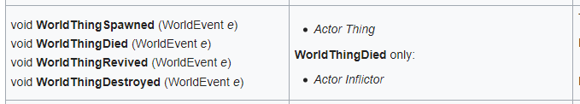

Por el momento, esto simplemente hace lo mismo que hicimos anteriormente para DoomOrb: registrará un mensaje con el nombre de clase del actor que murió ( e.Thing.getClassName() ).

Antes de poder probar esto, tenemos que hacer una cosa más. GZDoom tiene la opción de hacer que un controlador de eventos se aplique de forma global o solo en mapas específicos, por lo que es necesario indicarle dónde debe colocar el nuestro. Queremos que se lo llame durante todo el juego, por lo que lo especificaremos en una sección de información del juego en el bloque MAPINFO.

|  |
| --- |
| IMG_270**Cree un lote MAPINFO en la raíz del proyecto y especifique que se debe cargar nuestro controlador de eventos.** |

|  |
| --- |
| INFORMACIÓN DEL MAPA |
| Información del juego {      AddEventHandlers = "Manejador de eventos de muerte de monstruo"  } |

Prueba el proyecto ahora y deberías ver un mensaje aparecer cada vez que se mata a un monstruo, y el mensaje cambiará según el tipo de monstruo.

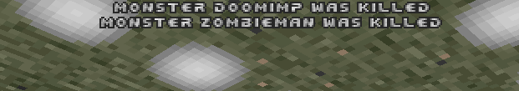

Ahora, en lugar de solo registrar el nombre de la clase, obtendremos otras dos piezas de información del actor moribundo para que podamos crear un DoomOrb en el lugar apropiado; puede ver estas propiedades en la página de ZDoom-docs sobre la clase Actor: [https://zdoom-docs.github.io/staging/Api/Base/Actor.html?highlight=pos#position](https://www.google.com/url?q=https://zdoom-docs.github.io/staging/Api/Base/Actor.html?highlight=pos%23position&sa=D&source=editors&ust=1677034908439724&usg=AOvVaw28EZ0ce4WySzfm1Q3YKlln)

* pos, que es un vector3 con las coordenadas x, y y z del actor.
* altura, la altura del actor en unidades de mapa.

Por cierto, un vector3 es un vector tridimensional. Se trata de una colección de tres coordenadas, escritas como tres números o variables entre paréntesis, por ejemplo (x, y, z)  o (17, 23, 24) . En ACS, las coordenadas a menudo tenían que expresarse de formas difíciles de manejar, utilizando variables y parámetros separados para cada una, como en A\_SpawnItemEx a continuación. El uso de vectores como este nos permite resumirlos de una manera mucho menos detallada.

|  |
| --- |
| bool, Actor **A\_SpawnItemEx** (clase<Actor> *misil* [, doble *xofs* [, doble *yofs* [, doble *zofs [* , doble *xvel [* , doble *yvel* [, doble *zvel* [, doble *ángulo* [, int *banderas* [, int *probabilidad de fallo* [, int *tid*]]]]]]]]]]) |

Una vez que hayamos obtenido la posición y la altura del monstruo moribundo, usaremos la función Actor.Spawn() (ver [https://zdoom.org/wiki/Spawn\_(ZScript)](https://www.google.com/url?q=https://zdoom.org/wiki/Spawn_(ZScript)&sa=D&source=editors&ust=1677034908442151&usg=AOvVaw0tfb_n_7v1lr9FyjZXd9WB) ) para crear un actor de DoomOrb. Esta función es mucho menos complicada que la gran biblioteca de ACS con nombres ligeramente diferentes, y simplemente toma un nombre de clase del actor que quieres generar y un vector3 que representa la posición mundial en la que generarlo. Al especificar (pos.x, pos.y, pos.z + (height/2)) como nuestro vector3, usaremos las posiciones X e Y originales del vector pos de los monstruos directamente, y agregaremos la mitad de la altura del monstruo a la coordenada z (moviendo así el punto de generación hacia arriba desde el piso).

|  |
| --- |
| IMG_272**Cambia la función WorldThingDied para obtener la posición del actor moribundo y crear un DoomOrb a la mitad de su altura.** |

|  |
| --- |
| Script Z |
| clase DoomOrb: Inventario {...}  clase MonsterDeathEventHandler : EventHandler {    anular void WorldThingDied(WorldEvent e) {  ~~console.printf("El monstruo %s fue asesinado", e.Thing.getClassName());~~  **vector3 pos = e.Cosa.pos;**  **doble altura = e.Cosa.altura;**  **Actor.Spawn("Orbe de la perdición", (pos.x, pos.y, pos.z + (altura/2)));**    }  } |

Con MonsterDeathEventHandler ahora activo, deberías poder ejecutar el juego y ver a los monstruos soltar los DoomOrbs cuando mueren.

### Dibujando en la pantalla

Todo esto funciona bien, pero sería bueno tener un contador visible en la pantalla de cuántos orbes hemos recogido en lugar de tener que recurrir a la consola cada vez que queremos comprobarlo. Agreguemos un contador básico al HUD.

En el mundo de ZScript, el proceso de dibujar elementos en la pantalla también lo gestionan los EventHandlers. Esta vez, vamos a crear uno para escuchar el evento RenderOverlay, que se llama en cada fotograma cuando GZDoom está listo para dibujar elementos del HUD sobre el mundo del juego renderizado.

(Por cierto, no hay nada que diga que no podríamos simplemente poner los eventos de muerte de monstruos y el dibujo de la interfaz de usuario en un solo controlador de eventos y hacer que maneje ambos casos implementando WorldThingDied y RenderOverlay. Pero me parece más fácil para la mente crear controladores de eventos separados para diferentes cosas).

|  |
| --- |
| IMG_273**Agregue otro controlador de eventos a nuestro archivo ZSCRIPT y agréguelo a los controladores de eventos que se llamarán durante el juego.** |

|  |
| --- |
| Script Z |
| versión "4.10.0"  clase DoomOrb: Inventario {...}  clase MonsterDeathEventHandler : EventHandler {...}  **clase OrbUIHandler : EventHandler {**  **anular void RenderOverlay(RenderEvent e) {**  **PlayerPawn p = PlayerPawn(jugadores[consoleplayer].mo);**  **int orbes = p.CountInv("DoomOrb");**  **Pantalla.DrawText(smallfont, Font.CR\_RED, 4, 4, orbes);**  **}**  **}** |

|  |
| --- |
| INFORMACIÓN DEL MAPA |
| Información del juego {      AddEventHandlers = "Manejador de eventos de muerte de monstruo **", "Manejador de interfaz de usuario de Orb**"  } |

Para esta función, necesitamos saber para qué jugador estamos dibujando el HUD para poder recuperar la cantidad de orbes rojos de su inventario. Los jugadores siempre se pueden recuperar de la matriz global llamada "players", como se indica en la página de globales en [https://zdoom-docs.github.io/staging/Api/Globals.html?highlight=players#players](https://www.google.com/url?q=https://zdoom-docs.github.io/staging/Api/Globals.html?highlight=players%23players&sa=D&source=editors&ust=1677034908450731&usg=AOvVaw3yrPllxDPSWPBd9vE6_AmS) , y el número del jugador actual también está disponible como consoleplayer . La matriz players almacena una colección de objetos PlayerInfo, que describen el estado de los jugadores en el juego; en el momento de escribir esto, la documentación para ellos aún no se ha terminado, pero las propiedades de ellos se pueden encontrar en el código fuente de zscript en [https://github.com/ZDoom/gzdoom/blob/master/wadsrc/static/zscript/actors/player/player.zs#L2680](https://www.google.com/url?q=https://github.com/ZDoom/gzdoom/blob/master/wadsrc/static/zscript/actors/player/player.zs%23L2680&sa=D&source=editors&ust=1677034908451266&usg=AOvVaw1eIkLKIaa5ZAE9RwaNey4i)  .

Un PlayerInfo tiene una referencia a su objeto PlayerPawn correspondiente bajo la propiedad llamada "mo". La diferencia es bastante difícil de entender y no podría describirla completamente yo mismo, pero el PlayerPawn es el objeto que se mueve y representa la presencia del jugador en el nivel, mientras que PlayerInfo almacena información más general sobre el jugador (cuántos secretos ha descubierto, sus preferencias de campo de visión, etc.). El PlayerPawn es el que tiene el inventario, por lo que en total, la primera línea de esta función tiene que:

* Obtenga el elemento *consoleplayer*de la matriz global de jugadores, que será un PlayerInfo

jugadores[consoleplayer]

* Obtener la propiedad mo de PlayerInfo

jugadores[consoleplayer].mo

* Convierte eso en un PlayerPawn poniendo todo eso entre los paréntesis de PlayerPawn()

JugadorPawn p = JugadorPawn(jugadores[jugadorconsola].mo)

Luego llamamos a CountInv() en PlayerPawn para contar cuántos DoomOrbs lleva nuestro jugador actual: esta es una de las funciones de actor de ZScript enumeradas en la wiki de ZDoom en [https://zdoom.org/wiki/CountInv](https://www.google.com/url?q=https://zdoom.org/wiki/CountInv&sa=D&source=editors&ust=1677034908452656&usg=AOvVaw0m6ijashonkuLg_rpFlixD) .

Una vez que hayamos obtenido ese recuento, ahora podemos escribirlo en la pantalla con la función Screen.DrawText documentada en [https://zdoom.org/wiki/DrawText](https://www.google.com/url?q=https://zdoom.org/wiki/DrawText&sa=D&source=editors&ust=1677034908453345&usg=AOvVaw0juREVDF3IJGPvI1vcSTUH)  . Esta es más o menos el equivalente de ZScript de HudMessage: es una forma rápida de colocar texto en el HUD con opciones mínimas. Nuestra llamada aquí utiliza los parámetros:

* Fuente: podríamos usar una personalizada aquí, pero smallfont es una variable global que solo usa la fuente pequeña predeterminada del juego actual.
* Color: se definen como constantes en la clase Fuente y son equivalentes a los colores CR\_… utilizados por ACS
* Coordenadas X e Y en las que dibujar la cadena: aquí he utilizado (4, 4), pero puedes cambiarlas como prefieras
* La cadena que queremos imprimir, en este caso, nuestra variable orbs.

Vuelve a iniciar GZDoom con esto instalado y verás que no se inicia. ¿Por qué?

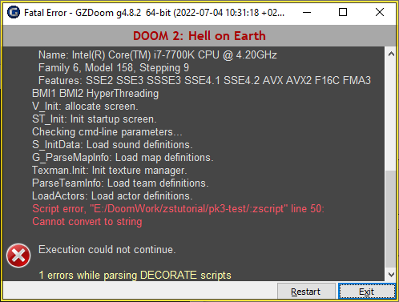

Resulta que ZScript es un poco exigente con los tipos de variables: nuestra variable orbs es un número y no una cadena. Si bien nosotros, como humanos, podemos pensar que es bastante obvio cómo imprimir un número como una cadena, la computadora no lo hará a menos que se lo pidamos específicamente, así que hagámoslo ahora.

Hay un par de formas de hacer esto. Una posibilidad es usar la función String.Format, que se comporta de forma muy similar a console.printf(), tomando una cadena con un conjunto de marcadores de posición y luego una lista de variables para intercambiar. Para convertir nuestro número en una cadena sin más adornos, podría usar el marcador de posición %d para representar un número (para recordar esto, siempre lo he llamado mentalmente "decimal", pero puede que esté totalmente equivocado):

Cadena.Formato("%d", orbes)

También puedes usar esto para agregar algún texto con el recuento, como:

String.Format("Orbes: %d", orbes)

Otra forma de convertir un número en una cadena, que me parece bastante más sencilla aunque parezca menos oficial, es concatenarle una cadena vacía; esto lo convertirá en una cadena automáticamente. En ZScript, el operador de concatenación son dos puntos, ..  ; por lo tanto, esto obligará a que los orbes int se traten como una cadena:

orbes .. ""

|  |
| --- |
| IMG_275**Elija su método preferido y modifique la línea Screen.DrawText para usarlo.** |

|  |
| --- |
| Script Z |
| …  Pantalla.DrawText(smallfont, Font.CR\_RED, 4, 4, **orbes .. ""**);  … |

Al iniciar GZDoom, ahora verás el contador en la esquina. Según tu resolución, puede que sea un poco difícil verlo... así que agreguemos algunos parámetros más a nuestra llamada para solucionarlo.

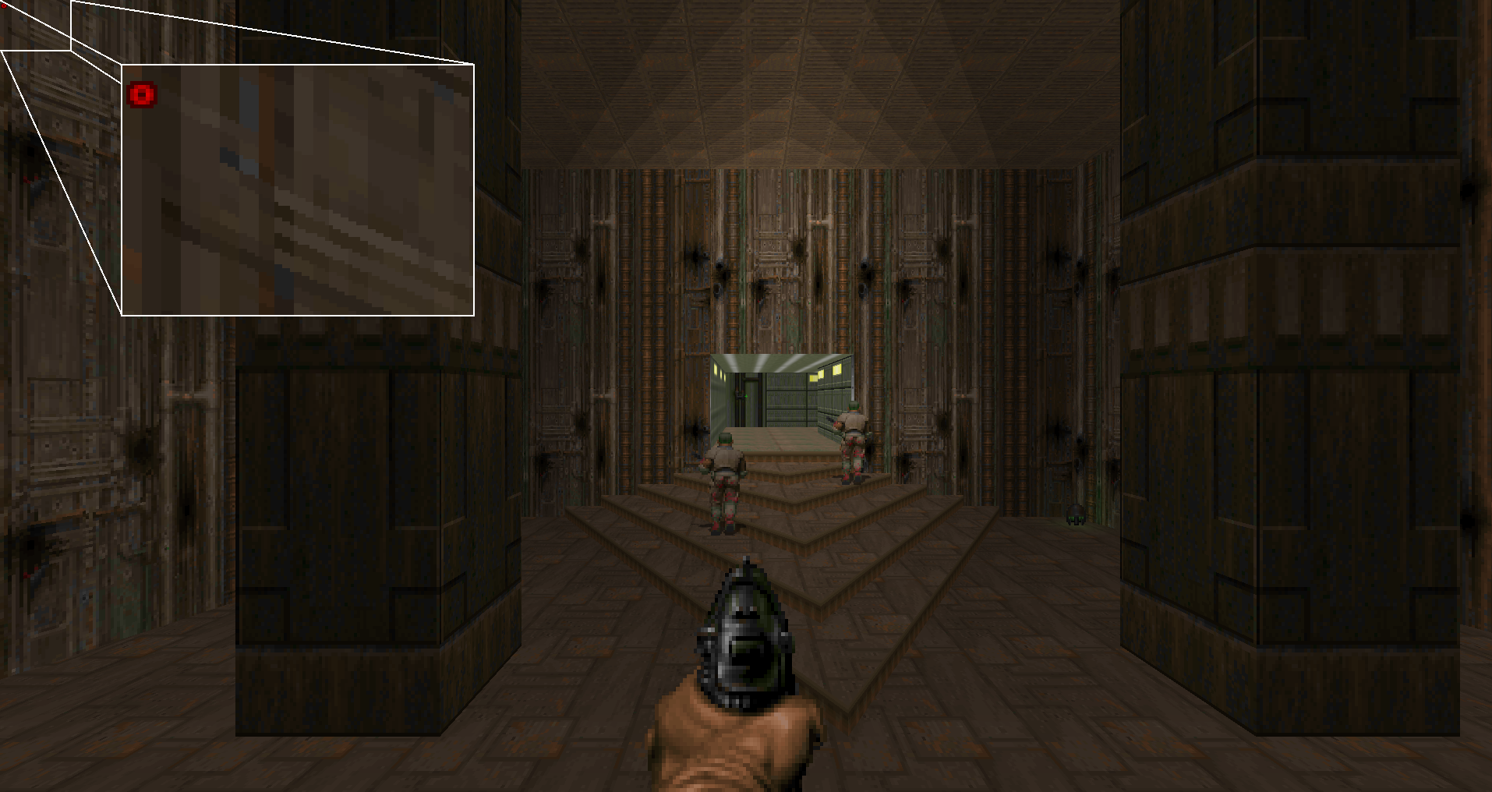

Según [https://zdoom.org/wiki/DrawText](https://www.google.com/url?q=https://zdoom.org/wiki/DrawText&sa=D&source=editors&ust=1677034908458500&usg=AOvVaw1l3Sm0kGC_sUxZPl3C6XEB) , la función DrawText puede tomar algunos parámetros más después de la cadena para mostrar, a los que llama "etiquetas", organizadas en pares con [el nombre de la opción], [el valor de la opción]. Al igual que SetHudSize() en ACS, las opciones DTA\_VirtualHeight y DTA\_VirtualWidth nos permiten decir que queremos que la cadena se escale e imprima como si la pantalla tuviera el tamaño que especificamos, así que reduzcamos eso de cualquier resolución impía que tengamos en una PC de la década de 2020 a una resolución más razonable de 640x480.

|  |
| --- |
| Script Z |
| …  Pantalla.DrawText(fuentepequeña, Fuente.CR\_RED, 4, 4, orbes .. "", DTA\_VirtualWidth, 640, DTA\_VirtualHeight, 480 );  … |

Ahora puedes jugar con los parámetros para ajustar el contador como prefieras.

Entonces, en solo unas pocas clases, hemos tenido un buen comienzo en ZScript e hicimos algunas cosas familiares para DECORAR/ACS de una manera más conveniente: tenemos un potenciador que se agota, tenemos monstruos que lo sueltan y tenemos un contador en pantalla para ellos.

## Parte 2. Realizando algunas mejoras

Ya tenemos algunos bloques de construcción básicos de ZSCRIPT funcionando: revisémoslos y puliéndolos un poco.

### Nuevo efecto de desaparición de orbe

Sería bueno avisar al jugador antes de que los orbes desaparezcan para animarlo a que se apresure a conseguirlos. Hagamos que parpadeen con un poco más de urgencia durante un rato antes de que desaparezcan.

|  |
| --- |
| IMG_277**Agrega un nuevo estado a la clase DoomOrb: haremos que el objeto salte aquí cuando esté a punto de desaparecer.** |

|  |
| --- |
| Script Z |
| clase DoomOrb : Inventario {      int edad;        por defecto {...}      estados {        Desovar:          DORB A 5;          DORB B 5;          Bucle;  **En descomposición:**  **DORB A 2;**  **DORB B 2;**  **TNT1A2;**  **Bucle;**      }      anular void Tick() {...}  } |

Esto alternará entre los dos cuadros de orbe más rápidamente, así como también el cuadro TNT1 A (que, por razones históricas, es el nombre de un cuadro sin sprite).

Ahora necesitamos encontrar una forma de verificar la variable de edad en algún punto durante el bucle Spawn. Todas las funciones DECORATE todavía se pueden usar en la lista de estados aquí, por lo que usar algún tipo de A\_JumpIf() podría funcionar... pero escribamos nuestra propia función de acción en su lugar, ¡porque eso es algo que ahora podemos hacer en ZScript!

|  |
| --- |
| IMG_278**Agregue una función de acción llamada checkAge() a la clase DoomOrb.** |

|  |
| --- |
| Script Z |
| clase DoomOrb : Inventario {      int edad;        por defecto {...}      estados {...}      anular void Tick() {...}  **acción void checkAge() {**  **si (invocador.edad > 250) {**  **invocador.SetState(ResolveState("En descomposición"));**  **}**  **}**  } |

Las funciones de acción se especifican de forma ligeramente diferente a otras funciones: se especifican con la palabra clave "acción", que les otorga propiedades especiales que les permiten distinguir entre el actor que las llama y la clase a la que realmente pertenece la función. Esto es importante para situaciones como cuando un jugador llama a una acción sobre un elemento que está en su inventario; en este caso, no tenemos que preocuparnos por esta posibilidad porque la acción siempre la llama el propio objeto del inventario, pero tenemos que ser conscientes de la diferencia que supone en la forma en que nos referimos a los objetos. Dentro de las funciones de acción, el objeto afectado por la acción ahora se conoce como "invocador" en lugar de "sí mismo", por lo que verificamos la propiedad de edad del invocador y, potencialmente, le decimos que salte a la etiqueta de estado "Decayendo".

Ahora llamemos a esta nueva función de acción en nuestro segundo estado bajo la etiqueta Spawn, especificándola después de la longitud del estado de la misma manera que lo haría con cualquier otra función de acción:

|  |
| --- |
| IMG_279**Haga que DoomOrb llame a checkAge() durante su bucle Spawn.** |

|  |
| --- |
| Script Z |
| clase DoomOrb : Inventario {      int edad;        por defecto {...}      estados {        Desovar:          DORB A 5;          DORB B 5 **checkAge()**;          Bucle;        En descomposición:          DORB A 2;          DORB B 2;          TNT1A2;          Bucle;      }      anular void Tick() {...}      acción void checkAge() {...}  } |

Ahora, cuando los monstruos sueltan orbes, deberías poder verlos comenzar a parpadear después de 250 tics (aproximadamente 7 segundos) antes de finalmente desaparecer.

### Nuevo efecto de apariencia de orbe

Los objetos que se recogen significan dopamina. ¿Cuál es la mejor manera de obtener más dopamina? ¡Más objetos que se recogen! Además, que todos los monstruos suelten un orbe no suena bien: parece que reventar un cacodemonio gigante debería valer más que derribar a un zombi con piel de plastilina con una pluma. Digamos que en lugar de solo uno por monstruo, debería soltar un orbe por cada diez puntos de salud que tenía antes de que aparecieras tú.

Necesitaremos ejecutar un bucle en nuestro MonsterDeathEventHandler esta vez, y esto se hace de la misma manera que otros lenguajes de estilo C: para saber cuántas veces ejecutar ese bucle, veamos nuevamente la documentación de los actores.

[https://zdoom-docs.github.io/staging/Api/Base/Actor.html?highlight=getmaxhealth#virtuals](https://www.google.com/url?q=https://zdoom-docs.github.io/staging/Api/Base/Actor.html?highlight=getmaxhealth%23virtuals&sa=D&source=editors&ust=1677034908476431&usg=AOvVaw2t8AjiC7nb4JZ3VVgjed7L)  - Este se ve bien. Probémoslo.

|  |
| --- |
| IMG_280**Agregue un bucle a MonsterDeathEventHandler para que suelte un orbe por cada 10 puntos de salud del GetMaxHealth() del monstruo moribundo.** |

|  |
| --- |
| Script Z |
| clase MonsterDeathEventHandler : EventHandler {    anular void WorldThingDied(WorldEvent e) {          vector3 pos = e.Cosa.pos;          doble altura = e.Cosa.altura;  **int maxSalud = e.Cosa.getMaxSalud();**  **para (int i = 0; i < SaludMáxima; i += 10) {**  Actor.Spawn("Orbe de la perdición", (pos.x, pos.y, pos.z + (altura/2)));  **}**    }  } |

Si juegas ahora, notarás que no pasa nada, en realidad: los monstruos parecen seguir soltando un orbe. Pero si corres y los recoges, verás que el contador aumenta más de lo que solía hacerlo: los nuevos orbes se están soltando, ¡pero todos están en el mismo lugar!

Vamos a distribuirlos un poco mejor. A diferencia de ACS, no tenemos que encontrar una función que nos permita crear un objeto de una manera muy específica que nos permita alterar su posición o velocidad: si mantenemos una referencia al objeto que se creó, ¡podemos alterar sus velocidades X, Y y Z directamente!

|  |
| --- |
| IMG_281**Añade un elemento aleatorio a las velocidades del DoomOrb cuando se genera.** |

|  |
| --- |
| Script Z |
| clase MonsterDeathEventHandler : EventHandler {    anular void WorldThingDied(WorldEvent e) {          vector3 pos = e.Cosa.pos;          doble altura = e.Cosa.altura;          int maxSalud = e.Cosa.getMaxSalud();          para (int i = 0; i < SaludMáxima; i += 10) {  **deje que spawnedActor =**Actor.Spawn("DoomOrb", (pos.x, pos.y, pos.z + (altura/2)));  **actor engendrado.vel.X = frandom(-3, 3);**  **actor generado.vel.Y = frandom(-3, 3);**  **actor engendrado.vel.Z = frandom(5, 10);**          }    }  } |

frandom() devolverá un valor aleatorio de punto fijo (no entero) entre los dos límites dados, por lo que cada orbe creado ahora será lanzado a una velocidad entre 5 y 10 hacia el aire, en una dirección horizontal aleatoria que puede tener una velocidad de -3 a 3 a lo largo de cada uno de los ejes X e Y. Y si no está familiarizado con la palabra clave let  , nos permite declarar una variable que realmente no se preocupa por su tipo: solo será el tipo que se le haya asignado, en este caso, el DoomOrb devuelto por la función spawn.

La velocidad, al igual que la posición de un objeto, es un vector3. He dividido las tres dimensiones aquí y las he asignado por separado porque creo que el código se ve más claro de esa manera, pero también podrías escribir:

actor generado.vel = (frandom(-3, 3), frandom(-3, 3), frandom(5, 10));

Inténtalo de nuevo y verás que el efecto es mucho más satisfactorio.

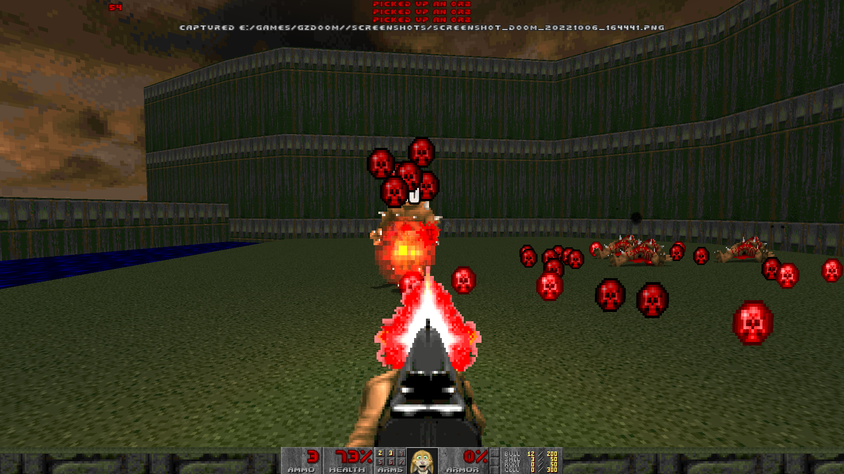

Seamos más ambiciosos. Intenta invocar un ciberdemonio en el nivel con Summon Cyberdemon , luego alinéalo en el medio de la pantalla y usa el comando de consola mdk  para causarle un millón de puntos de daño.

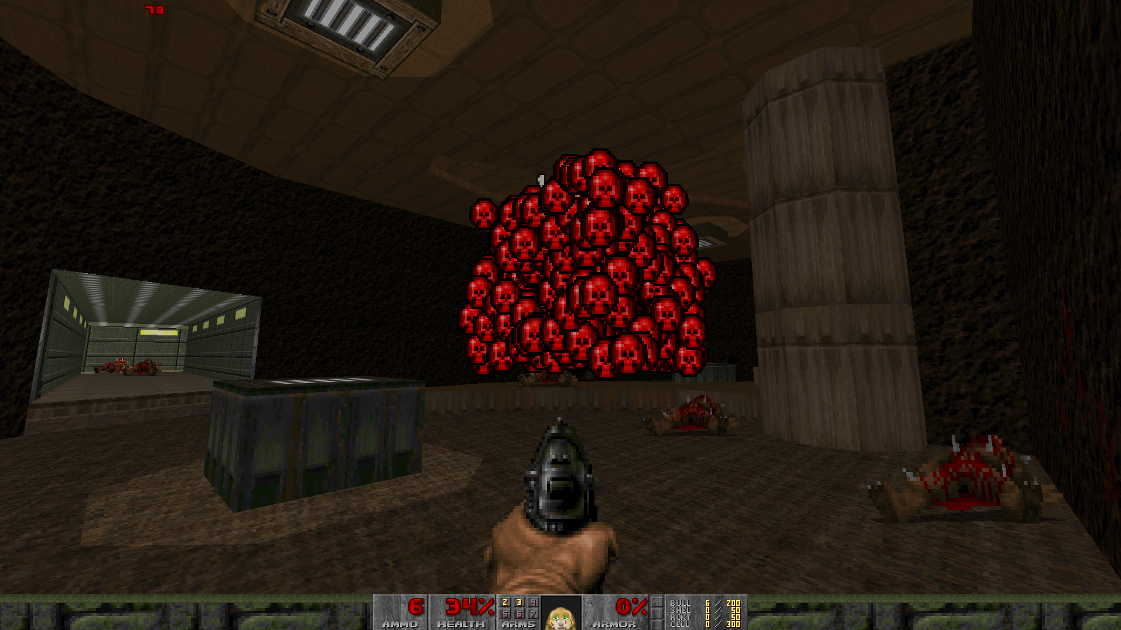

Mmm. En realidad, es demasiada dopamina. Tal vez deberíamos agregar un caso especial para cuando un monstruo tiene una cantidad muy alta de puntos de vida. Agreguemos una variedad mayor de orbes que otorguen más puntos.

|  |
| --- |
| IMG_284**Agregue otra clase a nuestro archivo ZScript que extienda la clase DoomOrb.** |

|  |
| --- |
| Script Z |
| clase DoomOrbBig : DoomOrb {      por defecto {          Inventario.PickupMessage "¡Recogí un orbe grande!";          Escala 2;      }        anular void AttachToOwner(Actor propietario) {          propietario.GiveInventory("DoomOrb", 10);          auto.Destruir();      }  } |

Nuevamente, hay un pequeño truco aquí. Esta clase extiende la clase DoomOrb, por lo que heredará las funciones y los estados que ya hemos especificado, pero necesitamos agregar una cosa más esta vez e implementar una función AttachToOwner. Esta es una de las funciones de actor virtual que se enumeran en [https://zdoom.org/wiki/ZScript\_virtual\_functions#Inventory](https://www.google.com/url?q=https://zdoom.org/wiki/ZScript_virtual_functions%23Inventory&sa=D&source=editors&ust=1677034908488853&usg=AOvVaw1Yfo8vq0myNgB81NkB-9BD) , que se comportan de manera muy similar a las funciones que están disponibles para los controladores de eventos: se  llaman cuando ZDoom detecta que algo le ha sucedido al objeto. En este caso, se llama a AttachToOwner cuando otro actor recoge el elemento.

Al recogerlo, queremos que el jugador no obtenga realmente el objeto DoomOrbBig, porque entonces tendría un recuento separado de DoomOrbs y DoomOrbBigs en su inventario; en cambio, le decimos a esta variante del orbe que agregue diez DoomOrbs al alijo de su propietario y luego se destruya a sí mismo, por lo que no permanecerá en el inventario.

Una vez que hayamos especificado nuestro nuevo orbe que vale diez de los más pequeños, debemos reescribir la función WorldThingDied de nuestro MonsterDeathEventHandler para que use tantos de estos dos tipos de orbe como sea necesario para llegar a la MaxHealth del monstruo. Con lo que ha aprendido sobre ZScript hasta ahora, intente hacer esto por su cuenta antes de mirar el código a continuación: hay muchas formas de hacerlo y este es solo un ejemplo.

|  |
| --- |
| IMG_285**Reescribe nuestro MonsterDeathEventHandler para crear tantos orbes grandes como sea posible antes de pasar a los más pequeños.** |

|  |
| --- |
| Script Z |
| **clase MonsterDeathEventHandler : EventHandler {**  **anular void WorldThingDied(WorldEvent e) {**  **vector3 pos = e.Cosa.pos;**  **doble altura = e.Cosa.altura;**  **pos.z += altura/2;**  **int maxSalud = e.Cosa.getMaxSalud();**  **mientras (SaludMáx >= 100) {**  **saludmáx -= 100;**  **self.createOrb(verdadero, pos);**  **}**  **mientras (SaludMáx >= 10) {**  **saludmáx -= 10;**  **self.createOrb(falso, pos);**  **}**  **}**    **void createOrb(bool grande, vector3 pos) {**  **Cadena className = "DoomOrb";**  **si (grande) { className = "DoomOrbBig"; }**  **deje que spawnedActor = Actor.Spawn(className, pos);**  **actor generado.vel = (frandom(-3, 3), frandom(-3, 3), frandom(5, 10));**  **}**  **}** |

En este ejemplo, he simplificado algunas cosas de la función anterior. Esta funciona así:

* Obtén la posición y la altura de la cosa como hicimos antes, y agrega la mitad de la altura a la dimensión Z de la posición. Esta será la posición desde la que queremos generar los orbes.
* Obtén la salud máxima del actor moribundo y colócala en una variable llamada maxHealth.
* Siempre que esta variable maxHealth sea superior a 100, réstale 100 y llama a una nueva función createOrb() con nuestra posición y el parámetro "true".
* Cuando ya no esté por encima de 100, siempre que esta variable maxHealth esté por encima de 10, réstale 10 y llama a createOrb() con nuestra posición y el parámetro "false".
* createOrb() utiliza el valor booleano para decidir si la clase generada debe ser DoomOrb o DoomOrbBig. Genera la clase que se necesite en la posición dada y luego establece la velocidad como un vector3 en lugar de tres dimensiones individuales.

Pruebe el proyecto nuevamente y asegúrese de que su función WorldThingDied esté funcionando como se espera: use console.printf() para ayudar si lo necesita.

### Mejorando la visualización

Mientras hacemos las revisiones, mejoremos un poco nuestra pieza de HUD personalizada y hagámosla más que un simple número estampado en la pantalla. Vamos a agregar un ícono de orbe rojo al lado para que quede más claro para qué sirve.

[https://zdoom.org/wiki/DrawTexture](https://www.google.com/url?q=https://zdoom.org/wiki/DrawTexture&sa=D&source=editors&ust=1677034908496185&usg=AOvVaw2VODgTjG50bvQn0qc879-p)  parece exactamente lo que necesitamos: es el equivalente de DrawText pero para gráficos. Sin embargo, si intentas agregar algo como esto a nuestro método RenderOverlay en OrbUIHandler, descubrirás que no funciona:

|  |
| --- |
| IMG_286**Prueba esto:** |

|  |
| --- |
| Script Z |
| clase OrbUIHandler : EventHandler {      anular void RenderOverlay(RenderEvent e) {          PlayerPawn p = PlayerPawn(jugadores[consoleplayer].mo);          int orbes = p.CountInv("DoomOrb");          Pantalla.DrawText(smallfont, Font.CR\_RED, 4, 4, orbes);  **Pantalla.DrawTexture("DORBA0", falso, 4, 4, DTA\_VirtualWidth, 640, DTA\_VirtualHeight, 480);**      }  } |

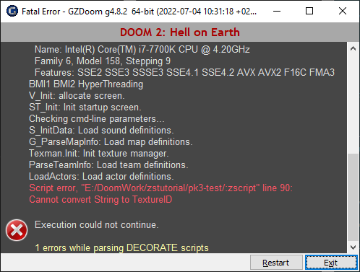

Como dice el mensaje de error, no se puede obtener una textura directamente de la cadena "DORBA0". Esto se debe a que, a diferencia del mundo ACS, ya no se pueden especificar gráficos simplemente como nombres de bloques. ZScript funciona con TextureID, que necesitan otro paso para buscarlos; tendremos que preguntarle al administrador de texturas al respecto.

#### Usando TexMan

El administrador de texturas se puede llamar desde cualquier lugar con el nombre TexMan - [https://zdoom-docs.github.io/staging/Api/Drawing/TexMan.html](https://www.google.com/url?q=https://zdoom-docs.github.io/staging/Api/Drawing/TexMan.html&sa=D&source=editors&ust=1677034908499827&usg=AOvVaw0dKAFq2tSzuu4ma5AXQ8Wv)  . Este es el objeto que maneja los gráficos disponibles para el juego - en otra redefinición confusa de la palabra "textura", aquí se refiere no exclusivamente a texturas de pared como la mayoría del motor Doom hace sino a cualquier tipo de gráfico incluyendo sprites y gráficos generales como TITLEPIC. Usaremos su método CheckForTexture para recuperar el primer sprite de DoomOrb, luego lo pasaremos a la función DrawTexture.

|  |
| --- |
| IMG_288**Utilice TexMan para buscar el TextureID que queremos para la pantalla y luego páselo a DrawTexture.** |

|  |
| --- |
| Script Z |
| clase OrbUIHandler : EventHandler {      anular void RenderOverlay(RenderEvent e) {          PlayerPawn p = PlayerPawn(jugadores[consoleplayer].mo);          int orbes = p.CountInv("DoomOrb");  ~~Pantalla.DrawText(fuentepequeña, Fuente.CR\_RED, 4, 4, orbes .. "", DTA\_VirtualWidth, 640, DTA\_VirtualHeight, 480);~~  **Pantalla.DrawText(fuentepequeña, Fuente.CR\_RED, 20, 8, orbes .. "", DTA\_VirtualWidth, 640, DTA\_VirtualHeight, 480);**  **TextureID orbTex = TexMan.CheckForTexture("DORBA0", TexMan.Type\_Sprite);**  **Pantalla.DrawTexture(orbTex, falso, 4, 4, DTA\_VirtualWidth, 640, DTA\_VirtualHeight, 480, DTA\_LeftOffset, 0, DTA\_TopOffset, 0);**      }  } |

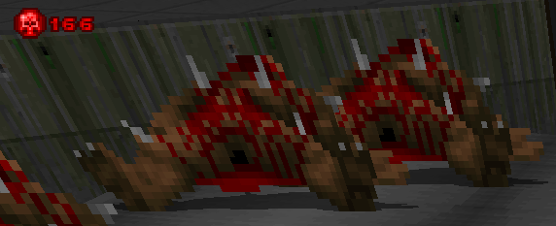

Aquí, la función CheckForTexture de TexMan toma el nombre del gráfico que queremos encontrar y el tipo que espera buscar (las opciones para esto se muestran en [https://zdoom.org/gitview/3a1228b/wadsrc/static/zscript/base.txt)](https://www.google.com/url?q=https://zdoom.org/gitview/3a1228b/wadsrc/static/zscript/base.txt&sa=D&source=editors&ust=1677034908504109&usg=AOvVaw08y4O8B5FJxj9PwK183xoG)  . Puedes especificar TexMan.Type\_All aquí para buscar en todo, pero darle una pista puede limitar la búsqueda y, por lo tanto, acelerarla.

La función DrawTexture toma parámetros de la misma manera que DrawText - aquí, le paso los mismos valores virtuales de ancho y alto, así como dos más - configurar DTA\_LeftOffset y DTA\_TopOffset a 0 ignorará los desplazamientos grAb que se han especificado en el sprite, y solo mostrará el sprite comenzando en su esquina superior izquierda. (Como resultado, la llamada a la función puede parecer bastante difícil de manejar, y si tienes muchas de estas, puede que sea mejor escribir tu propia función para encapsular la llamada).

Tenga en cuenta también que he movido el contador de texto hacia la derecha y un poco hacia abajo para alinearlo con la posición del orbe, cambiando las coordenadas de (4, 4) a (20, 8) - ajústelo según sus preferencias. Incluso podría agregar otro gráfico específicamente para la interfaz de usuario y usarlo. (Si opta por algo como esto, recuerde que los elementos de la interfaz de usuario se dibujan en la pantalla en el orden que usted los especifica, de atrás hacia adelante - por lo que deberá mover la línea que muestra el texto debajo de la línea que muestra el gráfico.)

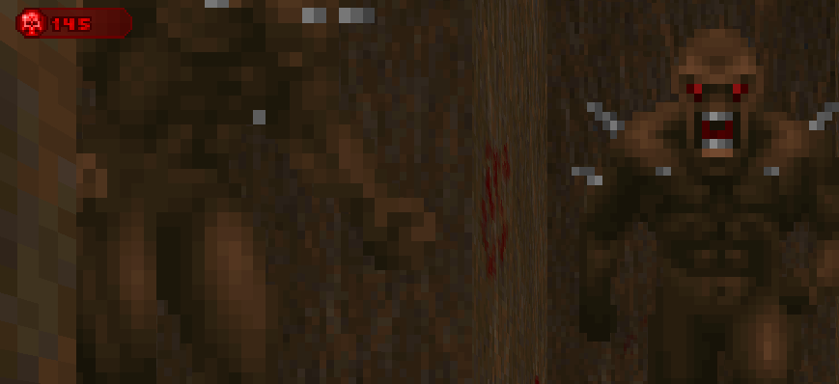

## Parte 3. ¿Para qué sirven los orbes?

## 

## 

## 

## 

## 

Hemos definido nuestro nuevo objeto orbe y su comportamiento, tenemos monstruos que los pueden dejar caer según su resistencia general, tenemos un recuento de ellos en la pantalla; hagamos que hagan algo útil. ¿Qué tal si dejamos que el jugador se cure a sí mismo presionando un botón cuando haya recolectado suficientes?

### Reaccionando a la entrada del jugador

Otra cosa que ZScript puede hacer es acceder a la entrada del juego, de modo que puedas reaccionar a las pulsaciones de botones (esto también es posible en mods basados ​​en DECORATE/ACS, pero puede ser bastante complicado de configurar). Al igual que los otros elementos que hemos codificado hasta ahora, la entrada en ZScript se maneja a través de oyentes.

Pondremos una nueva función en nuestra clase OrbUIHandler. [https://zdoom.org/wiki/Events\_and\_handlers](https://www.google.com/url?q=https://zdoom.org/wiki/Events_and_handlers&sa=D&source=editors&ust=1677034908506272&usg=AOvVaw1jPFnNtWc-NecmrFYoauos)  nos dice que la función InputProcess se llama siempre que haya una entrada que manejar y que se pasen seis datos en el evento. Queremos hacer dos cosas:

* Identificar cuándo el evento de entrada coincide con nuestros criterios: el jugador debe haber presionado la tecla USER1 (nombrada en el menú de controles como Estado del arma 1).
* Una vez que recibamos un evento como este, permitiremos al jugador intercambiar orbes por salud si tiene una cantidad suficiente de ellos.

No vamos a buscar directamente pulsaciones de teclas específicas del teclado porque no sabemos qué teclas ha configurado el jugador para el comando USER1 (y en este contexto, una "tecla" podría ser una tecla del teclado, un botón del ratón o un disparador del joystick), así que se lo vamos a pedir a la función global Bindings. Esto proporciona una función GetKeysForCommand, que puede darnos las teclas (de las cuales puede haber hasta dos) que el jugador ha configurado para el comando que queremos detectar. Luego, vamos a comprobar si la tecla mencionada en el evento de entrada coincide con las teclas que nos han dado; si es así, realizaremos nuestra acción. Por ahora, haremos lo que hicimos antes y simplemente haremos que la acción imprima algo para saber que funcionó.

(Desafortunadamente, no hay documentación disponible para el objeto Bindings en este momento; simplemente implementemos un ejemplo de cómo se usa...)

|  |
| --- |
| IMG_291**Agregue una función InputProcess a nuestro OrbUIHandler que solo detecte la clave:** |

|  |
| --- |
| Script Z |
| clase OrbUIHandler : EventHandler {      anular void RenderOverlay(RenderEvent e) {...}  **anular bool InputProcess(InputEvent e) {**  **int enlazar1, enlazar2;**  **[bind1, bind2] = Bindings.GetKeysForCommand("+usuario1");**  **si (e.Tipo == InputEvent.Type\_KeyDown && (e.KeyScan == bind1 || e.KeyScan == bind2)) {**  **console.printf("Ha presionado la tecla %d para USER1", e.KeyScan);**  **}**  **devuelve falso;**  **}**  } |

Aquí, estamos asignando valores a dos ints a la vez: bind1 y bind2. GetKeysForCommand siempre devuelve dos elementos porque la pantalla de controles permite que dos teclas estén vinculadas a un comando. Se devuelven como ints que identifican de forma única la tecla presionada, y no como cadenas como "Q" o "7"; y estos ints corresponderán al valor dado en e.KeyScan. También queremos comprobar que el tipo de evento sea un evento de pulsación de tecla; la acción debe ocurrir solo una vez por cada pulsación de tecla.

También ten en cuenta que, a diferencia de todas las demás funciones de eventos que hemos usado hasta ahora, ¡esta devuelve un valor booleano! La función que llama a InputProcess busca esto para decidir si continúa llamando a otros controladores de eventos para este evento. Si se devuelve verdadero  , entonces el juego considerará que el evento de entrada se ha manejado y no le pedirá a nadie más que haga nada al respecto. Esto es útil en situaciones como un cuadro de diálogo modal o una pantalla de inventario, donde quieres usar las teclas de movimiento del jugador para navegar por un cursor pero también para bloquear al jugador de reaccionar a esas mismas entradas si el cuadro de diálogo está activo. Por ejemplo, mira la función MenuEvent de la clase ConversationMenu, que devolverá verdadero si la pulsación de tecla fue una que el menú entendió y a la que reaccionó. [https://github.com/ZDoom/gzdoom/blob/master/wadsrc/static/zscript/ui/menu/conversationmenu.zs#L308](https://www.google.com/url?q=https://github.com/ZDoom/gzdoom/blob/master/wadsrc/static/zscript/ui/menu/conversationmenu.zs%23L308&sa=D&source=editors&ust=1677034908511797&usg=AOvVaw15pRcP4WGmWOD8x0k_NM88)

Vuelve a cargar el proyecto y asegúrate de tener una o más teclas asignadas al usuario1 (Armas/Estado del arma 1 en el menú de controles); luego deberías poder hacer que aparezca este mensaje presionándolas.

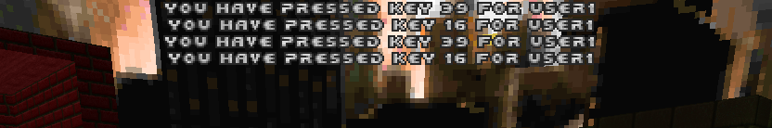

Con todo eso en funcionamiento, es bastante sencillo escribir nuestra acción real: hemos usado todos estos elementos antes y solo necesitamos recuperar al jugador y jugar un poco con su inventario. Mientras estamos en ello, agreguemos también un efecto de sonido: las funciones de DECORATE como A\_StartSound aún existen en ZScript y se pueden usar en el jugador como las otras funciones. misc/p\_pkup  es el sonido definido en SNDINFO de gzdoom.pk3 para indicar el sonido de encendido similar al de un gong.

|  |
| --- |
| IMG_293**Cuando se presiona la tecla USER1 y el jugador tiene suficientes orbes, recarga algo de salud.** |

|  |
| --- |
| Script Z |
| clase OrbUIHandler : EventHandler {      anular void RenderOverlay(RenderEvent e) {...}      anular bool InputProcess(InputEvent e) {          int enlazar1, enlazar2;          [bind1, bind2] = Bindings.GetKeysForCommand("+usuario1");          si (e.Tipo == InputEvent.Type\_KeyDown && (e.KeyScan == bind1 || e.KeyScan == bind2)) {  ~~console.printf("Ha presionado la tecla %d para USER1", e.KeyScan);~~  **PlayerPawn p = PlayerPawn(jugadores[consoleplayer].mo);**  **int orbes = p.CountInv("DoomOrb");**  **si (orbes >= 20) {**  **p.GiveInventory("Bono de Salud", 10);**  **p.TakeInventory("Orbe de la perdición", 20);**  **p.A\_StartSound("misc/p\_pkup");**  **}**          }          devuelve falso;      }  } |

Aquí le damos al jugador elementos de bonificación de salud para que pueda aumentar su salud hasta 200: si solo le diéramos un paquete de estimulantes, llegaría a 100. (Por supuesto, puede decidir la cantidad de orbes necesarios y la salud u otros elementos que desea devolver).

Así que vamos a ejecutar y probar esto…

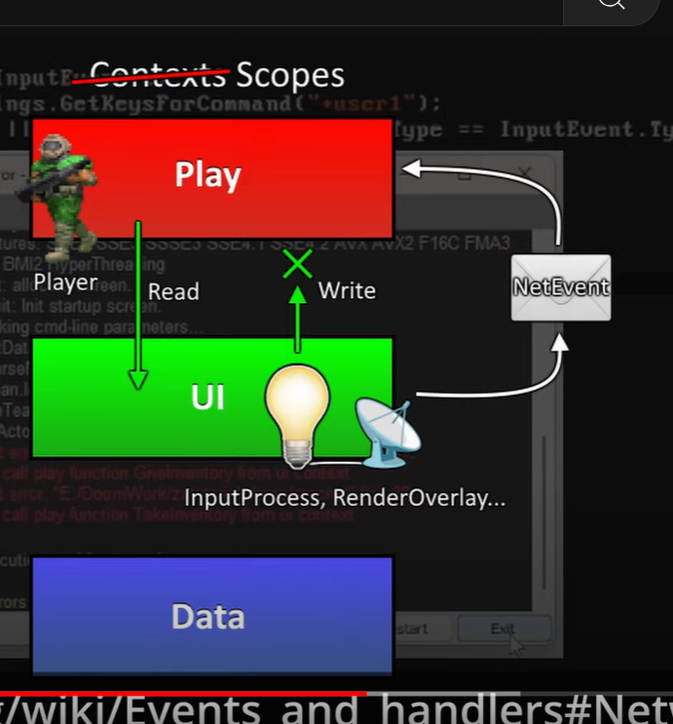

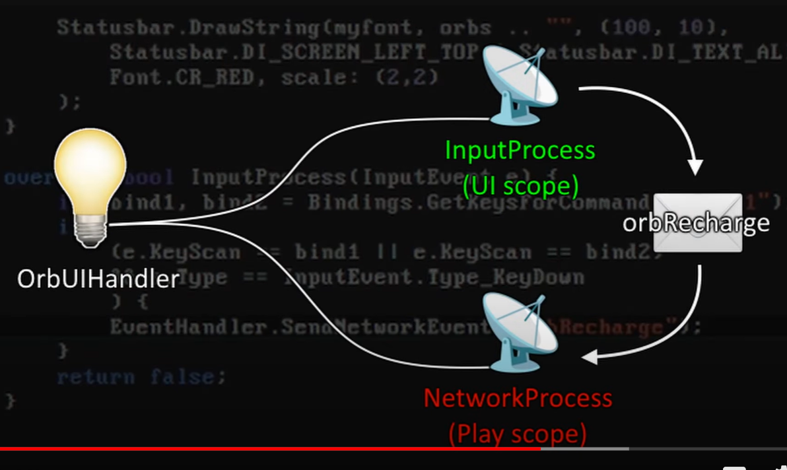

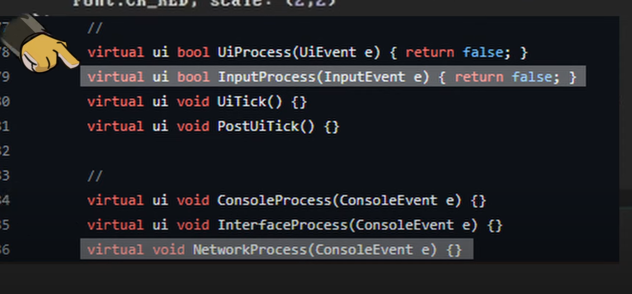

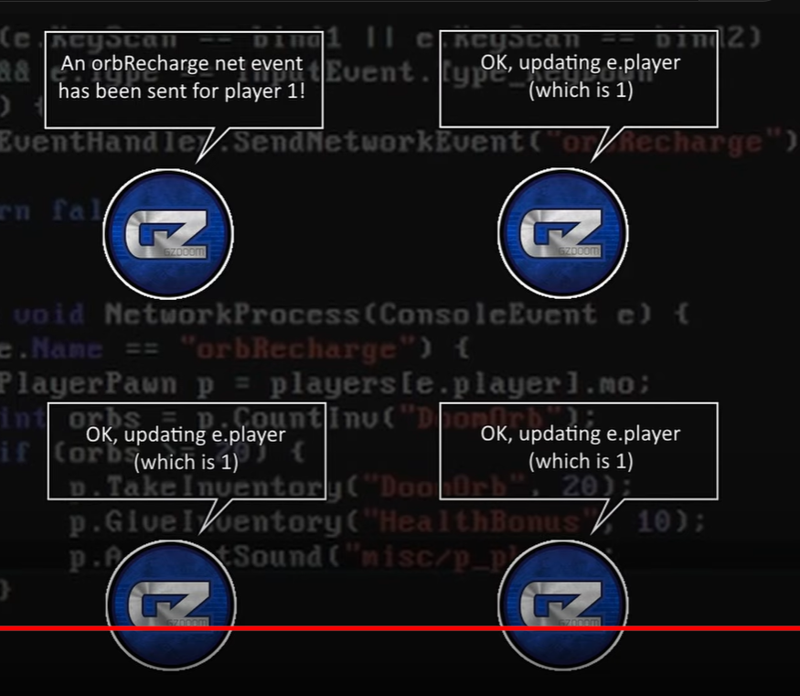

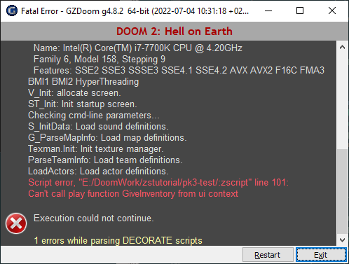

¡¿Qué?! ¿Por qué no?

### Manejo del alcance

Ya has visto el concepto de ámbito en ZScript, como se describe en [https://zdoom.org/wiki/Object\_scopes\_and\_versions](https://www.google.com/url?q=https://zdoom.org/wiki/Object_scopes_and_versions&sa=D&source=editors&ust=1677034908518182&usg=AOvVaw2fVkbiIA2NFJVvuokrdP-2)  . Esto es algo que no había visto en el mundo de la codificación en el que vivo en el trabajo, que es todo software empresarial aburrido, pero es algo importante que debes entender cuando trabajas con un mundo de juegos.

A los objetos de GZDoom se les puede asignar uno de tres ámbitos (o "contextos", como se dice en el mensaje de error; prefiero esta palabra, pero la wiki insiste bastante en que es incorrecta). Los ámbitos son *play*, *ui* y *data*. Existen para garantizar que el estado del juego se mantenga consistente y que no se modifiquen los datos cuando no se deben y que el juego se vuelva inestable (hay muchas otras formas de producir fallos en su lugar).

En nuestro caso, se dice que los objetos que componen el mundo del juego están en el ámbito *de juego* , y cuando estamos en funciones de controlador de eventos que se ocupan de cuestiones de la interfaz de usuario, como dibujar cosas en la pantalla o gestionar la entrada, estamos en el ámbito *de la interfaz de usuario* . Desde el ámbito *de la interfaz de usuario* , puedes leer libremente desde el ámbito *de juego* , pero no puedes modificarlo; solo otras cosas en el ámbito *de juego* pueden hacerlo.

La sección sobre redes en [https://zdoom.org/wiki/Events\_and\_handlers#Networking](https://www.google.com/url?q=https://zdoom.org/wiki/Events_and_handlers%23Networking&sa=D&source=editors&ust=1677034908519497&usg=AOvVaw0u7F0C2SrBJz2vZsyaRBgt)  describe qué hacer: en lugar de intentar alterar el inventario del jugador directamente debido a un evento de la interfaz de usuario, enviaremos un evento propio que le diga al juego que queremos que suceda algo.

|  |
| --- |
| IMG_295**En lugar de realizar la verificación y alterar el inventario del jugador aquí, utilice la función SendNetworkEvent de EventHandler para notificar que se ha solicitado una recarga de orbe.** |

|  |
| --- |
| Script Z |
| …  ~~PlayerPawn p = PlayerPawn(jugadores[consoleplayer].mo);~~  ~~int orbes = p.CountInv("DoomOrb");~~  ~~si (orbes >= 20) {~~  ~~p.GiveInventory("Salud", 10);~~  ~~p.TakeInventory("Orbe de la perdición", 20);~~  ~~}~~  **EventHandler.SendNetworkEvent("orbRecharge");**  … |

Ahora tenemos que configurar el otro lado, escribiendo una función que escuche los eventos y reaccione a este. NetworkProcess es otra función que está disponible para los manejadores de eventos. Me gusta ponerla en el manejador de la interfaz de usuario si se trata de eventos de la interfaz de usuario, pero puedes elegir si crear una nueva clase para ello o no.

|  |
| --- |
| IMG_296**Cree la función NetworkProcess para verificar el evento y reaccionar ante él.** |

|  |
| --- |
| Script Z |
| clase OrbUIHandler : EventHandler {      anular void RenderOverlay(RenderEvent e) {...}      anular bool InputProcess(InputEvent e) {...}  **anular void NetworkProcess(ConsoleEvent e) {**  **si (e.Nombre == "orbRecharge") {**  **JugadorPawn p = JugadorPawn(jugadores[e.jugador].mo);**  **int orbes = p.CountInv("DoomOrb");**  **si (orbes >= 20) {**  **p.TakeInventory("Orbe de la perdición", 20);**  **p.GiveInventory("Bono de Salud", 10);**  **p.A\_StartSound("misc/p\_pkup");**  **}**  **}**  **}**  } |

¡Ten en cuenta que la forma en que recuperamos el PlayerPawn es un poco diferente aquí! Esta vez, el evento tiene una propiedad player  que nos indica el número del jugador que activó este evento; solo queremos recargar la salud del jugador que lo solicitó. En el modo multijugador de Doom, cada instancia del juego ejecuta su propia simulación de juego y deben aplicar el código que llega al jugador que coincide con el número del evento; si usáramos consoleplayer como lo hicimos antes, entonces cada vez que cualquier jugador activara el evento orbRecharge, cada jugador vería afectada su propia salud.

Después de intentar explicar eso, el resto del código es sencillo: contamos la cantidad de DoomOrbs que tiene el jugador y, si es mayor o igual al precio de 20, tomamos nuestro pago y le devolvemos algo de salud.

Cuando comiences esto, deberías descubrir que puedes presionar la tecla USER1 para intercambiar orbes por salud, siempre que tengas 20 de ellos o más.

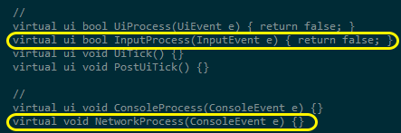

Así es como se pasan los eventos de la interfaz de usuario al juego en ZScript. La distinción entre los dos entornos no es muy clara desde aquí en nuestro controlador de eventos, pero están definidos de esta manera en la clase base StaticEventHandler: de forma predeterminada, la clase y sus elementos están en el ámbito del juego, pero cualquier función definida con la palabra clave "ui" se considera en el ámbito de la interfaz de usuario. (Usaremos esta técnica para nosotros mismos más adelante).

Si bien puede parecer extraño al principio, la separación también hace que las cosas sean comprobables: también puedes enviar un evento que será detectado por las funciones de NetworkProcess usando el  comando de consola netevent , como usar puke  para ACS.

Orbe de neteventRecarga

Tenga en cuenta que, a diferencia de casi todo lo demás en el mundo de GZDoom, los nombres de los eventos de red distinguen entre mayúsculas y minúsculas.

### Buscando y manipulando cosas

Bien, ahora  que el jugador puede cuidar su salud con los orbes, vamos a volvernos locos por el poder y eliminar todos los elementos de salud del nivel. En DECORATE, podríamos hacer esto reemplazando los elementos de salud con una nueva clase de cosa que no haga nada, porque no hay forma de abordar cosas individuales en un nivel que no estén etiquetadas como nada. ¡Sin embargo, ZScript nos da este poder!

Vamos a utilizar un ThinkerIterator como se describe en [https://zdoom.org/wiki/ThinkerIterator](https://www.google.com/url?q=https://zdoom.org/wiki/ThinkerIterator&sa=D&source=editors&ust=1677034908528698&usg=AOvVaw3h1qZ24vurcqJv4zApoKZu) . Este es un objeto que buscará entre los Thinkers que existen en el juego para nosotros. Al usar un bucle para llamar a su función Next()  repetidamente, nos devolverá cada Thinker que encuentre y podremos decidir qué hacer con él.

Agreguemos un controlador de eventos más al juego: este se encargará de configurar el nivel.

|  |
| --- |
| IMG_298**Agregue un tercer EventHandler al PK3. Recuerde agregarlo también a la lista de controladores de eventos en MAPINFO.** |

|  |
| --- |
| Script Z |
| **clase OrbSetupEventHandler: EventHandler {**  **anular void WorldLoaded(WorldEvent e) {**  **ThinkerIterator it = ThinkerIterator.Create("Salud", Thinker.STAT\_DEFAULT);**  **Artículo de salud;**  **mientras (item = Salud(it.Next())) {**  **console.printf("Se destruyó un %s", item.getClassName());**  **elemento.Destruir();**  **}**  **}**  **}** |

El primer argumento que se pasa a la función Create es la clase desde la que se va a empezar a buscar: nos interesa la clase GZDoom [https://zdoom.org/wiki/Classes:Health](https://www.google.com/url?q=https://zdoom.org/wiki/Classes:Health&sa=D&source=editors&ust=1677034908532838&usg=AOvVaw17UbvZ78VVzzZgWup4Q259)  y todos sus descendientes. En Doom, esto incluirá botiquines, paquetes de estimulantes, esferas de alma y las botellas de poción HealthBonus. (Ten en cuenta que Megasphere existe en la clase Powerup y no en la clase Health; dejaremos esta en paz por ahora para evitar complicar las cosas). El segundo argumento es un StatNum, y estos son una forma que GZDoom utiliza internamente para agrupar a los Thinkers; puedes ver la lista de ellos en [https://zdoom.org/wiki/Thinker](https://www.google.com/url?q=https://zdoom.org/wiki/Thinker&sa=D&source=editors&ust=1677034908533275&usg=AOvVaw3C8wjFNwL3n18d-bdhdB95)  .

Podríamos omitir este segundo argumento y hacer que el iterador simplemente busque entre todos los Pensadores del juego, pero es bueno ser lo más eficientes posible: pasar STAT\_DEFAULT  le indica al iterador que solo considere a los Actores del juego (y a los Pensadores personalizados que se definen como usando ese StatNum).

The thinker iterator is now ready to be used. We set up a Health variable which contains nothing to start with, then use a while loop to repeatedly put the iterator's Next() result into that variable as long as it hasn't run out. In the loop, we output a console line for debugging just to show that we're doing something, then destroy the selected item. After the last item found by the Iterator has been gone through, the Next() function will return null, and the loop will end.

Start the game up with this event handler included, and verify that you get a set of messages about destroying the health items when starting a level - after that, you can remove the console.printf line. Now we have a variant of Doom where health is a resource from monsters instead of being picked up in the level!

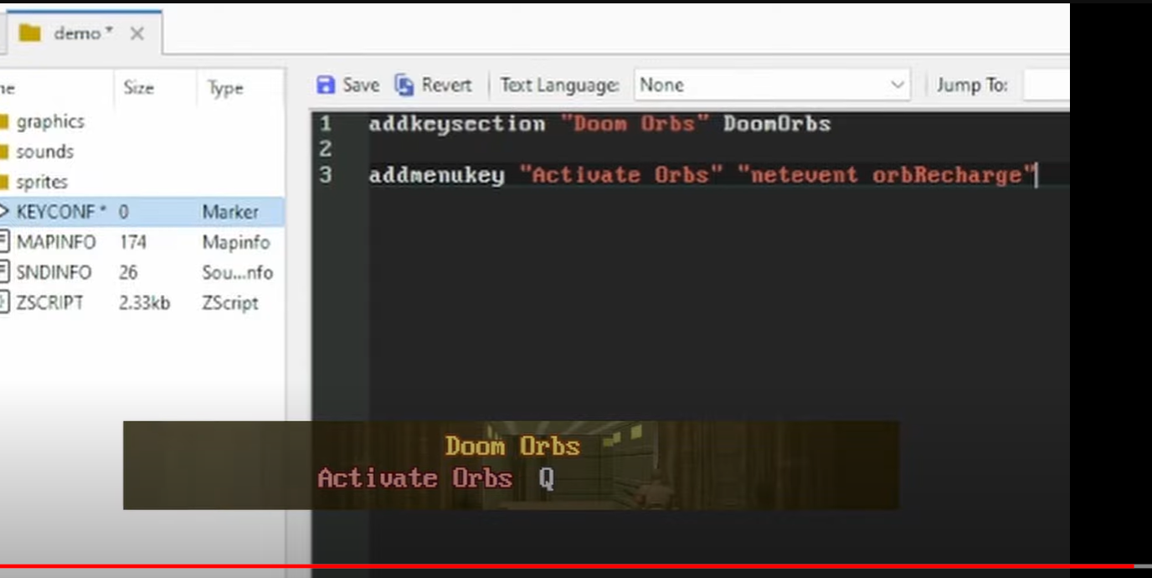

## Part 4. Keeping variables in a non-Actor Thinker

For the next stage of the project, we're going to set up a class that lives in the background and handles an aspect of our game - remember that unlike in DECORATE, the classes that we define don't have to have a physical presence in the level. The idea will be to reward rapid monster kills by gradually increasing a multiplier that affects how many orbs are dropped. To reward cooperation (but also to demonstrate another aspect of ZScript), this multiplier will be global across all players, with each player's kills counting towards the total.

### Making a non-actor Thinker

In the ACS/DECORATE world, you could sort of implement things like this by using global variables and an infinite loop running in the background. ZScript lets us do this more neatly - this example is lifted almost directly from the global variables page of the ZDoom wiki at [https://zdoom.org/wiki/ZScript\_global\_variables](https://www.google.com/url?q=https://zdoom.org/wiki/ZScript_global_variables&sa=D&source=editors&ust=1677034908535306&usg=AOvVaw15dena6HdFTAXP0THBHmfv) :

|  |
| --- |
| IMG_299**Add yet another new class to our ZSCRIPT file - a non-physical Thinker that will just control the score multiplier.** |

|  |
| --- |
| ZSCRIPT |
| **class OrbMultiplierThinker : Thinker**  **{**  **double orbMultiplier;**  **int ticksSinceKill;**    **OrbMultiplierThinker Init(void) {**  **ChangeStatNum(STAT\_USER);**  **self.orbMultiplier = 1;**  **return self;**  **}**  **static OrbMultiplierThinker GetInstance(void) {**  **ThinkerIterator it = ThinkerIterator.Create("OrbMultiplierThinker", STAT\_USER);**  **let p = OrbMultiplierThinker(it.Next());**  **if (p) return p;**  **return new("OrbMultiplierThinker").Init();**  **}**  **}** |

The two functions here work to make sure we only ever have one OrbMultiplierThinker in the game:

* The Init function is something that we'll call when an OrbMultiplierThinker is first set up. (Note, if this means anything to you, that this is not technically a constructor - it looks a lot like one, but these don't exist in ZScript and we have to call it manually instead.) In this function, we immediately use ChangeStatNum to put this Thinker in the STAT\_USER group of Thinkers, just so we know where to search for it when we need it. Then we set our orbMultiplier variable to 1 and return the object.
* The static GetInstance function will be used whenever we want to access this object. It uses the ThinkerIterator to check whether there's an OrbMultiplierThinker in the game yet - if there is, then it will return it. If there isn't, it will create a new one and call the Init() method on it before returning it.

If you've done object-oriented programming work before, you'll have recognized this as a singleton pattern - just with a couple of extra steps, as ZScript doesn't currently support class/static variables. We get around that by using the ThinkerIterator to retrieve the singleton.

If you haven't done object-oriented programming before, notice the static keyword on the GetInstance function. This means this function is not tied to a specific instance of the OrbMultiplierThinker - it will be callable from anywhere and not just when you already know which specific OrbMultiplierThinker you'll be referring to (that's its job - to find and return the actual live OrbMultiplierThinker object). As I'm doing a terrible job explaining this, referring to [https://www.codejava.net/java-core/the-java-language/what-is-static-method-in-java](https://www.google.com/url?q=https://www.codejava.net/java-core/the-java-language/what-is-static-method-in-java&sa=D&source=editors&ust=1677034908541439&usg=AOvVaw3p7C3XLPWgwiMUfABfkORn) or any introductory OOP course will help.

Now let's do something with this class. We're going to implement a way for another class to increase the multiplier, and a Tick function to bring it down again.

|  |
| --- |
| IMG_300**Add these functions to the OrbMultiplierThinker.** |

|  |
| --- |
| ZSCRIPT |
| class OrbMultiplierThinker : Thinker  {      double orbMultiplier;      int ticksSinceKill;        OrbMultiplierThinker Init(void) {...}      static OrbMultiplierThinker GetInstance(void) {...}  **void RaiseMultiplier() {**  **self.ticksSinceKill = 0;**  **self.orbMultiplier += 0.1;**  **console.printf("Raised multiplier to %f", self.orbMultiplier);**  **}**    **override void Tick() {**  **if (self.orbMultiplier > 1) {**  **self.ticksSinceKill += 1;**  **if (self.ticksSinceKill > 350) {**  **self.ticksSinceKill = 0;**  **self.orbMultiplier = 1;**  **console.printf("Reset multiplier");**  **}**  **}**  **}**  } |

When called, RaiseMultiplier will raise the multiplier by 0.1, reset the ticksSinceKill to 0, and as usual, print a console message to tell us what's happening. The Tick function works the same way as on the Doom orb, being called on every tick and gradually increasing a counter - for this object, if the orb multiplier is above 1, we'll start counting ticks until we reach over 350. When that happens, we'll reset the multiplier back to 1 and print a message acknowledging we've done so, therefore giving the player a time limit if they want to keep their multiplier going.

Let's now hook this multiplier thinker into the game by getting our monster death event handler to update it when a monster is killed.

|  |
| --- |
| IMG_301**Go back to our MonsterDeathEventHandler and get it to interact with the OrbMultiplierThinker.** |

|  |
| --- |
| ZSCRIPT |
| class MonsterDeathEventHandler : EventHandler {      override void WorldThingDied(WorldEvent e) {          vector3 pos = e.Thing.pos;          double height = e.Thing.height;          pos.z += height/2;  **let o = OrbMultiplierThinker.GetInstance();**  ~~int maxHealth = e.Thing.getMaxHealth();~~  **double maxHealth = e.Thing.getMaxHealth();**  **maxHealth \*= o.orbMultiplier;**  **console.printf("Points for %s after multiplying: %f", e.Thing.getClassName(), maxHealth);**  **o.RaiseMultiplier();**          while (maxHealth >= 100) {              maxHealth -= 100;              self.createOrb(true, pos);          }          while (maxHealth >= 10) {              maxHealth -= 10;              self.createOrb(false, pos);          }      }        void createOrb(bool big, vector3 pos) {...}  } |

Now when a monster is killed, we use our OrbMultiplierThinker.GetInstance function to find the instance of the OrbMultiplierThinker object (or to create it, if there isn't one). Then. instead of using the monster's maxHealth property directly, we multiply it by the current value of orbMultiplier - we've turned maxHealth from an int into a double here so that the decimal from our multiplication isn't eliminated. The giving out of orbs can then be done with this altered value - but before that, we also tell the OrbMultiplierThinker to raise the multiplier and reset the time limit to 0.

Try playing with all of this in the game now - you should see the multiplier in the console logs getting bigger, and more orbs gradually being dropped by enemies as a consequence. Use some IDKFA assistance to see some dramatic increases!

Of course, the console messages are just there so we can see what's happening while testing - it would be good for the player to have an idea of their current multiplier as well. Let's add that to our UI.

### Accessing the Thinker from UI

We already know how to display text on the HUD, so putting information from this Thinker in the UI should be simple - it involves going back to our OrbUIHandler again and adding a reference to the OrbMultiplierThinker.

|  |
| --- |
| IMG_302**Alter the OrbUIHandler to get the information we need from our Thinker.** |

|  |
| --- |
| ZSCRIPT |
| class OrbUIHandler : EventHandler {      override void RenderOverlay(RenderEvent e) {          PlayerPawn p = PlayerPawn(players[consoleplayer].mo);          int orbs = p.CountInv("DoomOrb");  **let o = OrbMultiplierThinker.GetInstance();**  **String multiplierText = String.Format("x%.1f", o.orbMultiplier);**          Screen.DrawText(smallfont, Font.CR\_RED, 20, 8, orbs .. "", DTA\_VirtualWidth, 640, DTA\_VirtualHeight, 480);          TextureID orbTex = TexMan.CheckForTexture("DORBA0", TexMan.Type\_Sprite);          Screen.DrawTexture(orbTex, false, 4, 4, DTA\_VirtualWidth, 640, DTA\_VirtualHeight, 480, DTA\_LeftOffset, 0, DTA\_TopOffset, 0);  **Screen.DrawText(smallfont, Font.CR\_YELLOW, 60, 8, multiplierText, DTA\_VirtualWidth, 640, DTA\_VirtualHeight, 480);**      }      override bool InputProcess(InputEvent e) {...}      override void NetworkProcess(ConsoleEvent e) {...}  } |

Now, as part of the drawing of the UI, we get the OrbMultiplierThinker instance and put its orbMultiplier into a string by using the String.Format function. This time, we use the format %.1f to mean a decimal value with one decimal place (again, see [https://zdoom.org/wiki/String#Methods](https://www.google.com/url?q=https://zdoom.org/wiki/String%23Methods&sa=D&source=editors&ust=1677034908558092&usg=AOvVaw1_SApbnVrferJJxB8cfJYr) for the formats available), and we add an "x" to the front. Then we add one more Screen.DrawText line to put this new string up on to the screen.

Start this up in GZDoom now. Can you see what's coming?

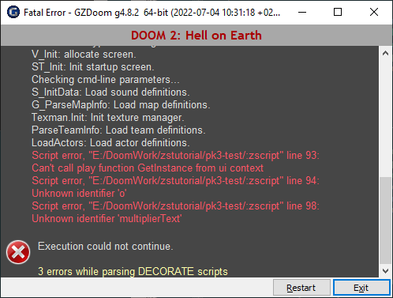

Scope foils us again! We can't call the GetInstance function from the UI because the OrbMultiplierThinker object, like all Thinkers, exists in the *play* scope - and using NetworkEvents won't help here because we need a response, we're not just sending a signal one way. Instead, we're going to do what we saw in the StaticEventHandler class a while ago, and put a function in a different scope from the rest of the class.

The keyword we're going to be using is *clearscope*, which makes a function callable both from *ui* and *play* scopes but puts other limits on them in exchange - just like the *ui* scope, *clearscope* classes and functions can only read from the play scope and not write to it. That means we can't just put *clearscope* directly on the GetInstance function that we already have, because of this line:

|  |
| --- |
| static OrbMultiplierThinker GetInstance(void) {          ThinkerIterator it = ThinkerIterator.Create("OrbMultiplierThinker", STAT\_USER);          let p = OrbMultiplierThinker(it.Next());          if (p) return p;  **return new("OrbMultiplierThinker").Init();**      } |

If we added *clearscope* to the start of this function, we would get a different script error because there's the possibility that the function might attempt to create a *play*-scoped object. So instead, we'll have to create an alternative GetInstance method that only ever tries to read.

|  |
| --- |
| IMG_304**Add a new function with the clearscope keyword to OrbMultiplierThinker, to get an instance without ever trying to create one.** |

|  |
| --- |
| ZSCRIPT |
| class OrbMultiplierThinker : Thinker  {  .  .  .      static OrbMultiplierThinker GetInstance(void) {...}  **clearscope static OrbMultiplierThinker GetReadOnlyInstance(void) {**  **ThinkerIterator it = ThinkerIterator.Create("OrbMultiplierThinker", STAT\_USER);**  **let p = OrbMultiplierThinker(it.Next());**  **if (p) return p;**  **return null;**  **}**  **.**  **.**  **.**  } |

This variant of the GetInstance function won't try to create a new OrbMultiplierThinker if one isn't available - it will just return nothing. Let's get our OrbUIHandler to use that instead.

|  |
| --- |
| IMG_305**Use the new GetReadOnlyInstance() method in OrbUIHandler instead of GetInstance().** |

|  |
| --- |
| ZSCRIPT |
| class OrbUIHandler : EventHandler {  …      override void RenderOverlay(RenderEvent e) {          …          let o = OrbMultiplierThinker.Get**ReadOnly**Instance();          …      }  …  } |

That should allow us to read from the Thinker from the UI scope. Test this again - you'll find GZDoom starts up without a problem, but now try entering a map - what's it moaning about now?!

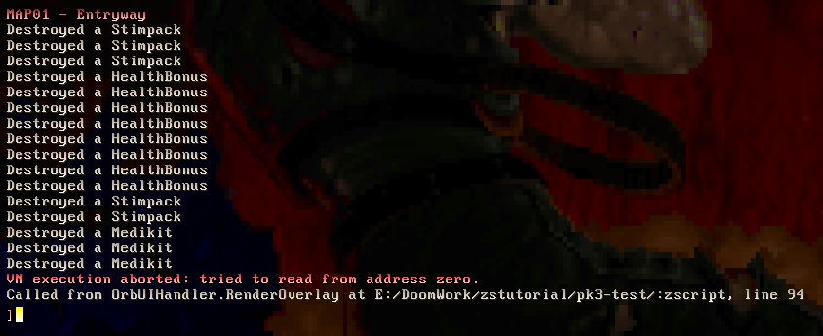

VM execution aborted: tried to read from address zero is an error that you're likely to encounter a lot when piecing ZScript together, and it sounds a lot scarier than it really is - despite it sounding like an issue with low level memory management, the problem is usually that you're attempting to call a method or alter a property on a null.

And thinking through our code again, it's easy to see why this happens - the instance of OrbMultiplierThinker is only created the first time GetInstance() is called, and that happens when the *play* scope needs it - currently that's only called when a monster dies. The GetReadOnlyInstance() function is called from the UI right from the start of the level, and will return null if the conditions for actually creating the thinker haven't happened yet.

There are a couple of things we can do to safeguard ourselves against this. First, it definitely pays to code defensively, and handle the condition where we just don't have an OrbMultiplierThinker yet:

|  |
| --- |
| IMG_307**Get the OrbUIHandler to handle the possibility of the OrbMultiplierThinker not existing by defining a default multiplierText.** |

|  |
| --- |
| ZSCRIPT |
| class OrbUIHandler : EventHandler {      override void RenderOverlay(RenderEvent e) {          PlayerPawn p = PlayerPawn(players[consoleplayer].mo);          int orbs = p.CountInv("DoomOrb");          let o = OrbMultiplierThinker.GetReadOnlyInstance();  **String multiplierText = "x1.0";**  **if (o) {**  **multiplierText = String.Format("x%.1f", o.orbMultiplier);**  **}**          TextureID orbTex = TexMan.CheckForTexture("HUDORB", TexMan.Type\_Any);          Screen.DrawTexture(orbTex, false, 4, 4, DTA\_VirtualWidth, 640, DTA\_VirtualHeight, 480, DTA\_LeftOffset, 0, DTA\_TopOffset, 0);          Screen.DrawText(smallfont, Font.CR\_RED, 20, 8, orbs .. "", DTA\_VirtualWidth, 640, DTA\_VirtualHeight, 480);          Screen.DrawText(smallfont, Font.CR\_YELLOW, 60, 8, multiplierText, DTA\_VirtualWidth, 640, DTA\_VirtualHeight, 480);      }      override bool InputProcess(InputEvent e) {...}      override void NetworkProcess(ConsoleEvent e) {...}  } |

And if we want to make sure that the OrbMultiplierThinker exists from the start of the level, we just have to make sure we tell the game to create it when the level starts.

|  |
| --- |
| IMG_308**Tell our OrbSetupEventHandler to do exactly that as part of its WorldLoaded function.** |

|  |
| --- |
| ZSCRIPT |
| class OrbSetupEventHandler : EventHandler {      override void WorldLoaded(WorldEvent e) {  **OrbMultiplierThinker.GetInstance();**          ThinkerIterator it = ThinkerIterator.Create("Health", Thinker.STAT\_DEFAULT);          Health item;          while (item = Health(it.Next())) {              console.printf("Destroyed a %s", item.getClassName());              item.Destroy();          }      }  } |

### IMG_309

The game will start up correctly again now. And this is beginning to look a lot more satisfying! The display of the multiplier encourages the player to keep it topped up. Let's add one more element - a display of how much time the player has remaining to kill another demon before losing their multiplier.

### More UI drawing

We could do this just by putting a third number on the screen, but a diminishing bar would have a more urgent visual effect. We can make one by using the DrawTexture method again, using a couple more of its options and a bit of mathematics.

Let's start by rearranging our OrbMultiplierThinker to make things a little easier for ourselves:

|  |
| --- |
| IMG_310**Rewrite the OrbMultiplierThinker so that it has a property for the maximum time limit, and counts down instead of up.** |

|  |
| --- |
| ZSCRIPT |
| class OrbMultiplierThinker : Thinker  {      double orbMultiplier;      int ticksSinceKill;  **int tickCountdown;**  **int maxTicksSinceKill;**        OrbMultiplierThinker Init(void) {          ChangeStatNum(STAT\_USER);          self.orbMultiplier = 1;  **self.maxTicksSinceKill = 350;**          return self;      }      static OrbMultiplierThinker GetInstance(void) {...}        clearscope static OrbMultiplierThinker GetReadOnlyInstance(void) {...}        void RaiseMultiplier() {          self.ticksSinceKill = 0;  **self.tickCountdown = self.maxTicksSinceKill;**          self.orbMultiplier += 0.1;  ~~console.printf("Raised multiplier to %f", self.orbMultiplier);~~      }        override void Tick() {  ~~if (self.orbMultiplier > 1) {~~  ~~self.ticksSinceKill += 1;~~  ~~if (self.ticksSinceKill > 350) {~~  ~~self.ticksSinceKill = 0;~~  ~~self.orbMultiplier = 1;~~  ~~console.printf("Reset multiplier");~~  ~~}~~  ~~}~~  **if (self.tickCountdown > 0) {**  **self.tickCountdown -= 1;**  **return;**  **}**  **self.orbMultiplier = 1;**      }  } |

This alteration won't change anything from the player's point of view, but it will help us as the mod author a little. We've put the maximum time limit into the property maxTicksSinceKill so we can just refer to that property when we want the time limit, instead of putting the unexplained number 350 everywhere in our code (therefore if we want to adjust it later we can do it in only one place). Counting down instead of up also makes us have to do a bit less work when using this value to adjust an on-screen counter.

Let's look at [the DrawTexture tags](https://www.google.com/url?q=https://zdoom.org/wiki/DrawTexture&sa=D&source=editors&ust=1677034908587624&usg=AOvVaw3lFI9mQ_UEjbUp2B-mc8V9) again. There are a couple of them that look useful, altering the width of the texture or how much of it is drawn on screen. We'll use DTA\_WindowRightF in this example, which defines how far over to the right to stop drawing the graphic - a value that's less than the real width of the graphic will cut it off, and we can use this to make a decreasing bar. A graphic for a bar is provided in the project graphics folder under the name HUDBAR, but you can replace it with your own if you like.

So this is what we want to do:

* Get the HUDBAR texture from the texture manager.
* Find the width of the texture when the bar is full.
* Calculate how much of the texture we want to draw, depending on the current value of the countdown in OrbMultiplierThinker.
* Draw the texture only up to that width using the DTA\_WindowRightF tag in DrawTexture.

We could skip the second step and just hard-code the number 100 (or whatever the width of our bar texture is), but working it out from the texture itself will avoid us having to update this number if we ever change the texture. [TexMan's GetSize function](https://www.google.com/url?q=https://zdoom-docs.github.io/staging/Api/Drawing/TexMan.html?highlight=GetSize&sa=D&source=editors&ust=1677034908588898&usg=AOvVaw0EfwBvqZtxJqFfWj6Dr2lK) will do this for us, given a texture ID - like Bindings.GetKeysForCommand which we used to get the player's key configuration, it returns two variables at once (the X and Y size).

To work out how much of the texture to draw, we'll get the fraction that the current tickCountdown is of the maxTicksSinceKill (if it's full, it will be 350/350 which is 1.0, if it's half full, it will be 175/350 which is 0.5) and then multiply the width of our texture by that. That will result in the number of pixels along the X axis where we want to stop - the input for DTA\_WindowRightF.

Putting it all together:

|  |
| --- |
| IMG_311**Add a routine to the end of our RenderOverlay function in OrbUIHandler to get the bar texture, calculate how much of it to display by looking at the OrbMultiplierThinker and then draw it.** |

|  |
| --- |
| ZSCRIPT |
| class OrbUIHandler : EventHandler {      override void RenderOverlay(RenderEvent e) {          ...  **TextureID barTex = TexMan.CheckForTexture("HUDBAR", TexMan.TYPE\_MISCPATCH);**  **int barSizeX, barSizeY;**  **[barSizeX, barSizeY] = TexMan.GetSize(barTex);**  **double widthFraction = o.tickCountdown \* 1.0 / o.maxTicksSinceKill;**  **double barWidth = barSizeX \* widthFraction;**  **Screen.DrawTexture(barTex, false, 4, 20, DTA\_VirtualWidth, 640, DTA\_VirtualHeight, 480, DTA\_LeftOffset, 0, DTA\_TopOffset, 0, DTA\_WindowRightF, barWidth);**      }      override bool InputProcess(InputEvent e) {...}      override void NetworkProcess(ConsoleEvent e) {...}  } |

Now select your preferred monster-packed map and watch the red orbs fly! Because all of this code runs without relying on any alterations to existing GZDoom classes, it will also work on very customized WADs with nonstandard weapons and monsters - or even other GZDoom games.

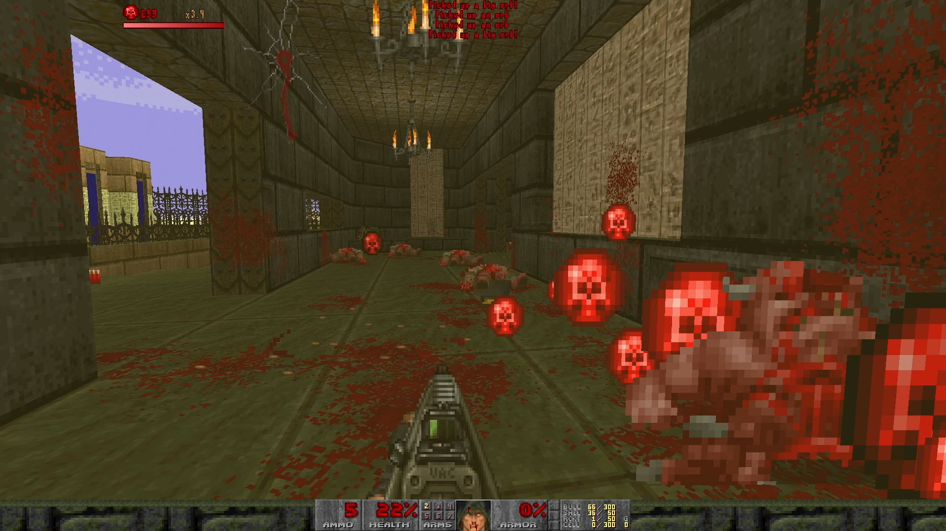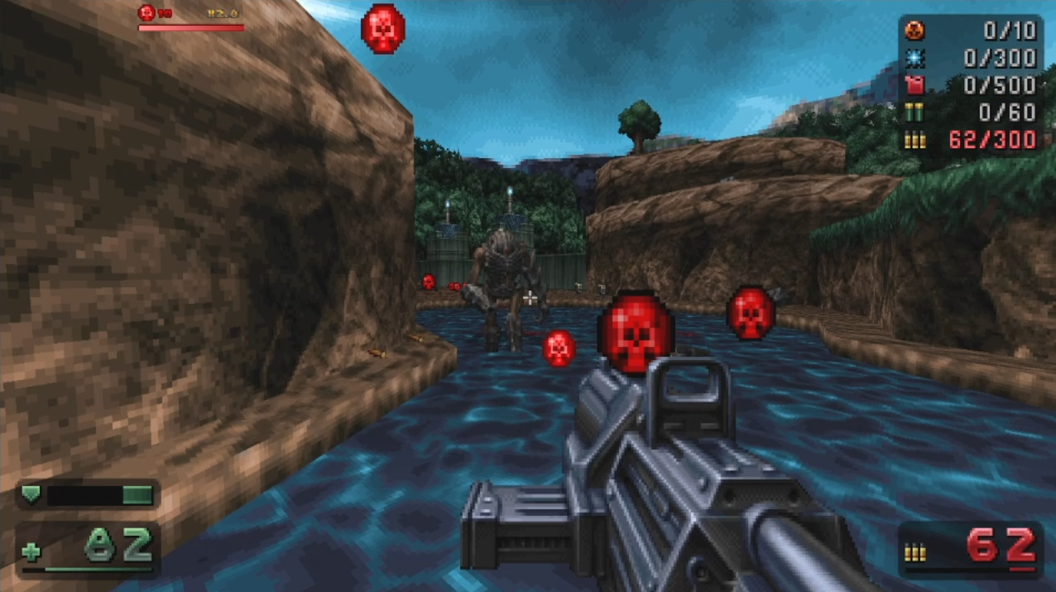

This project is really taking shape now - we have some multiplier logic and expiring pickups encouraging the player to move quickly and aggressively, accumulating that multiplier and collecting the ever-increasing collection of red orbs that burst out of the fallen monsters. Feel free to clean up the remaining debugging messages, play around with this a bit and adjust the multiplier bonuses and costs/rewards of converting orbs to health to your liking!

## Interlude. Tidying things up

Our monolithic ZScript lump is getting a bit big now. Before we go on, we should take some time to organize things better and make them more efficient.

### Multiple ZScript files

Like DECORATE, additional ZScript lumps can be loaded with the #include directive. With this arrangement, the base ZSCRIPT lump is the only one that requires a version declaration. I've separated our six classes by general subject into just four files - dealing with the in-game objects, the event handlers for things happening in the game, our UI handler, and the multiplier thinker - but some people prefer one class per file.

|  |
| --- |
| IMG_314**Arrange the project according to your preference - the tutorial will refer to classes and not files from now on. This is one possibility.** |

|  |
| --- |
| ZSCRIPT.includes |
| **version "4.10.0"**  **#include "zscript/OrbObjects.zs"**  **#include "zscript/OrbEventHandlers.zs"**  **#include "zscript/OrbUI.zs"**  **#include "zscript/OrbThinkers.zs"** |

|  |
| --- |
| zscript/OrbObjects.zs |
| class DoomOrb : Inventory { ... }  class DoomOrbBig : DoomOrb { ... } |

|  |
| --- |
| zscript/OrbEventHandlers.zs |
| class OrbSetupEventHandler : EventHandler { ... }  class MonsterDeathEventHandler : EventHandler { ... } |

|  |
| --- |
| zscript/OrbUI.zs |
| class OrbUIHandler : EventHandler { ... } |

|  |
| --- |
| zscript/OrbThinkers.zs |
| class OrbMultiplierThinker : Thinker { ... } |

As with other files that represent lumps, the file extension to ZScript lumps doesn't matter - GZDoom only cares about the portion of the filename before the dot. Using .txt or .zs seem to be the usual choices, and for the top-level one that only has #include directives, I tend to use .includes.

### Optimizing TexMan calls

Computers have come a long way since id Software had to implement their ingenious pile of workarounds to trick a computer into showing a 3D world in 1993, but it still pays to think about how we could make our code more efficient - especially in an environment like GZDoom where anything we add to the game is running on several layers of VM and interpretation.

As an example, take a look at these lines in our routine for drawing the UI:

|  |
| --- |
| OrbUIHandler |
| Screen.DrawText(smallfont, Font.CR\_RED, 20, 8, String.Format("%d", orbs), DTA\_VirtualWidth, 640, DTA\_VirtualHeight, 480);  **TextureID orbTex = TexMan.CheckForTexture("DORBA0", TexMan.Type\_Sprite);**          Screen.DrawTexture(orbTex, false, 4, 4, DTA\_VirtualWidth, 640, DTA\_VirtualHeight, 480, DTA\_LeftOffset, 0, DTA\_TopOffset, 0);          Screen.DrawText(smallfont, Font.CR\_YELLOW, 60, 8, multiplierText, DTA\_VirtualWidth, 640, DTA\_VirtualHeight, 480);    **TextureID barTex = TexMan.CheckForTexture("HUDBAR", TexMan.TYPE\_MISCPATCH);**          int barSizeX, barSizeY;  **[barSizeX, barSizeY] = TexMan.GetSize(barTex);**          double widthFraction = o.tickCountdown \* 1.0 / o.maxTicksSinceKill;          double barWidth = barSizeX \* widthFraction;          Screen.DrawTexture(barTex, false, 4, 20, DTA\_VirtualWidth, 640, DTA\_VirtualHeight, 480, DTA\_LeftOffset, 0, DTA\_TopOffset, 0, DTA\_WindowRightF, barWidth); |

Our three calls to ask TexMan to look something up for us are done when every single frame is drawn, and these answers aren't going to change during the runtime of the game. Even though you might not have noticed anything at this scale, the cost of calls like this can add up - it would be enough to just call these once and to remember the results in class variables.

I like to populate class variables in a function called Init(), and use the absence of one of them to indicate to the game that it should call this function to look everything up.

|  |
| --- |
| IMG_315**Move the looking up of textures and their sizes to a function that only has to be called once.** |

|  |
| --- |
| OrbUIHandler |
| class OrbUIHandler : EventHandler {  **ui TextureID orbTex;**  **ui TextureID barTex;**  **ui int barMaxWidth;**    **ui void Init() {**  **self.orbTex = TexMan.CheckForTexture("DORBA0", TexMan.Type\_Sprite);**  **self.barTex = TexMan.CheckForTexture("HUDBAR", TexMan.TYPE\_MISCPATCH);**  **int barSizeX, barSizeY;**  **[barSizeX, barSizeY] = TexMan.GetSize(barTex);**  **self.barMaxWidth = barSizeX;**  **}**        override void RenderOverlay(RenderEvent e) {    **if (!orbTex) {**  **self.Init();**  **}**          PlayerPawn p = PlayerPawn(players[consoleplayer].mo);          int orbs = p.CountInv("DoomOrb");          let o = OrbMultiplierThinker.GetReadOnlyInstance();          String multiplierText = "x1.0";          if (o) {              multiplierText = String.Format("x%.1f", o.orbMultiplier);          }          Screen.DrawText(smallfont, Font.CR\_RED, 20, 8, String.Format("%d", orbs), DTA\_VirtualWidth, 640, DTA\_VirtualHeight, 480);  ~~TextureID orbTex = TexMan.CheckForTexture("DORBA0", TexMan.Type\_Sprite);~~          Screen.DrawTexture(orbTex, false, 4, 4, DTA\_VirtualWidth, 640, DTA\_VirtualHeight, 480, DTA\_LeftOffset, 0, DTA\_TopOffset, 0);          Screen.DrawText(smallfont, Font.CR\_YELLOW, 60, 8, multiplierText, DTA\_VirtualWidth, 640, DTA\_VirtualHeight, 480);  ~~TextureID barTex = TexMan.CheckForTexture("HUDBAR", TexMan.TYPE\_MISCPATCH);~~  ~~int barSizeX, barSizeY;~~  ~~[barSizeX, barSizeY] = TexMan.GetSize(barTex);~~          double widthFraction = o.tickCountdown \* 1.0 / o.maxTicksSinceKill;  ~~double barWidth = barSizeX \* widthFraction;~~          double barWidth = self.barMaxWidth \* widthFraction;          Screen.DrawTexture(barTex, false, 4, 20, DTA\_VirtualWidth, 640, DTA\_VirtualHeight, 480, DTA\_LeftOffset, 0, DTA\_TopOffset, 0, DTA\_WindowRightF, barWidth); |

This is better. When RenderOverlay is called the first time, it will check if orbTex is empty, and if it is, it will call the Init function to work out what our textures and sizes should be. Therefore, all those calls to TexMan only happen once, and all other times this function runs, it only does the stuff that we really have to update continuously.

## Part 5. Storing more game data

Up until now, the player hasn't really had any incentive to save up the orbs they've collected - as long as they haven't reached 200 health, they might as well immediately cash them in and take the health boost. Let's reward accumulating orbs more by letting the player exchange them for better items if they hold on to them.

At the most straightforward level, we could do something like this…

|  |
| --- |
| OrbUIHandler |
| class OrbUIHandler : EventHandler {      ...      override void NetworkProcess(ConsoleEvent e) {          if (e.Name == "orbRecharge") {              PlayerPawn p = PlayerPawn(players[e.player].mo);              int orbs = p.CountInv("DoomOrb");              if (orbs >= 500) {                  p.GiveInventory("InvulnerabilitySphere", 1);                  p.TakeInventory("DoomOrb", 500);                  p.A\_StartSound("misc/p\_pkup");                  return;              }              if (orbs >= 150) {                  p.GiveInventory("HealthBonus", 100);                  p.TakeInventory("DoomOrb", 150);                  p.A\_StartSound("misc/p\_pkup");                  return;              }              if (orbs >= 40) {                  p.GiveInventory("HealthBonus", 25);                  p.TakeInventory("DoomOrb", 40);                  p.A\_StartSound("misc/p\_pkup");                  return;              }              if (orbs >= 20) {                  p.GiveInventory("HealthBonus", 10);                  p.TakeInventory("DoomOrb", 20);                  p.A\_StartSound("misc/p\_pkup");                  return;              }          }      }  } |

…but this is very verbose and unwieldy, and if we wanted to have some representation of the item that the player can currently buy on-screen (which we will) then we'd need another entire stack of if statements in the RenderOverlay function to handle that.

### Creating a data library thinker

Instead, let's set up a data store that we can consult wherever we need to. First, we need a new class that can hold everything we need to represent a buyable item - we need to know the cost of the item, the quantity and type of inventory object that buying it will give to the player, and how the item will be represented visually.

|  |
| --- |
| IMG_316**Create this OrbBuyableItem class.** |

|  |
| --- |
| OrbBuyableItem |
| **class OrbBuyableItem**  **{**  **int cost;**  **TextureID texture;**  **string itemClassName;**  **int itemQuantity;**    **OrbBuyableItem Init(int cost, string texture, string itemClassName, int itemQuantity) {**  **self.cost = cost;**  **self.texture = TexMan.CheckForTexture(texture, TexMan.Type\_Any);**  **self.itemClassName = itemClassName;**  **self.itemQuantity = itemQuantity;**  **return self;**  **}**  **}** |

This is a value object - unlike everything else we've implemented so far, it isn't a Thinker or an EventHandler, and the game has no special behaviour related to it by default, it's just there to hold data for us. It works exactly like a class in any other OOP language - it has four class variables, and a constructor (or in this case an approximation of one) that accepts values for each of them and assigns them. We use TexMan to look up the textureIDs for the texture names provided instead of just storing them as strings, so that we can avoid having to look them up every time when reading them.

(Despite this not being a Thinker, I put this class in my OrbThinkers file anyway because it will be used by a new Thinker we're about to implement, but you can choose your preferred location for yourself.)

Now we need to set up a Thinker which will store a collection of these objects and provide a function to tell us which one is currently available to the player. While this isn't an official piece of terminology, I tend to use the term "data library" for a Thinker that's used to look up data in this way, so this will be our OrbDataLibrary. It's going to start out looking a lot like our OrbMultiplierThinker, but with one important difference.

|  |
| --- |
| IMG_317**Create this OrbDataLibrary class, and make sure we initialize it on the WorldLoaded event in the OrbSetupEventHandler.** |

|  |
| --- |
| OrbDataLibrary |
| **class OrbDataLibrary : Thinker**  **{**  **OrbDataLibrary Init(void) {**  **ChangeStatNum(STAT\_STATIC);**  **return self;**  **}**  **static OrbDataLibrary GetInstance(void) {**  **ThinkerIterator it = ThinkerIterator.Create("OrbDataLibrary", STAT\_STATIC);**  **let p = OrbDataLibrary(it.Next());**  **if (p) return p;**  **return new("OrbDataLibrary").Init();**  **}**    **clearscope static OrbDataLibrary GetReadOnlyInstance(void) {**  **ThinkerIterator it = ThinkerIterator.Create("OrbDataLibrary", STAT\_STATIC);**  **let p = OrbDataLibrary(it.Next());**  **if (p) return p;**  **return null;**  **}**  **}** |

|  |
| --- |
| OrbSetupEventHandler |
| class OrbSetupEventHandler : EventHandler {      override void WorldLoaded(WorldEvent e) {          OrbMultiplierThinker.GetInstance();  **OrbDataLibrary.GetInstance();**          ThinkerIterator it = ThinkerIterator.Create("Health", Thinker.STAT\_DEFAULT);          Health item;          while (item = Health(it.Next())) {              console.printf("Destroyed a %s", item.getClassName());              item.Destroy();          }      }  } |

We provide the same Init, GetInstance and GetReadOnlyInstance functions as we did in the OrbMultiplierThinker, but this time, we assign it the STAT\_STATIC stat number instead of STAT\_USER (and we therefore use STAT\_STATIC in the ThinkerIterators as well). This makes the object a *static thinker*, which gives it a couple of special properties:

* It will keep its state throughout the game, carrying over between maps.
* GZDoom will not call its Tick() function.

These features make static thinkers a good choice for objects that only need to be set up once and are called when they're needed, instead of having to be updated constantly. They make a good alternative to putting things in ACS's global variables or storing things in the player's inventory - and as usual, doing it this way is a lot more flexible and less clumsy than the ACS/DECORATE implementation.

Let's now add an array of buyable items and populate it by creating several of our OrbBuyableItem objects.

|  |
| --- |
| IMG_318**Add an array to the OrbDataLibrary, and populate it in the Init method.** |

|  |
| --- |
| OrbDataLibrary |
| class OrbDataLibrary : Thinker  {  **Array<OrbBuyableItem> buyableItems;**      OrbDataLibrary Init(void) {          ChangeStatNum(STAT\_STATIC);  **self.buyableItems.push(new("OrbBuyableItem").Init(20, "STIMA0", "HealthBonus", 10));**  **self.buyableItems.push(new("OrbBuyableItem").Init(40, "MEDIA0", "HealthBonus", 25));**  **self.buyableItems.push(new("OrbBuyableItem").Init(150, "SOULA0", "HealthBonus", 100));**  **self.buyableItems.push(new("OrbBuyableItem").Init(500, "ARM2A0", "BlueArmor", 1));**  **self.buyableItems.push(new("OrbBuyableItem").Init(1000, "PINVA0", "InvulnerabilitySphere", 1));**          return self;      }      static OrbDataLibrary GetInstance(void) {...}        clearscope static OrbDataLibrary GetReadOnlyInstance(void) {...}  **}** |

The five new lines in the Init method are doing several things at a time - creating new OrbBuyableItems, and then immediately calling their own Init methods to populate them with the orb cost, texture, and the item and quantity that they will actually give the player. The push method is then called to add the item to the buyableItems array - [see the arrays page on the ZDoom wiki for more things you can do with them](https://www.google.com/url?q=https://zdoom.org/wiki/Dynamic_arrays&sa=D&source=editors&ust=1677034908639097&usg=AOvVaw0cPNlWnCokOnK1nqH1tefD).

So now we have an array of possible items to buy, and the number of orbs at which they'll become available. The last thing we need to do here is provide a method that will give us the highest-value item that's available to the player.

|  |
| --- |
| IMG_319**Add this last method to our OrbDataLibrary.** |

|  |
| --- |
| OrbDataLibrary |
| class OrbDataLibrary : Thinker  {      Array<OrbBuyableItem> buyableItems;      OrbDataLibrary Init(void) {...}      static OrbDataLibrary GetInstance(void) {...}        clearscope static OrbDataLibrary GetReadOnlyInstance(void) {...}  **clearscope static OrbBuyableItem GetCurrentBuyableItem(int currentOrbs) {**  **int lowestCost = -1;**  **OrbBuyableItem selectedItem = null;**  **foreach (item : OrbDataLibrary.GetReadOnlyInstance().buyableItems) {**  **if (item.cost > lowestCost && item.cost <= currentOrbs) {**  **selectedItem = item;**  **lowestCost = item.cost;**  **}**  **}**  **return selectedItem;**  **}**  **}** |

We want this method to be accessible from both the UI and play scopes, so it's a clearscope method that uses GetReadOnlyInstance. It will loop through the buyableItems array and find the highest-priced one that has a cost equal to or lower than the value we pass in (the player's current orbs).

With that done, we just have to alter our UI classes now - on the UI, we want to display the item that the player currently has available, and when the orbRecharge event is fired, we need to look up the appropriate items to give the player. This doesn't involve any completely new concepts - we just have to consult the data library and use the data we get back from it to draw things to the screen or decide how to manipulate the player's inventory.

|  |
| --- |
| IMG_320**Consult the data library in the RenderOverlay and NetworkProcess methods to decide the item to display or give to the player.** |

|  |
| --- |
| OrbUIHandler |
| class OrbUIHandler : EventHandler  {  …      override void RenderOverlay(RenderEvent e) {          …  **OrbBuyableItem item = OrbDataLibrary.GetCurrentBuyableItem(orbs);**  **if (item) {**  **Screen.DrawText(smallfont, Font.CR\_YELLOW, 112, 32, item.cost .. "", DTA\_VirtualWidth, 640, DTA\_VirtualHeight, 480);**  **Screen.DrawTexture(item.texture, false, 120, 30, DTA\_VirtualWidth, 640, DTA\_VirtualHeight, 480, DTA\_LeftOffset, 0, DTA\_TopOffset, 0, DTA\_CenterBottomOffset, true);**          }      }      …      override void NetworkProcess(ConsoleEvent e) {          if (e.Name == "orbRecharge") {              PlayerPawn p = PlayerPawn(players[e.player].mo);  ~~int orbs = p.CountInv("DoomOrb");~~  ~~if (orbs >= 20) {~~  ~~p.GiveInventory("HealthBonus", 10);~~  ~~p.TakeInventory("DoomOrb", 20);~~  ~~p.A\_StartSound("misc/p\_pkup");~~  ~~}~~  **OrbBuyableItem item = OrbDataLibrary.GetCurrentBuyableItem(p.CountInv("DoomOrb"));**  **if (item) {**  **p.GiveInventory(item.itemClassName, item.itemQuantity);**  **p.TakeInventory("DoomOrb", item.cost);**  **p.A\_StartSound("misc/p\_pkup");**  **}**          }      }  **}** |

I'm just using one new tag in the DrawTexture method here, to force the sprite to start drawing from its bottom centre - this makes it a lot easier to place it on the screen, without worrying about the varying heights and widths of sprites.

Have a play about with this now, try to keep your kill streak going, and experiment with adjusting the hierarchy of items!

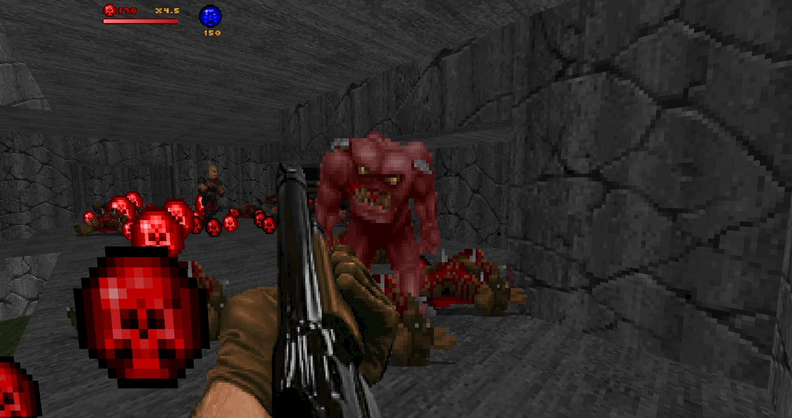

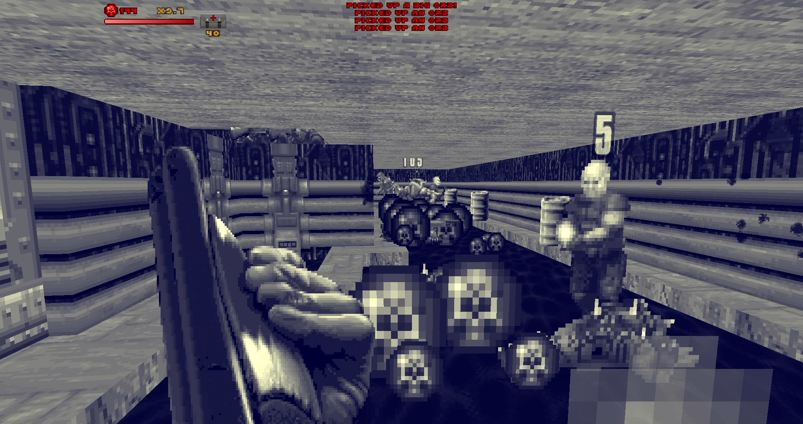

There's one extra thing that I want to mention, but we're basically finished with this demonstration project now. You can download the complete runnable PK3 from [https://doom.teamouse.net/zstutorial/zstutorial-complete.pk3](https://www.google.com/url?q=https://doom.teamouse.net/zstutorial/zstutorial-complete.pk3&sa=D&source=editors&ust=1677034908653209&usg=AOvVaw2UwEv0IaGuU792gy8N2k0V) if you want to compare it to your own!

### Loading data from lumps

Esta última parte es una ventaja porque es excesiva para un proyecto como este, pero otra cosa interesante que te permite hacer ZScript es cargar datos desde tus propios lumps personalizados. Los usé para proyectos más grandes como RAMP 2022, donde necesitaba almacenar una lista de dificultades de nivel y puntos de premio, o para Phobian Odyssey para mantener una base de datos de posibles grupos de monstruos y dónde podrían encontrarse.

Nuestro conjunto de datos será bastante pequeño en comparación, pero nos permitirá evitar codificar de forma rígida la lista de elementos disponibles en nuestra OrbDataLibrary.

|  |
| --- |
| IMG_323**Crea un nuevo lote en la raíz de tu proyecto llamado ORBITEMS.** |

|  |
| --- |
| ÓRBITEOS |
| **20, STIMA0, Bono de salud, 10**  **40,MEDIA0,Bono de salud,25**  **150, SOULA0, Bono de salud, 100**  **500, ARM2A0, Armadura azul, 1**  **1000, PINVA0, Esfera de invulnerabilidad, 1** |

Esto es exactamente lo mismo que los argumentos que pasamos a OrbBuyableItems anteriormente, organizados en una lista separada por comas.

Ahora podemos usar el [global Wads](https://www.google.com/url?q=https://zdoom-docs.github.io/staging/Api/Base/Wads.html&sa=D&source=editors&ust=1677034908656528&usg=AOvVaw27J6GizpfDHVWFGyJzwhF3)  para encontrar el lote ORBITEMS en tiempo de ejecución, leer su contenido en una cadena, luego realizar una división de cadenas para obtener nuestras líneas y elementos de datos individuales y crear nuestros OrbBuyableItems recorriéndolos en bucle:

|  |
| --- |
| IMG_324**Reemplace los elementos codificados en el método Init de OrbDataLibrary con una lectura establecida del conjunto ORBITEMS.** |

|  |
| --- |
| Biblioteca de datos Orb |
| clase OrbDataLibrary : Pensador  {      …      OrbDataLibrary Init(vacío) {          CambiarStatNum(STAT\_STATIC);  ~~self.buyableItems.push(new("OrbBuyableItem").Init(20, "STIMA0", "HealthBonus", 10));~~  ~~self.buyableItems.push(new("OrbBuyableItem").Init(40, "MEDIA0", "Bono de salud", 25));~~  ~~self.buyableItems.push(new("OrbBuyableItem").Init(150, "SOULA0", "Bono de salud", 100));~~  ~~self.buyableItems.push(new("OrbBuyableItem").Init(500, "ARM2A0", "BlueArmor", 1));~~  ~~self.buyableItems.push(new("OrbBuyableItem").Init(1000, "PINVA0", "InvulnerabilitySphere", 1));~~  **int orbItemsIndex = Wads.FindLump('ORBITEMS', 0);**  **Cadena orbItemsData = Wads.ReadLump(orbItemsIndex);**  **Array<String> líneas; orbItemsData.Split(líneas, "\n");**  **foreach (línea: líneas) {**  **si (linea.length() < 2) { continuar; }**  **Elementos de Array<String>; línea.Split(elementos, ",");**  **int costo = elementos[0].ToInt();**  **Textura de cadena = elementos[1];**  **Cadena itemClassName = elementos[2];**  **int itemQuantity = elementos[3].ToInt();**  **self.buyableItems.push(new("OrbBuyableItem").Init(costo, textura, nombreClaseArtículo, CantidadArtículo));**      }      …  **}** |

Hay un par de cosas nuevas o inusuales aquí que vale la pena mencionar:

* Wads.FindLump  buscará el índice del primer bloque con el nombre indicado, comenzando en la posición indicada en el WAD. Luego, Wads.ReadLump  tomará el bloque en ese índice y leerá su contenido en una cadena.
* La sintaxis para dividir una cadena en una matriz de cadenas es inusual: primero hay que declarar la matriz y luego pasarla como primer argumento al método Split  . La primera vez que esto sucede, dividimos en el carácter \n  o de nueva línea, lo que nos da una matriz de líneas.
* La condición if line.length() < 2  es una comprobación básica para omitir una línea si está vacía (es decir, si solo contiene un carácter, una nueva línea), ya que ZScript actualmente carece de un método trim().
* Luego dividimos nuestros elementos de datos alrededor de las comas y los convertimos en números enteros cuando es necesario para pasarlos a nuestra matriz de artículos comprables.

En este caso, el código para leer el bloque personalizado es más largo que simplemente codificarlo todo, pero demuestra otra cosa interesante que ZScript puede hacer para proyectos que necesitan datos además de los que proporciona el juego base. Es mejor que abusar del bloque LANGUAGE y tratarlo como una base de datos de clave-valor.

## Conclusión

Espero que este proyecto te haya dado una idea de cómo funciona ZScript y cómo se puede utilizar para ampliar las posibilidades de los proyectos de GZDoom. Evité utilizar ZScript durante mucho tiempo porque me parecía impenetrable, pero ahora que me he adentrado en ese mundo, me resulta muy difícil parar.

Gracias a todos los que están en el Discord y los foros de GZDoom, así como en mi propio Discord, por sus consejos sobre ZScript y por probar mis instrucciones y decirme dónde no tenían sentido. ¡Gracias también a todos los que están escribiendo documentación para ZScript para que sea más accesible para todos!

### Más ideas

¡Algunas ideas para ampliar el proyecto! Vea qué más puede hacer con él.

* Haz que los monstruos suelten una bonificación adicional si la muerte provocó una salvación de último momento: verifica que el conteo regresivo de tics en OrbMultiplierThinker esté cerca de cero.
* Agrega otra matriz a la biblioteca de datos para que puedas establecer cantidades específicas de orbes para los monstruos, en lugar de depender de su salud máxima.
* Otorga al jugador una bonificación por matar a todos los monstruos en un nivel y nunca perder su multiplicador: verifica las [estadísticas disponibles en el objeto LevelLocals](https://www.google.com/url?q=https://zdoom-docs.github.io/staging/Api/Level/LevelLocals.html%23statistics&sa=D&source=editors&ust=1677034908667004&usg=AOvVaw1EAKJvHBbTwwwY-TYecbaU)  (accesible con el nombre "nivel" desde cualquier lugar) para realizar un seguimiento de la cantidad de monstruos presentes.
* Mejora la idea del multiplicador/cuenta regresiva para que los diferentes monstruos contribuyan con diferentes cantidades a tu multiplicador, o otorga tiempo adicional antes de que se reinicie.

# Knee-Deep in ZScript

A guide to writing your first ZScript project for GZDoom!

## Why should I use ZScript?

This is a big question that I think many ZScript guides don’t address - why do you need to switch to ZScript?

The truth is, if you can do everything that you want to in GZDoom already with ACS and DECORATE, you really don’t need to switch! DECORATE is still a useful feature of the engine, and it isn’t going to go away - for creating Things like scenery and monsters, it still works fine. But once you get a bit more ambitious, you’ll start running into its limitations - perhaps you need to keep track of some variables on a monster to give it a more complex behaviour than normal. You might find yourself having to assign a specific TID to the player at the start of the level so that you can refer to them from an ACS script later, or write and compile an ACS library because a pickup needs to make a call to get something that isn’t available to it in DECORATE.



It’s possible to work around all of these in the old DECORATE/ACS environments - for the first RAMP in 2021 I wrote an entire garden building minigame using them, but it was clunky and required a lot of thinking around obstacles, keeping track of TIDs and generally tricking the computer into doing it. ZScript lets you get much deeper into the details of GZDoom than the old scripting languages do - you can react to a much greater variety of things happening in the game, manipulate game elements like linedefs and sectors without having to specifically make them addressable with tags, and create classes that don’t just exist in the game world as Things but can interact with data behind the scenes as well.

ZScript isn’t easy to get into - this greater reach into the game all comes at the cost of a steep learning curve, an overwhelming number of possibilities and a much greater variety of opportunities to produce crashes. Once you get into the way it works, though, you begin to realize just how much more control you have over the game environment, and exploring its possibilities becomes as addictive as any other aspect of Doom mapping.

### How ZScript Works

Like DECORATE, ZScript is written as one or more text-format lumps and is used to define objects and their behaviour. It shares much of its concept and syntax with other object-oriented programming languages such as Java and C# - going over these is a large job and I’ll try to explain the OOP concepts that you’ll need to know about as they come up, but before really diving into ZScript it might help to follow a beginner tutorial for either of those. Having a grasp of concepts like object inheritance and overridden/virtual functions will help understand what’s happening throughout ZScript, but I hope that I can give a good enough introduction to them here for them to be understandable.

ZScript suffers a bit from a lack of documentation because there’s just so much of ZScript to document - various tutorials and references for what all the components do have been written, and [https://zdoom-docs.github.io/staging/](https://www.google.com/url?q=https://zdoom-docs.github.io/staging/&sa=D&source=editors&ust=1677034908407660&usg=AOvVaw3I5dM4XWzlPTwymd-cY1kw) by Alison G. Watson and Fira Watson is currently my preferred reference. However, I think a lot of ZScript’s possibilities can be summed up by looking at just two concepts.

### ZScript’s two superstars

Before I got into using ZScript, the major thing putting me off was not knowing where I was supposed to start. I began with ACS and DECORATE by saying “I’d like to make this switch do something that isn’t in the standard action specials” or “I’d like to make a new kind of pickup” - I didn’t have an equivalent goal that could only be accomplished in the ZScript world. It was only after grasping the following two ideas that I realized what ZScript would allow me to do:

#### Thinkers

A Thinker is an object that can perform actions. In the DECORATE world, you’re always working with Actors, which are present as physical entities in the game - imps or teleport destinations or heads on sticks. But Thinkers exist one place above them in the object hierarchy, as objects that don’t necessarily have a presence and that can just quietly work away in the background. Instead of telling it what to do by defining a list of states as you would for a DECORATE actor, you can define a Thinker’s behaviour by writing a Tick() method for it - this will be called on every game tick automatically.



An Actor is now just one of the many types of Thinkers that you can use - actors use their Tick() method to advance through their list of states and call the functions defined in it, but other Thinkers might work very differently.



#### Event Handlers

Event handlers allow you to react to things happening in the game world, without the clumsiness of having to assign tags to objects and make calls through ACS. When you add an event handler to the game, it will be notified whenever something happens that it’s set up to listen for. You could think of these in a similar way to the special ACS scripts - you could have code in an event handler for a map being loaded, or a player entering or exiting it.

However, the big difference here is that event handlers can also react to much more detailed things - a monster being damaged, a line being activated and even the player making keypresses. See [https://zdoom.org/wiki/Events\_and\_handlers](https://www.google.com/url?q=https://zdoom.org/wiki/Events_and_handlers&sa=D&source=editors&ust=1677034908409855&usg=AOvVaw3mgj1Hzw8XP-spOAmMsFL4) for a list of events that can be detected by these handlers - the possibilities are extensive.



A lot of ZScript's power comes from a behaviour common to both of these objects - they provide functions that you can override in your custom subclasses to insert your own logic. Anything that extends the Thinker class will have its Tick() method called 35 times per second, and an EventHandler will run functions for whatever events it's set up to listen for. Using these together, plus the access that ZScript gives you to the internals of the game world, it's possible to make some very interesting stuff.

## The project

In this tutorial we’re going to use ZScript to do something that Doom never asked for - adding a little economy of sorts so that the player can buy health and powerups. We’re also going to reward the player for their speed in killing hellspawn, and learn how to use ZScript to add a widget to the HUD to display the state of everything. To do all this, we'll be using both thinkers and event handlers to alter the level, handle input and react to events, draw to the screen and even read from elsewhere in the WAD.

One of the most difficult things about starting ZScript for me was knowing where to go to find information - therefore, throughout this tutorial I won't just talk about how to build the project, but where the functionality that I'm using is documented and how to discover more of it for yourself.

### Setting up

You can download the resources for this project from [https://doom.teamouse.net/zstutorial/zstutorial-start.zip](https://www.google.com/url?q=https://doom.teamouse.net/zstutorial/zstutorial-start.zip&sa=D&source=editors&ust=1677034908411595&usg=AOvVaw1BhnkWEmDkScJECiojh2xa) - it contains a couple of sprites and extras that we'll refer to in our ZScript, but you're welcome to make up your own version of any of these assets.

A lot of this tutorial will be explanations of what we're doing and how they work. Actions for you to take will be highlighted in a box with Doom's skull icon - here's your first one:

|  |
| --- |
| IMG_260**Download the resources ZIP and unzip it into a new folder.** |



This will be our PK3 folder - the contents of this can be zipped into a PK3 to create a packaged mod for GZDoom. To test it, you can drag the folder to GZDoom.exe without zipping - alternatively, I prefer to use the command line, passing . as a file to indicate the current directory:



(Yes, I have my gzdoom folder in my Windows PATH - more normal people would have to enter the full path to gzdoom here instead)

From here, this tutorial will guide you through adding some ZScript elements. Good luck!

## Part 1. The groundwork

### Doom orbs

#### Creating a ZScript actor class

Let’s start with the most basic element of our mod and build up from there - we’re going to need an item that the player can pick up to award them points. The appearance and name of this can be up to you, but I’m going to follow the lead of Devil May Cry and make them red orbs. A basic actor pickup that extends Inventory would look like this in DECORATE:

|  |
| --- |
| DECORATE example of a basic DoomOrb item |
| Actor DoomOrb : Inventory {      Inventory.MaxAmount 999999      Inventory.Amount 1      Inventory.PickupSound "orbs/inventory/up"      +BRIGHT      states {        Spawn:          DORB A 5          DORB B 5          Loop      }  } |

The equivalent of this in ZScript doesn’t have anything too surprising - there is a guide to the differences between DECORATE and ZScript on the ZDoom wiki at [https://zdoom.org/wiki/Converting\_DECORATE\_code\_to\_ZScript](https://www.google.com/url?q=https://zdoom.org/wiki/Converting_DECORATE_code_to_ZScript&sa=D&source=editors&ust=1677034908417150&usg=AOvVaw1dIn2HQR_ZVSqV732SkJlf) which goes into some detail, but in our case we just need to know a few things:

* We're now defining a class that happens to be an actor, not defining an Actor directly
* Lines of code, state declarations, properties, etc now consistently end with a semicolon
* The properties that were just hanging around in the Actor definition in DECORATE now go into a code block called "default"

|  |
| --- |
| IMG_263**Create a file called ZSCRIPT in your PK3 folder and add this DoomOrb class to it.** |

|  |
| --- |
| ZSCRIPT |
| **version "4.10.0"**  **class DoomOrb : Inventory {**  **default {**  **Inventory.MaxAmount 999999;**  **Inventory.Amount 1;**  **Inventory.PickupMessage "Picked up an orb";**  **Inventory.PickupSound "orbs/inventory/up";**  **+BRIGHT;**  **}**  **states {**  **Spawn:**  **DORB A 5;**  **DORB B 5;**  **Loop;**  **}**  **}** |

ZSCRIPT has to start off with a version declaration so GZDoom knows how to interpret it - at the time of writing, 4.10.0 is the latest ZSCRIPT version, and the project we're building should work in that version of GZDoom or above.

The rest of the file is very similar to the DECORATE example above - and that's all it's taken to make our first ZScript class. If you load this project up in GZDoom, enter the first level and bring down the console with the backtick (`) key, you can type the summon doomorb command to create one in front of the player. It will blink away to itself happily until you walk over it to pick it up.



If you're not familiar with GZDoom's ecosystem already, it's worth mentioning that "Inventory" here means something slightly different from in most Doom-engine games. In things like Heretic and Hexen, inventory items are specifically things that you can pick up, scroll through and then use later - for example the famous Tomes of Power or the other magic items that you can carry with you. In GZDoom, "inventory" refers to everything that the player owns - weapons, ammunition as well as usable inventory items are included here. These items won't appear in a Hexen-style inventory - they're just tokens that get put in the player's inventory behind the scenes.

So that's a simple DECORATE-style inventory object that we've just ported straight to ZScript, but now we come to the interesting part where we can use ZScript to alter its logic in ways that were off limits to us in DECORATE. We don't want these orbs to hang around forever - if they're not picked up within a certain time, we'll make them eventually vanish.

In DECORATE, you might do this by trying to construct a limited loop of states by remembering the various rules you have to adhere to with user variables and how to manipulate them in anonymous functions - or if you're like me, just give up on that and write a ton of ABABABAB over and over to make enough states to last the duration I want. ZScript allows us a much more elegant way to do this: writing a Tick() function for the object.

#### Adding a Tick() function

The Tick() function is the heart of a ZScript class's logic - every time the game updates, i.e. "on every tick", this function will be called on all objects so they can decide what they need to do on this frame. The Tick() function exists in the Thinker parent class, and for Actors, it handles all the standard stuff like moving the object through its list of states and so on. In our DoomOrb, we want to do that and then add some logic of our own.

Writing this part is exactly the same as writing a function for an object in C# or Java - we want to add a variable that each instance of this class can use to keep track of how long it's been around, and then increment that on each tick until it's time to remove it.

|  |
| --- |
| IMG_265**Add an instance variable and a Tick() function to our DoomOrb:** |

|  |
| --- |
| ZSCRIPT |
| class DoomOrb : Inventory {  **int age;**      default {...}      states {...}  **override void Tick() {**  **super.Tick();**  **age++;**  **if (age > 350) {**  **self.Destroy();**  **}**  **}**  } |

The logic here is simple enough - add 1 to the 'age' instance variable on each tick, and if it's now over 350, remove the object from the game by calling its Destroy() function. There are 35 ticks per second in the GZDoom world, so this object should last ten seconds before disappearing.

The keyword "self" here is used to refer to the object that's running this code, the same way as C# and Java would use "this" - [https://zdoom.org/wiki/ZScript\_special\_words](https://www.google.com/url?q=https://zdoom.org/wiki/ZScript_special_words&sa=D&source=editors&ust=1677034908426308&usg=AOvVaw23p7UTaBOukUdSHqfvc2uV) shows a list of keywords like this. The Destroy() function exists for all ZScript objects, and marks the object for deletion - it's defined in the Object class at the very top of the hierarchy. [https://zdoom-docs.github.io/staging/Api/Base/Object.html#instance-methods](https://www.google.com/url?q=https://zdoom-docs.github.io/staging/Api/Base/Object.html%23instance-methods&sa=D&source=editors&ust=1677034908426701&usg=AOvVaw2UqxlvgoJNaSp_Xr0c3MI8)

Another thing that's different from some other object-oriented languages is that ZScript doesn't allow you to specify a default value for instance variables. This might cause you some concern if you're coming from C++ where this would result in just getting whatever happens to be in memory at the time, but not to worry - an int will always be initialized to 0.

Lastly, the call to super.Tick() at the top is very important - this will call the Tick() function in the Actor parent class so that the actor actually performs the logic that's in there as well as all of our added stuff. Without this call, the object will be awkwardly frozen in time - try removing it if you like, and you'll see the object isn't affected by gravity and doesn't animate because it isn't advancing through its states.

Try opening this project in GZDoom again, and this time (as long as the call to super.Tick() is intact) when you enter the command summon doomorb, you should see it vanish after ten seconds.

#### Debugging the Tick() function

Try summoning a few of these objects and picking them up. If you bring down the console and type printinv afterwards, you should see them being listed in your inventory… but what's happening? After a few seconds, you might not have as many in your inventory as you thought you had picked up.

We can make what's happening clear by adding some logging to our function. You might be familiar with Log() and A\_Log() - in ZScript, we can print a message to the console by using the console.printf() function.

|  |
| --- |
| IMG_266**Add a line to log when a DoomOrb has aged enough to be destroyed.** |

|  |
| --- |
| ZSCRIPT |
| …      override void Tick() {          super.Tick();          age++;          if (age > 350) {  **console.printf("Destroying a %s", self.getClassName());**              self.Destroy();          }      }  … |

console.printf is a very useful function that's available from anywhere. It's like the function of the same name in C, and it works a bit like an easier-to-parse Log function from ACS - you specify a string to log with placeholders for values, followed by the values to go into the string. In this case we're using %s in our output string to tell printf that it should expect a string to go into that slot, and we're then telling it to replace that %s with the result of self.getClassName() (which will be "DoomOrb" or whatever you called this class).

The available substitutions are listed on the ZDoom wiki at [https://zdoom.org/wiki/String#Methods](https://www.google.com/url?q=https://zdoom.org/wiki/String%23Methods&sa=D&source=editors&ust=1677034908430233&usg=AOvVaw3xJkq5e2QUVM39HCFJpgv7) .

Now run the game again and do the same thing, summoning and picking up the DoomOrbs. Soon you'll notice the problem - the DoomOrb objects still exist the same way as they did in the game world when they're in the player's inventory, and so they will continue to age and be destroyed!

To prevent this, we'll add a new condition to our Tick() function that makes the object avoid aging if it's in the inventory of a player. We can detect this by checking if the object has an owner.

|  |
| --- |
| IMG_267**Add a check for the DoomOrb having been picked up, and stop it aging. We can also remove the console.printf() line.** |

|  |
| --- |
| ZSCRIPT |
| …      override void Tick() {          super.Tick();  **if (self.owner) {return;}**          age++;          if (age > 180) {  ~~console.printf("Destroying a %s", self.getClassName());~~              self.Destroy();          }      }  … |

Here, we're testing if this object's owner is anything - if it's non-null, then return early only having performed the superclass's Tick() function and ignoring all the aging logic. If you test this now, you should see the orbs in your inventory staying around as you'd expect.

### Handling an event

Now that our orb object works, let's get enemies to drop some for the player to collect when they die. In the DECORATE world, we would at this point have to write a new subclass of every monster and alter their drop chances or Death states to include the commands to create new orbs. But because we're in ZScript, we can write an event handler which will be called automatically whenever a monster death occurs, and add new actions in that event instead of having to alter the object itself.

[https://zdoom.org/wiki/Events\_and\_handlers](https://www.google.com/url?q=https://zdoom.org/wiki/Events_and_handlers&sa=D&source=editors&ust=1677034908433904&usg=AOvVaw3S8mU3PNxyjKLwK5ajd1BW) shows us that we can use the WorldThingDied event to react when a Thing reaches zero health, so let's implement an EventHandler with that event now.

|  |
| --- |
| IMG_268**Add another class below the DoomOrb in our ZSCRIPT file - this one is our event handler.** |

|  |
| --- |
| ZSCRIPT |
| version "4.10.0"  class DoomOrb : Inventory {...}  **class MonsterDeathEventHandler : EventHandler {**  **override void WorldThingDied(WorldEvent e) {**  **console.printf("Monster %s was killed", e.Thing.getClassName());**  **}**  **}** |

This new class extends EventHandler, and implements the WorldThingDied function. Event handler functions are given an event "e", and the the ZDoom wiki page on event handlers tells us that in this particular event, we will have access to the actor that died (referred to as Thing) and the actor that inflicted the damage that caused the death (Inflictor).



At the moment, this just does the same thing as we did above for the DoomOrb - it will log a message with the class name of the actor that died (e.Thing.getClassName()).

Before we can test this, we need to do one more thing. GZDoom has the option to make an event handler apply either globally or just in specific maps, so it needs to be told where it should put ours. We want it to be called throughout the whole game, so we'll specify that in a gameinfo section in the MAPINFO lump.

|  |
| --- |
| IMG_270**Create a MAPINFO lump in the root of the project and specify that our event handler should be loaded.** |

|  |
| --- |
| MAPINFO |
| GameInfo {      AddEventHandlers = "MonsterDeathEventHandler"  } |

Try the project out now and you should see a message coming up whenever a monster is killed, with the message changing depending on the monster type.



Now instead of just logging the class name, we'll get two other pieces of information out of the dying actor so that we can create a DoomOrb at the appropriate place - you can see these properties on ZDoom-docs' page about the Actor class: [https://zdoom-docs.github.io/staging/Api/Base/Actor.html?highlight=pos#position](https://www.google.com/url?q=https://zdoom-docs.github.io/staging/Api/Base/Actor.html?highlight=pos%23position&sa=D&source=editors&ust=1677034908439724&usg=AOvVaw28EZ0ce4WySzfm1Q3YKlln)

* pos, which is a vector3 with the x, y and z coordinates of the actor.
* height, the actor's height in map units.

A vector3, by the way, is a three-dimensional vector. This is a collection of three coordinates, written as three numbers or variables in parentheses - for example (x, y, z) or (17, 23, 24). In ACS, coordinates often had to be expressed in unwieldy ways, using separate variables and parameters for each one like in A\_SpawnItemEx below - using vectors like this lets us wrap them up in a way that's much less verbose.

|  |
| --- |
| bool, Actor **A\_SpawnItemEx** (class<Actor> *missile* [, double *xofs* [, double *yofs* [, double *zofs* [, double *xvel* [, double *yvel* [, double *zvel* [, double *angle* [, int *flags* [, int *failchance* [, int *tid*]]]]]]]]]]) |

Having got the position and the height of the dying monster, we'll use the Actor.Spawn() function (see [https://zdoom.org/wiki/Spawn\_(ZScript)](https://www.google.com/url?q=https://zdoom.org/wiki/Spawn_(ZScript)&sa=D&source=editors&ust=1677034908442151&usg=AOvVaw0tfb_n_7v1lr9FyjZXd9WB)) to create a DoomOrb actor. This function is a lot less clunky than the large library of slightly-differently-named ACS ones, and simply takes a class name of the actor you want to spawn, and a vector3 representing the world position at which to spawn it. By specifying (pos.x, pos.y, pos.z + (height/2)) as our vector3, we'll use the original X and Y positions from the monsters' pos vector directly, and add half the height of the monster to the z-coordinate (therefore moving the spawn point up off the floor).

|  |
| --- |
| IMG_272**Change the WorldThingDied function to get the position of the dying actor and create a DoomOrb halfway up its height.** |

|  |
| --- |
| ZSCRIPT |
| class DoomOrb : Inventory {...}  class MonsterDeathEventHandler : EventHandler {    override void WorldThingDied(WorldEvent e) {  ~~console.printf("Monster %s was killed", e.Thing.getClassName());~~  **vector3 pos = e.Thing.pos;**  **double height = e.Thing.height;**  **Actor.Spawn("DoomOrb", (pos.x, pos.y, pos.z + (height/2)));**    }  } |

With the MonsterDeathEventHandler now active, you should be able to run the game and see monsters dropping the DoomOrbs when they're killed.

### Drawing to the screen

This all works nicely, but it would be good to have a count of how many orbs we've picked up visible on the screen instead of having to duck into the console every time we want to check. Let's add a basic counter to the HUD.

In the ZScript world, the process of drawing things to the screen is also handled by EventHandlers. This time, we're going to create one to listen for the RenderOverlay event, which is called on every frame when GZDoom is ready to draw HUD elements on top of the rendered game world.

(By the way, there's nothing saying that we couldn't just put the monster death events and UI drawing into one single event handler and have it handle both the cases by implementing both WorldThingDied and RenderOverlay. But I find it easier on the brain to make separate event handlers for different things.)

|  |
| --- |
| IMG_273**Add another event handler to our ZSCRIPT file, and add it to the event handlers to be called throughout the game.** |

|  |
| --- |
| ZSCRIPT |
| version "4.10.0"  class DoomOrb : Inventory {...}  class MonsterDeathEventHandler : EventHandler {...}  **class OrbUIHandler : EventHandler {**  **override void RenderOverlay(RenderEvent e) {**  **PlayerPawn p = PlayerPawn(players[consoleplayer].mo);**  **int orbs = p.CountInv("DoomOrb");**  **Screen.DrawText(smallfont, Font.CR\_RED, 4, 4, orbs);**  **}**  **}** |

|  |
| --- |
| MAPINFO |
| GameInfo {      AddEventHandlers = "MonsterDeathEventHandler**", "OrbUIHandler**"  } |

For this function, we need to know which player we're drawing the HUD for so we can retrieve the number of red orbs from their inventory. Players can always be retrieved from the global array called "players", as listed in the globals page at [https://zdoom-docs.github.io/staging/Api/Globals.html?highlight=players#players](https://www.google.com/url?q=https://zdoom-docs.github.io/staging/Api/Globals.html?highlight=players%23players&sa=D&source=editors&ust=1677034908450731&usg=AOvVaw3yrPllxDPSWPBd9vE6_AmS), and the number of the current player is also available as consoleplayer. The players array stores a collection of PlayerInfo objects, which describe the state of players in the game - at the time of writing the documentation for them hasn't been finished yet, but the properties on them can be found in the zscript source code at [https://github.com/ZDoom/gzdoom/blob/master/wadsrc/static/zscript/actors/player/player.zs#L2680](https://www.google.com/url?q=https://github.com/ZDoom/gzdoom/blob/master/wadsrc/static/zscript/actors/player/player.zs%23L2680&sa=D&source=editors&ust=1677034908451266&usg=AOvVaw1eIkLKIaa5ZAE9RwaNey4i) .

A PlayerInfo has a reference to its corresponding PlayerPawn object under the property called "mo". The difference is rather difficult to get your head round and I couldn't fully describe it myself, but the PlayerPawn is the object that moves about and represents the player's presence in the level, while PlayerInfo stores more general information about the player (how many secrets they've discovered, their FOV preferences, and so on). The PlayerPawn is the one with the inventory - so in total, the first line of this function has to:

* Get the *consoleplayer*th item out of the global players array, which will be a PlayerInfo

players[consoleplayer]

* Get the PlayerInfo's mo property

players[consoleplayer].mo

* Cast that to a PlayerPawn by putting all of that between the PlayerPawn() parentheses

PlayerPawn p = PlayerPawn(players[consoleplayer].mo)

We then call CountInv() on the PlayerPawn to count how many DoomOrbs our current player is carrying - this is one of the ZScript actor functions listed on the ZDoom wiki at [https://zdoom.org/wiki/CountInv](https://www.google.com/url?q=https://zdoom.org/wiki/CountInv&sa=D&source=editors&ust=1677034908452656&usg=AOvVaw0m6ijashonkuLg_rpFlixD).

Having got that count, we can now write it on the screen with the Screen.DrawText function documented at [https://zdoom.org/wiki/DrawText](https://www.google.com/url?q=https://zdoom.org/wiki/DrawText&sa=D&source=editors&ust=1677034908453345&usg=AOvVaw0juREVDF3IJGPvI1vcSTUH) . This is more or less the ZScript equivalent of HudMessage - it's a quick way of putting text on to the HUD with minimal options. Our call here uses the parameters:

* Font - we could use a custom one here, but smallfont is a global variable that just uses the current game's default small font
* Colour - these are defined as constants in the Font class, and are equivalent to the CR\_… colours used by ACS
* X and Y coordinates at which to draw the string - I've used (4, 4) here, but you can change them as you prefer
* The string we want to print - in this case, our orbs variable.

Start up GZDoom again with this in place, and you'll see… it fails to start up. Why?



It turns out ZScript is a bit picky about types of variables - our orbs variable is a number and not a string. While we as humans might think it fairly obvious how to print a number as a string, the computer won't do it unless we've specifically asked it to - so let's do that now.

There are a couple of ways to do this. One possibility is to use the String.Format function - this behaves a lot like console.printf() does, taking a string with a set of placeholders and then a list of variables to swap in. To convert our number to a string without further embellishments, you could use the %d placeholder to represent a number (to remember this I've always mentally called it "decimal" but I may be totally wrong):

String.Format("%d", orbs)

You could also use this to add some text with the count, such as:

String.Format("Orbs: %d", orbs)

Another way to convert a number to a string, which I find rather easier even if it feels less official, is to concatenate an empty string on to it - this will convert it to a string automatically. In ZScript, the concatenation operator is two dots, .. - therefore, this will force the int orbs to be treated as a string:

orbs .. ""

|  |
| --- |
| IMG_275**Choose your preferred method and alter the Screen.DrawText line to use it.** |

|  |
| --- |
| ZSCRIPT |
| …  Screen.DrawText(smallfont, Font.CR\_RED, 4, 4, **orbs .. ""**);  … |

Starting up GZDoom will now give you the counter in the corner. Depending on your resolution it might be a bit hard to see… so let's add some more parameters to our call to fix that.



According to [https://zdoom.org/wiki/DrawText](https://www.google.com/url?q=https://zdoom.org/wiki/DrawText&sa=D&source=editors&ust=1677034908458500&usg=AOvVaw1l3Sm0kGC_sUxZPl3C6XEB), the DrawText function can take some more parameters after the string to display which it calls "tags", arranged in pairs with [the name of the option], [the value for the option]. Like SetHudSize() in ACS, the DTA\_VirtualHeight and DTA\_VirtualWidth options let us say that we want the string scaled and printed as if the screen were the size we specify - so let's reduce that from whatever ungodly resolution we have on a 2020s PC to a more reasonable 640x480.

|  |
| --- |
| ZSCRIPT |
| …  Screen.DrawText(smallfont, Font.CR\_RED, 4, 4, orbs .. "", DTA\_VirtualWidth, 640, DTA\_VirtualHeight, 480);  … |

You can play about with the parameters now to adjust the counter however you'd prefer.

So in just a few classes, we've made a good start to ZScript and done some things familiar to DECORATE/ACS in a more convenient way already - we have a powerup that times out, have got monsters to drop it, and we have an onscreen counter for them.

## Part 2. Making some improvements

We've got some basic ZSCRIPT building blocks working now - let's revisit them and polish them up a bit.

### New orb disappearance effect

It would be nice to give the player a warning before the orbs disappear, to encourage them to hurry up and get it. Let's make them blink a bit more urgently for a while before they vanish.

|  |
| --- |
| IMG_277**Add a new state to the DoomOrb class - we'll make the object jump to here when it's about to disappear.** |

|  |
| --- |
| ZSCRIPT |
| class DoomOrb : Inventory {      int age;        default {...}      states {        Spawn:          DORB A 5;          DORB B 5;          Loop;  **Decaying:**  **DORB A 2;**  **DORB B 2;**  **TNT1 A 2;**  **Loop;**      }      override void Tick() {...}  } |

This will cycle between the two orb frames more rapidly as well as the TNT1 A frame (which, for historical reasons, is the name for a frame with no sprite).

Now we need to work out a way of checking the age variable at some point during the Spawn loop. All the DECORATE functions can still be used in the state list here, so using some sort of A\_JumpIf() could work… but let's write our own action function instead, because that's something we can do now in ZScript!

|  |
| --- |
| IMG_278**Add an action function called checkAge() to the DoomOrb class.** |

|  |
| --- |
| ZSCRIPT |
| class DoomOrb : Inventory {      int age;        default {...}      states {...}      override void Tick() {...}  **action void checkAge() {**  **if (invoker.age > 250) {**  **invoker.SetState(ResolveState("Decaying"));**  **}**  **}**  } |

Action functions are specified slightly differently from other functions - they're specified with the keyword "action", which gives them special properties that allow them to distinguish between the actor that's calling them and the class that the function actually belongs to. This is important for situations like when a player is calling an action on an item that's in their inventory - in this case we don't have to worry about this possibility because the action is always called by the inventory object itself, but we have to be aware of the difference it makes to how we refer to objects. Inside action functions, the object affected by the action is now known as "invoker" instead of "self" - so we check the age property of the invoker, and potentially tell it to jump to the state label "Decaying".

Let's now call this new action function on our second state under the Spawn label, by specifying it after the state length in the same way as you would any other action function:

|  |
| --- |
| IMG_279**Make the DoomOrb call checkAge() during its Spawn loop.** |

|  |
| --- |
| ZSCRIPT |
| class DoomOrb : Inventory {      int age;        default {...}      states {        Spawn:          DORB A 5;          DORB B 5 **checkAge()**;          Loop;        Decaying:          DORB A 2;          DORB B 2;          TNT1 A 2;          Loop;      }      override void Tick() {...}      action void checkAge() {...}  } |

Now, when monsters drop orbs, you should be able to see them start blinking after 250 ticks (about 7 seconds) before eventually disappearing.

### New orb appearance effect

Pickups mean dopamine. What's the best way to get more dopamine? More pickups! Besides, having all the monsters drop one orb doesn't sound right - it feels like bursting a giant cacodemon should be worth more than knocking a plasticine-skinned zombie over with a feather. Let's say that instead of just one each, a monster should drop an orb for every ten health points it had before you came along.

We'll need to run a loop in our MonsterDeathEventHandler this time, and this is done in much the same way as other C-styled languages - to get how many times to run that loop, let's look at the documentation for actors again.

[https://zdoom-docs.github.io/staging/Api/Base/Actor.html?highlight=getmaxhealth#virtuals](https://www.google.com/url?q=https://zdoom-docs.github.io/staging/Api/Base/Actor.html?highlight=getmaxhealth%23virtuals&sa=D&source=editors&ust=1677034908476431&usg=AOvVaw2t8AjiC7nb4JZ3VVgjed7L) - This one looks good. Let's try that out.

|  |
| --- |
| IMG_280**Add a loop to MonsterDeathEventHandler so that it drops one orb for every 10 health points out of the GetMaxHealth() of the dying monster.** |

|  |
| --- |
| ZSCRIPT |
| class MonsterDeathEventHandler : EventHandler {    override void WorldThingDied(WorldEvent e) {          vector3 pos = e.Thing.pos;          double height = e.Thing.height;  **int maxHealth = e.Thing.getMaxHealth();**  **for (int i = 0; i < maxHealth; i += 10) {**  Actor.Spawn("DoomOrb", (pos.x, pos.y, pos.z + (height/2)));  **}**    }  } |

If you play this now, you'll notice… nothing much, really - the monsters still seem to drop one orb. But if you run over and pick them up, you'll see the counter incrementing more than it used to - the new orbs are being dropped, but they're all in the same place!

Let's distribute them a bit better. Unlike ACS, we don't have to find a function that will let us create an object in a very specific way that lets us alter its position or velocity - if we keep a reference to the object that was created, we can alter its X, Y and Z velocities directly!

|  |
| --- |
| IMG_281**Add a random element to the velocities of the DoomOrb when it's spawned.** |

|  |
| --- |
| ZSCRIPT |
| class MonsterDeathEventHandler : EventHandler {    override void WorldThingDied(WorldEvent e) {          vector3 pos = e.Thing.pos;          double height = e.Thing.height;          int maxHealth = e.Thing.getMaxHealth();          for (int i = 0; i < maxHealth; i += 10) {  **let spawnedActor =**Actor.Spawn("DoomOrb", (pos.x, pos.y, pos.z + (height/2)));  **spawnedActor.vel.X = frandom(-3, 3);**  **spawnedActor.vel.Y = frandom(-3, 3);**  **spawnedActor.vel.Z = frandom(5, 10);**          }    }  } |

frandom() will return a random fixed-point (non-integer) value between the two given bounds - so each orb created now will be thrown at a velocity between 5 and 10 up into the air, in a random horizontal direction that can have a velocity of -3 to 3 along each of the X and Y axes. And if you're unfamiliar with the let keyword, it allows us to declare a variable that doesn't really care about its type - it'll just be whatever type was assigned to it, in this case the DoomOrb returned by the spawn function.

Velocity, like an object's pos, is a vector3 - I've broken the three dimensions of it out here and assigned them separately because I think the code looks clearer that way, but you could equally write:

spawnedActor.vel = (frandom(-3, 3), frandom(-3, 3), frandom(5, 10));

Try this out again and you'll see the effect is much more satisfying.



Let's get more ambitious. Try calling a cyberdemon into the level with summon cyberdemon, then align it in the middle of the screen and use the console command mdk to deal a million hit points of damage to it.



Hmm. Actually that's a bit too much dopamine - maybe we should add a special case for when a monster has a very high number of hit points. Let's add a bigger variety of orb that awards more points.

|  |
| --- |
| IMG_284**Add another class to our ZScript file that extends the DoomOrb class.** |

|  |
| --- |
| ZSCRIPT |
| class DoomOrbBig : DoomOrb {      default {          Inventory.PickupMessage "Picked up a big orb!";          Scale 2;      }        override void AttachToOwner(Actor owner) {          owner.GiveInventory("DoomOrb", 10);          self.Destroy();      }  } |

Again, there's a bit of a trick here. This class extends the DoomOrb class so it will inherit the functions and states that we've already specified - but we need to add one more thing this time and implement an AttachToOwner function. This is one of the virtual actor functions listed on [https://zdoom.org/wiki/ZScript\_virtual\_functions#Inventory](https://www.google.com/url?q=https://zdoom.org/wiki/ZScript_virtual_functions%23Inventory&sa=D&source=editors&ust=1677034908488853&usg=AOvVaw1Yfo8vq0myNgB81NkB-9BD), which behave a lot like the functions that are available to event handlers - they're called when ZDoom detects something has happened to the object. In this case, AttachToOwner is called when the item is picked up by another actor.

On pickup, we want the player not to actually obtain the DoomOrbBig object, because then they would have a separate count of DoomOrbs and DoomOrbBigs in their inventory - instead, we tell this variant of the orb to add ten DoomOrbs to its owner's stash and then to destroy itself, therefore not staying in the inventory.

Having specified our new orb that's worth ten of the smaller ones, we need to rewrite our MonsterDeathEventHandler's WorldThingDied function so that it uses as many of both of these orb types as it needs to get to the monster's MaxHealth. With what you've learned about ZScript so far, try doing this on your own before looking at the code below - there are many ways to do this and this is just one example.

|  |
| --- |
| IMG_285**Rewrite our MonsterDeathEventHandler to create as many of the big orbs as it can before going to the smaller ones.** |

|  |
| --- |
| ZSCRIPT |
| **class MonsterDeathEventHandler : EventHandler {**  **override void WorldThingDied(WorldEvent e) {**  **vector3 pos = e.Thing.pos;**  **double height = e.Thing.height;**  **pos.z += height/2;**  **int maxHealth = e.Thing.getMaxHealth();**  **while (maxHealth >= 100) {**  **maxHealth -= 100;**  **self.createOrb(true, pos);**  **}**  **while (maxHealth >= 10) {**  **maxHealth -= 10;**  **self.createOrb(false, pos);**  **}**  **}**    **void createOrb(bool big, vector3 pos) {**  **String className = "DoomOrb";**  **if (big) { className = "DoomOrbBig"; }**  **let spawnedActor = Actor.Spawn(className, pos);**  **spawnedActor.vel = (frandom(-3, 3), frandom(-3, 3), frandom(5, 10));**  **}**  **}** |

In this example I've streamlined a few things from the function as it was before. This one works like this:

* Get the Thing's position and height like we did before, and add half of the height to the position's Z dimension. This will be the position that we want to spawn the orbs from.
* Get the maximum health of the dying actor and put it in a variable called maxHealth.
* As long as this maxHealth variable is above 100, subtract 100 from it and call a new function createOrb() with our position and the parameter "true".
* When it's no longer above 100, as long as this maxHealth variable is above 10, subtract 10 from it and call createOrb() with our position and the parameter "false".
* createOrb() uses the boolean to decide whether the class spawned should be a DoomOrb or a DoomOrbBig. It spawns whatever class is needed at the given position, then sets the velocity as one vector3 instead of three individual dimensions.

Test the project again and make sure that your WorldThingDied function is working as expected - use console.printf() to help out if you need it.

### Improving the display

While we're making revisions, let's improve our custom HUD piece a bit and make it more than just a number slapped on the screen. We're going to add a red orb icon beside it to make it clearer what it's for.

[https://zdoom.org/wiki/DrawTexture](https://www.google.com/url?q=https://zdoom.org/wiki/DrawTexture&sa=D&source=editors&ust=1677034908496185&usg=AOvVaw2VODgTjG50bvQn0qc879-p) looks like exactly what we need - it's the equivalent of DrawText but for graphics. However, if you try adding something like this to our RenderOverlay method in the OrbUIHandler, you'll discover it doesn't work:

|  |
| --- |
| IMG_286**Try this out:** |

|  |
| --- |
| ZSCRIPT |
| class OrbUIHandler : EventHandler {      override void RenderOverlay(RenderEvent e) {          PlayerPawn p = PlayerPawn(players[consoleplayer].mo);          int orbs = p.CountInv("DoomOrb");          Screen.DrawText(smallfont, Font.CR\_RED, 4, 4, orbs);  **Screen.DrawTexture("DORBA0", false, 4, 4, DTA\_VirtualWidth, 640, DTA\_VirtualHeight, 480);**      }  } |



Like the error message says, it can't work out how to get a texture from the string "DORBA0" directly. This is because unlike the ACS world, you can't specify graphics as just lump names any more. ZScript works with TextureIDs, which need another step to look them up - we'll have to ask the texture manager about it.

#### Using TexMan

The texture manager can be called up from anywhere under the name TexMan - [https://zdoom-docs.github.io/staging/Api/Drawing/TexMan.html](https://www.google.com/url?q=https://zdoom-docs.github.io/staging/Api/Drawing/TexMan.html&sa=D&source=editors&ust=1677034908499827&usg=AOvVaw0dKAFq2tSzuu4ma5AXQ8Wv) . This is the object that handles the graphics available to the game - in yet another confusing redefinition of the word "texture", it refers here not exclusively to wall textures like most of the Doom engine does but to any kind of graphic including sprites and general graphics like TITLEPIC. We'll use its CheckForTexture method to retrieve the first DoomOrb sprite, then pass it to the DrawTexture function.

|  |
| --- |
| IMG_288**Use TexMan to look up the TextureID we want for the display, then pass that to DrawTexture.** |

|  |
| --- |
| ZSCRIPT |
| class OrbUIHandler : EventHandler {      override void RenderOverlay(RenderEvent e) {          PlayerPawn p = PlayerPawn(players[consoleplayer].mo);          int orbs = p.CountInv("DoomOrb");  ~~Screen.DrawText(smallfont, Font.CR\_RED, 4, 4, orbs .. "", DTA\_VirtualWidth, 640, DTA\_VirtualHeight, 480);~~  **Screen.DrawText(smallfont, Font.CR\_RED, 20, 8, orbs .. "", DTA\_VirtualWidth, 640, DTA\_VirtualHeight, 480);**  **TextureID orbTex = TexMan.CheckForTexture("DORBA0", TexMan.Type\_Sprite);**  **Screen.DrawTexture(orbTex, false, 4, 4, DTA\_VirtualWidth, 640, DTA\_VirtualHeight, 480, DTA\_LeftOffset, 0, DTA\_TopOffset, 0);**      }  } |



Here, TexMan's CheckForTexture function takes the lump name for the graphic we want to find, and a type that it's expecting to look for - the options for these are shown in [https://zdoom.org/gitview/3a1228b/wadsrc/static/zscript/base.txt](https://www.google.com/url?q=https://zdoom.org/gitview/3a1228b/wadsrc/static/zscript/base.txt&sa=D&source=editors&ust=1677034908504109&usg=AOvVaw08y4O8B5FJxj9PwK183xoG) . You could specify TexMan.Type\_All here to just search through everything, but giving it a clue can narrow down and therefore speed up its search.

The DrawTexture function takes parameters in the same way as DrawText does - here, I'm passing the same virtual width and height values into it, as well as two more - setting the DTA\_LeftOffset and DTA\_TopOffset to 0 will ignore the grAb offsets that have been specified on the sprite, and just displays the sprite starting at its top left corner. (As a result the function call can look rather unwieldy, and if you have a lot of these it might be better to write your own function to wrap the call.)

Note also that I've moved the text counter over to the right and down a little to align it with the position of the orb, changing the coordinates from (4, 4) to (20, 8) - adjust it to your own preference. You could even add another graphic specifically for the UI and use that. (If you go with something like this, remember that the UI elements are drawn on the screen in the order you specify them, from back to front - so you'll need to move the line that displays the text below the line that displays the graphic.)



## Part 3. What are orbs for?

We've defined our new orb object and its behaviour, we've got monsters to drop them according to their general toughness, we've got a count of them on screen - let's make them do something useful. How about letting the player heal themselves with a button press when they've collected enough of them?

### Reacting to player input

Another thing that ZScript can do is access the game input, so you can react to button presses (this is possible in mods based on DECORATE/ACS as well, but it can be quite clumsy to set up). Just like the other elements we've coded so far, input in ZScript is handled via listeners.

We'll put a new function into our OrbUIHandler class. [https://zdoom.org/wiki/Events\_and\_handlers](https://www.google.com/url?q=https://zdoom.org/wiki/Events_and_handlers&sa=D&source=editors&ust=1677034908506272&usg=AOvVaw1jPFnNtWc-NecmrFYoauos) tells us the InputProcess function is called whenever there's input to be handled, and that a healthy six pieces of data are passed in the event. We want to do two things:

* Identify when the input event matches our criteria - the player has to have pressed the USER1 key (named in the controls menu as Weapon State 1).
* Once we've received an event like this, allow the player to exchange orbs for health if they have a sufficient number of them.

We're not going to look for specific keyboard keypresses directly because we don't know what the player's set the USER1 key(s) up to be (and in this context, a "key" could be a keyboard key, a mouse button or a joystick trigger) - so we're going to ask the Bindings global for it. This provides a GetKeysForCommand function, which can give us the keys (of which there can be up to two) that the player has set up for the command we want to detect. Then we're going to check if the key mentioned in the input event matches the keys we've been given - if so, we'll perform our action. For now, we'll do what we did before and just make the action to print something out so that we know it worked.

(Unfortunately, no documentation for the Bindings object is available at the moment - let's just implement an example of how it's used…)

|  |
| --- |
| IMG_291**Add an InputProcess function to our OrbUIHandler that just detects the key:** |

|  |
| --- |
| ZSCRIPT |
| class OrbUIHandler : EventHandler {      override void RenderOverlay(RenderEvent e) {...}  **override bool InputProcess(InputEvent e) {**  **int bind1, bind2;**  **[bind1, bind2] = Bindings.GetKeysForCommand("+user1");**  **if (e.Type == InputEvent.Type\_KeyDown && (e.KeyScan == bind1 || e.KeyScan == bind2)) {**  **console.printf("You have pressed key %d for USER1", e.KeyScan);**  **}**  **return false;**  **}**  } |

Here, we're assigning values to two ints at once - bind1 and bind2. GetKeysForCommand always returns two items because the controls screen allows for two keys to be bound to one command. They're returned as ints that uniquely identify the pressed key, and not as strings like "Q" or "7" - and these ints will correspond to the value given in e.KeyScan. We also want to check that the event type is a keydown event - the action should happen only once per keypress.

Also note that unlike every other event function that we've used so far, this one returns a boolean value! The function that calls InputProcess looks for this to decide whether to continue calling other event handlers for this event. If true is returned, then the game will consider the input event as handled and won't ask anything else to do anything about it. This is useful in situations like a modal dialogue box or inventory screen, where you want to use the player movement keys to navigate a cursor around but also to block the player from reacting to those same inputs if the dialogue box is active. For an example, look at the ConversationMenu class's MenuEvent function, which will return true if the keypress was one that the menu understood and reacted to. [https://github.com/ZDoom/gzdoom/blob/master/wadsrc/static/zscript/ui/menu/conversationmenu.zs#L308](https://www.google.com/url?q=https://github.com/ZDoom/gzdoom/blob/master/wadsrc/static/zscript/ui/menu/conversationmenu.zs%23L308&sa=D&source=editors&ust=1677034908511797&usg=AOvVaw15pRcP4WGmWOD8x0k_NM88)

Load up the project again and make sure you have one or more keys bound to user1 (Weapons/Weapon State 1 in the controls menu) - you should then be able to get this message to appear by pressing them.



With all that working, it's simple enough to write our real action - we've used all these elements before, and we just need to retrieve the player and fiddle with their inventory a bit. While we're at it, let's add a sound effect as well - functions from DECORATE like A\_StartSound still exist in ZScript, and can be used on the player like the other functions. misc/p\_pkup is the sound defined in gzdoom.pk3's SNDINFO to mean the gong-like powerup sound.

|  |
| --- |
| IMG_293**When the USER1 key is pressed and the player has sufficient orbs, recharge some health.** |

|  |
| --- |
| ZSCRIPT |
| class OrbUIHandler : EventHandler {      override void RenderOverlay(RenderEvent e) {...}      override bool InputProcess(InputEvent e) {          int bind1, bind2;          [bind1, bind2] = Bindings.GetKeysForCommand("+user1");          if (e.Type == InputEvent.Type\_KeyDown && (e.KeyScan == bind1 || e.KeyScan == bind2)) {  ~~console.printf("You have pressed key %d for USER1", e.KeyScan);~~  **PlayerPawn p = PlayerPawn(players[consoleplayer].mo);**  **int orbs = p.CountInv("DoomOrb");**  **if (orbs >= 20) {**  **p.GiveInventory("HealthBonus", 10);**  **p.TakeInventory("DoomOrb", 20);**  **p.A\_StartSound("misc/p\_pkup");**  **}**          }          return false;      }  } |

We're giving the player HealthBonus items here so that it can boost their health up to 200 - if we just gave one stimpack, it would top out at 100. (You can, of course, decide on the quantities of orbs required and health or other item(s) to give back yourself.)

So let's run and test this…



What! Why not?!

### Dealing with scope

You've now encountered the concept of scope in ZScript, as described in [https://zdoom.org/wiki/Object\_scopes\_and\_versions](https://www.google.com/url?q=https://zdoom.org/wiki/Object_scopes_and_versions&sa=D&source=editors&ust=1677034908518182&usg=AOvVaw2fVkbiIA2NFJVvuokrdP-2) . This is something that I hadn't encountered in the coding world I live in at work which is all dull backend business software, but it's an important thing to get your head around when you're dealing with a game world.

Objects in GZDoom can be assigned one of three scopes (or "contexts", as said in the error message - I prefer this word, but the wiki is fairly insistent that it's wrong). The scopes are *play*, *ui* and *data*. They exist to make sure that the state of the game stays consistent, and that you're not modifying any data where you shouldn't be and making the game unstable (there are plenty of other ways to produce crashes instead).

In our case, the objects that make up the game world are said to be in the *play* scope, and when we're in event handler functions that deal with user interface concerns like drawing things to the screen or handling input, we are in the *ui* scope. From the *ui* scope, you can read freely from the *play* scope, but you cannot modify it - only other things in the *play* scope can do that.

The section on networking in [https://zdoom.org/wiki/Events\_and\_handlers#Networking](https://www.google.com/url?q=https://zdoom.org/wiki/Events_and_handlers%23Networking&sa=D&source=editors&ust=1677034908519497&usg=AOvVaw0u7F0C2SrBJz2vZsyaRBgt) describes what to do - instead of trying to alter the player's inventory directly because of a UI event, we're going to send out an event of our own that tells the game that we want something to happen.

|  |
| --- |
| IMG_295**Instead of doing the check and altering the player's inventory here, use the EventHandler's SendNetworkEvent function to notify that an orb recharge has been requested.** |

|  |
| --- |
| ZSCRIPT |
| …  ~~PlayerPawn p = PlayerPawn(players[consoleplayer].mo);~~  ~~int orbs = p.CountInv("DoomOrb");~~  ~~if (orbs >= 20) {~~  ~~p.GiveInventory("Health", 10);~~  ~~p.TakeInventory("DoomOrb", 20);~~  ~~}~~  **EventHandler.SendNetworkEvent("orbRecharge");**  … |

Now we need to set up the other side, by writing a function that will listen for events and react to this one. NetworkProcess is another function that's available to EventHandlers - I like to put this into the UI handler if it's dealing with UI events, but you can choose whether to create a new class for it or not.

|  |
| --- |
| IMG_296**Create the NetworkProcess function to check for and react to the event.** |

|  |
| --- |
| ZSCRIPT |
| class OrbUIHandler : EventHandler {      override void RenderOverlay(RenderEvent e) {...}      override bool InputProcess(InputEvent e) {...}  **override void NetworkProcess(ConsoleEvent e) {**  **if (e.Name == "orbRecharge") {**  **PlayerPawn p = PlayerPawn(players[e.player].mo);**  **int orbs = p.CountInv("DoomOrb");**  **if (orbs >= 20) {**  **p.TakeInventory("DoomOrb", 20);**  **p.GiveInventory("HealthBonus", 10);**  **p.A\_StartSound("misc/p\_pkup");**  **}**  **}**  **}**  } |

Note that the way that we retrieve the PlayerPawn is a little different here! This time, the event has a property player that tells us the number of the player that activated this event - we only want to recharge the health of the player that requested it. In multiplayer Doom, each instance of the game is running its own playsim, and they need to apply the code that's coming up to the player matching the number in the event - if we used consoleplayer like we did before, then whenever the orbRecharge event was activated by any player, each player would see their own health being affected.

Having attempted to explain that, the rest of the code is straightforward - we count the number of DoomOrbs that the player has, and if it's greater or equal to the price of 20, we take our payment and award them some health back.

When you start this up, you should now find that you can press the USER1 key to swap orbs for health, provided you have 20 of them or more.



This is how events are passed from the UI to the game in ZScript. The distinction between the two environments isn't very clear from down here in our event handler, but they're defined this way in the base StaticEventHandler class - by default the class and its elements are in the play scope, but any function defined with the "ui" keyword is considered in the UI scope. (We'll be using this technique for ourselves later on.)

While it may seem awkward at first, the separation also makes things testable - you can also send an event that will be picked up by NetworkProcess functions by using the netevent console command, like using puke for ACS.

netevent orbRecharge

Note that unlike almost everything else in the GZDoom world, the names of the network events are case-sensitive.

### Searching and manipulating Things

Right, now that the player can take care of their health with the orbs, let's go power-mad and remove all the health items from the level. In DECORATE, we might do this by replacing the health items with a new Thing class that does nothing, because there's no way to address individual Things in a level that aren't tagged as anything. ZScript, however, gives us this power!

We're going to use a ThinkerIterator as described in [https://zdoom.org/wiki/ThinkerIterator](https://www.google.com/url?q=https://zdoom.org/wiki/ThinkerIterator&sa=D&source=editors&ust=1677034908528698&usg=AOvVaw3h1qZ24vurcqJv4zApoKZu). This is an object that will search through the Thinkers that exist in the game for us - by using a loop to call its Next() function repeatedly, it will give us back each Thinker it found and we can decide what to do with it.

Let's add one more event handler to the game - this one's going to take care of setting up the level.

|  |
| --- |
| IMG_298**Add a third EventHandler to the PK3. Remember to add it to the list of event handlers in MAPINFO as well.** |

|  |
| --- |
| ZSCRIPT |
| **class OrbSetupEventHandler : EventHandler {**  **override void WorldLoaded(WorldEvent e) {**  **ThinkerIterator it = ThinkerIterator.Create("Health", Thinker.STAT\_DEFAULT);**  **Health item;**  **while (item = Health(it.Next())) {**  **console.printf("Destroyed a %s", item.getClassName());**  **item.Destroy();**  **}**  **}**  **}** |

The first argument passed to the Create function is the class to start searching from - we're interested in the GZDoom class [https://zdoom.org/wiki/Classes:Health](https://www.google.com/url?q=https://zdoom.org/wiki/Classes:Health&sa=D&source=editors&ust=1677034908532838&usg=AOvVaw17UbvZ78VVzzZgWup4Q259) and all its descendants. In Doom, this will include Medikits, Stimpacks, Soulspheres and the HealthBonus potion bottles. (Note that Megasphere exists under the Powerup class and not Health - we'll leave this one alone for now to avoid complicating things.) The second argument is a StatNum, and these are a way GZDoom uses internally to group Thinkers together - you can see the list of them at [https://zdoom.org/wiki/Thinker](https://www.google.com/url?q=https://zdoom.org/wiki/Thinker&sa=D&source=editors&ust=1677034908533275&usg=AOvVaw3C8wjFNwL3n18d-bdhdB95) .

We could leave this second argument out and have the iterator just search through all the Thinkers in the game, but it's nice to be as efficient as we can - passing STAT\_DEFAULT tells the iterator only to consider in-game Actors (and custom Thinkers that are defined as using that StatNum).

The thinker iterator is now ready to be used. We set up a Health variable which contains nothing to start with, then use a while loop to repeatedly put the iterator's Next() result into that variable as long as it hasn't run out. In the loop, we output a console line for debugging just to show that we're doing something, then destroy the selected item. After the last item found by the Iterator has been gone through, the Next() function will return null, and the loop will end.

Start the game up with this event handler included, and verify that you get a set of messages about destroying the health items when starting a level - after that, you can remove the console.printf line. Now we have a variant of Doom where health is a resource from monsters instead of being picked up in the level!

## Part 4. Keeping variables in a non-Actor Thinker

For the next stage of the project, we're going to set up a class that lives in the background and handles an aspect of our game - remember that unlike in DECORATE, the classes that we define don't have to have a physical presence in the level. The idea will be to reward rapid monster kills by gradually increasing a multiplier that affects how many orbs are dropped. To reward cooperation (but also to demonstrate another aspect of ZScript), this multiplier will be global across all players, with each player's kills counting towards the total.

### Making a non-actor Thinker

In the ACS/DECORATE world, you could sort of implement things like this by using global variables and an infinite loop running in the background. ZScript lets us do this more neatly - this example is lifted almost directly from the global variables page of the ZDoom wiki at [https://zdoom.org/wiki/ZScript\_global\_variables](https://www.google.com/url?q=https://zdoom.org/wiki/ZScript_global_variables&sa=D&source=editors&ust=1677034908535306&usg=AOvVaw15dena6HdFTAXP0THBHmfv) :

|  |
| --- |
| IMG_299**Add yet another new class to our ZSCRIPT file - a non-physical Thinker that will just control the score multiplier.** |

|  |
| --- |
| ZSCRIPT |
| **class OrbMultiplierThinker : Thinker**  **{**  **double orbMultiplier;**  **int ticksSinceKill;**    **OrbMultiplierThinker Init(void) {**  **ChangeStatNum(STAT\_USER);**  **self.orbMultiplier = 1;**  **return self;**  **}**  **static OrbMultiplierThinker GetInstance(void) {**  **ThinkerIterator it = ThinkerIterator.Create("OrbMultiplierThinker", STAT\_USER);**  **let p = OrbMultiplierThinker(it.Next());**  **if (p) return p;**  **return new("OrbMultiplierThinker").Init();**  **}**  **}** |

The two functions here work to make sure we only ever have one OrbMultiplierThinker in the game:

* The Init function is something that we'll call when an OrbMultiplierThinker is first set up. (Note, if this means anything to you, that this is not technically a constructor - it looks a lot like one, but these don't exist in ZScript and we have to call it manually instead.) In this function, we immediately use ChangeStatNum to put this Thinker in the STAT\_USER group of Thinkers, just so we know where to search for it when we need it. Then we set our orbMultiplier variable to 1 and return the object.
* The static GetInstance function will be used whenever we want to access this object. It uses the ThinkerIterator to check whether there's an OrbMultiplierThinker in the game yet - if there is, then it will return it. If there isn't, it will create a new one and call the Init() method on it before returning it.

If you've done object-oriented programming work before, you'll have recognized this as a singleton pattern - just with a couple of extra steps, as ZScript doesn't currently support class/static variables. We get around that by using the ThinkerIterator to retrieve the singleton.

If you haven't done object-oriented programming before, notice the static keyword on the GetInstance function. This means this function is not tied to a specific instance of the OrbMultiplierThinker - it will be callable from anywhere and not just when you already know which specific OrbMultiplierThinker you'll be referring to (that's its job - to find and return the actual live OrbMultiplierThinker object). As I'm doing a terrible job explaining this, referring to [https://www.codejava.net/java-core/the-java-language/what-is-static-method-in-java](https://www.google.com/url?q=https://www.codejava.net/java-core/the-java-language/what-is-static-method-in-java&sa=D&source=editors&ust=1677034908541439&usg=AOvVaw3p7C3XLPWgwiMUfABfkORn) or any introductory OOP course will help.

Now let's do something with this class. We're going to implement a way for another class to increase the multiplier, and a Tick function to bring it down again.

|  |
| --- |
| IMG_300**Add these functions to the OrbMultiplierThinker.** |

|  |
| --- |
| ZSCRIPT |
| class OrbMultiplierThinker : Thinker  {      double orbMultiplier;      int ticksSinceKill;        OrbMultiplierThinker Init(void) {...}      static OrbMultiplierThinker GetInstance(void) {...}  **void RaiseMultiplier() {**  **self.ticksSinceKill = 0;**  **self.orbMultiplier += 0.1;**  **console.printf("Raised multiplier to %f", self.orbMultiplier);**  **}**    **override void Tick() {**  **if (self.orbMultiplier > 1) {**  **self.ticksSinceKill += 1;**  **if (self.ticksSinceKill > 350) {**  **self.ticksSinceKill = 0;**  **self.orbMultiplier = 1;**  **console.printf("Reset multiplier");**  **}**  **}**  **}**  } |

When called, RaiseMultiplier will raise the multiplier by 0.1, reset the ticksSinceKill to 0, and as usual, print a console message to tell us what's happening. The Tick function works the same way as on the Doom orb, being called on every tick and gradually increasing a counter - for this object, if the orb multiplier is above 1, we'll start counting ticks until we reach over 350. When that happens, we'll reset the multiplier back to 1 and print a message acknowledging we've done so, therefore giving the player a time limit if they want to keep their multiplier going.

Let's now hook this multiplier thinker into the game by getting our monster death event handler to update it when a monster is killed.

|  |
| --- |
| IMG_301**Go back to our MonsterDeathEventHandler and get it to interact with the OrbMultiplierThinker.** |

|  |
| --- |
| ZSCRIPT |
| class MonsterDeathEventHandler : EventHandler {      override void WorldThingDied(WorldEvent e) {          vector3 pos = e.Thing.pos;          double height = e.Thing.height;          pos.z += height/2;  **let o = OrbMultiplierThinker.GetInstance();**  ~~int maxHealth = e.Thing.getMaxHealth();~~  **double maxHealth = e.Thing.getMaxHealth();**  **maxHealth \*= o.orbMultiplier;**  **console.printf("Points for %s after multiplying: %f", e.Thing.getClassName(), maxHealth);**  **o.RaiseMultiplier();**          while (maxHealth >= 100) {              maxHealth -= 100;              self.createOrb(true, pos);          }          while (maxHealth >= 10) {              maxHealth -= 10;              self.createOrb(false, pos);          }      }        void createOrb(bool big, vector3 pos) {...}  } |

Now when a monster is killed, we use our OrbMultiplierThinker.GetInstance function to find the instance of the OrbMultiplierThinker object (or to create it, if there isn't one). Then. instead of using the monster's maxHealth property directly, we multiply it by the current value of orbMultiplier - we've turned maxHealth from an int into a double here so that the decimal from our multiplication isn't eliminated. The giving out of orbs can then be done with this altered value - but before that, we also tell the OrbMultiplierThinker to raise the multiplier and reset the time limit to 0.

Try playing with all of this in the game now - you should see the multiplier in the console logs getting bigger, and more orbs gradually being dropped by enemies as a consequence. Use some IDKFA assistance to see some dramatic increases!

Of course, the console messages are just there so we can see what's happening while testing - it would be good for the player to have an idea of their current multiplier as well. Let's add that to our UI.

### Accessing the Thinker from UI

We already know how to display text on the HUD, so putting information from this Thinker in the UI should be simple - it involves going back to our OrbUIHandler again and adding a reference to the OrbMultiplierThinker.

|  |
| --- |
| IMG_302**Alter the OrbUIHandler to get the information we need from our Thinker.** |

|  |
| --- |
| ZSCRIPT |
| class OrbUIHandler : EventHandler {      override void RenderOverlay(RenderEvent e) {          PlayerPawn p = PlayerPawn(players[consoleplayer].mo);          int orbs = p.CountInv("DoomOrb");  **let o = OrbMultiplierThinker.GetInstance();**  **String multiplierText = String.Format("x%.1f", o.orbMultiplier);**          Screen.DrawText(smallfont, Font.CR\_RED, 20, 8, orbs .. "", DTA\_VirtualWidth, 640, DTA\_VirtualHeight, 480);          TextureID orbTex = TexMan.CheckForTexture("DORBA0", TexMan.Type\_Sprite);          Screen.DrawTexture(orbTex, false, 4, 4, DTA\_VirtualWidth, 640, DTA\_VirtualHeight, 480, DTA\_LeftOffset, 0, DTA\_TopOffset, 0);  **Screen.DrawText(smallfont, Font.CR\_YELLOW, 60, 8, multiplierText, DTA\_VirtualWidth, 640, DTA\_VirtualHeight, 480);**      }      override bool InputProcess(InputEvent e) {...}      override void NetworkProcess(ConsoleEvent e) {...}  } |

Now, as part of the drawing of the UI, we get the OrbMultiplierThinker instance and put its orbMultiplier into a string by using the String.Format function. This time, we use the format %.1f to mean a decimal value with one decimal place (again, see [https://zdoom.org/wiki/String#Methods](https://www.google.com/url?q=https://zdoom.org/wiki/String%23Methods&sa=D&source=editors&ust=1677034908558092&usg=AOvVaw1_SApbnVrferJJxB8cfJYr) for the formats available), and we add an "x" to the front. Then we add one more Screen.DrawText line to put this new string up on to the screen.

Start this up in GZDoom now. Can you see what's coming?



Scope foils us again! We can't call the GetInstance function from the UI because the OrbMultiplierThinker object, like all Thinkers, exists in the *play* scope - and using NetworkEvents won't help here because we need a response, we're not just sending a signal one way. Instead, we're going to do what we saw in the StaticEventHandler class a while ago, and put a function in a different scope from the rest of the class.

The keyword we're going to be using is *clearscope*, which makes a function callable both from *ui* and *play* scopes but puts other limits on them in exchange - just like the *ui* scope, *clearscope* classes and functions can only read from the play scope and not write to it. That means we can't just put *clearscope* directly on the GetInstance function that we already have, because of this line:

|  |
| --- |
| static OrbMultiplierThinker GetInstance(void) {          ThinkerIterator it = ThinkerIterator.Create("OrbMultiplierThinker", STAT\_USER);          let p = OrbMultiplierThinker(it.Next());          if (p) return p;  **return new("OrbMultiplierThinker").Init();**      } |

If we added *clearscope* to the start of this function, we would get a different script error because there's the possibility that the function might attempt to create a *play*-scoped object. So instead, we'll have to create an alternative GetInstance method that only ever tries to read.

|  |
| --- |
| IMG_304**Add a new function with the clearscope keyword to OrbMultiplierThinker, to get an instance without ever trying to create one.** |

|  |
| --- |
| ZSCRIPT |
| class OrbMultiplierThinker : Thinker  {  .  .  .      static OrbMultiplierThinker GetInstance(void) {...}  **clearscope static OrbMultiplierThinker GetReadOnlyInstance(void) {**  **ThinkerIterator it = ThinkerIterator.Create("OrbMultiplierThinker", STAT\_USER);**  **let p = OrbMultiplierThinker(it.Next());**  **if (p) return p;**  **return null;**  **}**  **.**  **.**  **.**  } |

This variant of the GetInstance function won't try to create a new OrbMultiplierThinker if one isn't available - it will just return nothing. Let's get our OrbUIHandler to use that instead.

|  |
| --- |
| IMG_305**Use the new GetReadOnlyInstance() method in OrbUIHandler instead of GetInstance().** |

|  |
| --- |
| ZSCRIPT |
| class OrbUIHandler : EventHandler {  …      override void RenderOverlay(RenderEvent e) {          …          let o = OrbMultiplierThinker.Get**ReadOnly**Instance();          …      }  …  } |

That should allow us to read from the Thinker from the UI scope. Test this again - you'll find GZDoom starts up without a problem, but now try entering a map - what's it moaning about now?!



VM execution aborted: tried to read from address zero is an error that you're likely to encounter a lot when piecing ZScript together, and it sounds a lot scarier than it really is - despite it sounding like an issue with low level memory management, the problem is usually that you're attempting to call a method or alter a property on a null.

And thinking through our code again, it's easy to see why this happens - the instance of OrbMultiplierThinker is only created the first time GetInstance() is called, and that happens when the *play* scope needs it - currently that's only called when a monster dies. The GetReadOnlyInstance() function is called from the UI right from the start of the level, and will return null if the conditions for actually creating the thinker haven't happened yet.

There are a couple of things we can do to safeguard ourselves against this. First, it definitely pays to code defensively, and handle the condition where we just don't have an OrbMultiplierThinker yet:

|  |
| --- |
| IMG_307**Get the OrbUIHandler to handle the possibility of the OrbMultiplierThinker not existing by defining a default multiplierText.** |

|  |
| --- |
| ZSCRIPT |
| class OrbUIHandler : EventHandler {      override void RenderOverlay(RenderEvent e) {          PlayerPawn p = PlayerPawn(players[consoleplayer].mo);          int orbs = p.CountInv("DoomOrb");          let o = OrbMultiplierThinker.GetReadOnlyInstance();  **String multiplierText = "x1.0";**  **if (o) {**  **multiplierText = String.Format("x%.1f", o.orbMultiplier);**  **}**          TextureID orbTex = TexMan.CheckForTexture("HUDORB", TexMan.Type\_Any);          Screen.DrawTexture(orbTex, false, 4, 4, DTA\_VirtualWidth, 640, DTA\_VirtualHeight, 480, DTA\_LeftOffset, 0, DTA\_TopOffset, 0);          Screen.DrawText(smallfont, Font.CR\_RED, 20, 8, orbs .. "", DTA\_VirtualWidth, 640, DTA\_VirtualHeight, 480);          Screen.DrawText(smallfont, Font.CR\_YELLOW, 60, 8, multiplierText, DTA\_VirtualWidth, 640, DTA\_VirtualHeight, 480);      }      override bool InputProcess(InputEvent e) {...}      override void NetworkProcess(ConsoleEvent e) {...}  } |

And if we want to make sure that the OrbMultiplierThinker exists from the start of the level, we just have to make sure we tell the game to create it when the level starts.

|  |
| --- |
| IMG_308**Tell our OrbSetupEventHandler to do exactly that as part of its WorldLoaded function.** |

|  |
| --- |
| ZSCRIPT |
| class OrbSetupEventHandler : EventHandler {      override void WorldLoaded(WorldEvent e) {  **OrbMultiplierThinker.GetInstance();**          ThinkerIterator it = ThinkerIterator.Create("Health", Thinker.STAT\_DEFAULT);          Health item;          while (item = Health(it.Next())) {              console.printf("Destroyed a %s", item.getClassName());              item.Destroy();          }      }  } |

### IMG_309

The game will start up correctly again now. And this is beginning to look a lot more satisfying! The display of the multiplier encourages the player to keep it topped up. Let's add one more element - a display of how much time the player has remaining to kill another demon before losing their multiplier.

### More UI drawing

We could do this just by putting a third number on the screen, but a diminishing bar would have a more urgent visual effect. We can make one by using the DrawTexture method again, using a couple more of its options and a bit of mathematics.

Let's start by rearranging our OrbMultiplierThinker to make things a little easier for ourselves:

|  |
| --- |
| IMG_310**Rewrite the OrbMultiplierThinker so that it has a property for the maximum time limit, and counts down instead of up.** |

|  |
| --- |
| ZSCRIPT |
| class OrbMultiplierThinker : Thinker  {      double orbMultiplier;      int ticksSinceKill;  **int tickCountdown;**  **int maxTicksSinceKill;**        OrbMultiplierThinker Init(void) {          ChangeStatNum(STAT\_USER);          self.orbMultiplier = 1;  **self.maxTicksSinceKill = 350;**          return self;      }      static OrbMultiplierThinker GetInstance(void) {...}        clearscope static OrbMultiplierThinker GetReadOnlyInstance(void) {...}        void RaiseMultiplier() {          self.ticksSinceKill = 0;  **self.tickCountdown = self.maxTicksSinceKill;**          self.orbMultiplier += 0.1;  ~~console.printf("Raised multiplier to %f", self.orbMultiplier);~~      }        override void Tick() {  ~~if (self.orbMultiplier > 1) {~~  ~~self.ticksSinceKill += 1;~~  ~~if (self.ticksSinceKill > 350) {~~  ~~self.ticksSinceKill = 0;~~  ~~self.orbMultiplier = 1;~~  ~~console.printf("Reset multiplier");~~  ~~}~~  ~~}~~  **if (self.tickCountdown > 0) {**  **self.tickCountdown -= 1;**  **return;**  **}**  **self.orbMultiplier = 1;**      }  } |

This alteration won't change anything from the player's point of view, but it will help us as the mod author a little. We've put the maximum time limit into the property maxTicksSinceKill so we can just refer to that property when we want the time limit, instead of putting the unexplained number 350 everywhere in our code (therefore if we want to adjust it later we can do it in only one place). Counting down instead of up also makes us have to do a bit less work when using this value to adjust an on-screen counter.

Let's look at [the DrawTexture tags](https://www.google.com/url?q=https://zdoom.org/wiki/DrawTexture&sa=D&source=editors&ust=1677034908587624&usg=AOvVaw3lFI9mQ_UEjbUp2B-mc8V9) again. There are a couple of them that look useful, altering the width of the texture or how much of it is drawn on screen. We'll use DTA\_WindowRightF in this example, which defines how far over to the right to stop drawing the graphic - a value that's less than the real width of the graphic will cut it off, and we can use this to make a decreasing bar. A graphic for a bar is provided in the project graphics folder under the name HUDBAR, but you can replace it with your own if you like.

So this is what we want to do:

* Get the HUDBAR texture from the texture manager.
* Find the width of the texture when the bar is full.
* Calculate how much of the texture we want to draw, depending on the current value of the countdown in OrbMultiplierThinker.
* Draw the texture only up to that width using the DTA\_WindowRightF tag in DrawTexture.

We could skip the second step and just hard-code the number 100 (or whatever the width of our bar texture is), but working it out from the texture itself will avoid us having to update this number if we ever change the texture. [TexMan's GetSize function](https://www.google.com/url?q=https://zdoom-docs.github.io/staging/Api/Drawing/TexMan.html?highlight=GetSize&sa=D&source=editors&ust=1677034908588898&usg=AOvVaw0EfwBvqZtxJqFfWj6Dr2lK) will do this for us, given a texture ID - like Bindings.GetKeysForCommand which we used to get the player's key configuration, it returns two variables at once (the X and Y size).

To work out how much of the texture to draw, we'll get the fraction that the current tickCountdown is of the maxTicksSinceKill (if it's full, it will be 350/350 which is 1.0, if it's half full, it will be 175/350 which is 0.5) and then multiply the width of our texture by that. That will result in the number of pixels along the X axis where we want to stop - the input for DTA\_WindowRightF.

Putting it all together:

|  |
| --- |
| IMG_311**Add a routine to the end of our RenderOverlay function in OrbUIHandler to get the bar texture, calculate how much of it to display by looking at the OrbMultiplierThinker and then draw it.** |

|  |
| --- |
| ZSCRIPT |
| class OrbUIHandler : EventHandler {      override void RenderOverlay(RenderEvent e) {          ...  **TextureID barTex = TexMan.CheckForTexture("HUDBAR", TexMan.TYPE\_MISCPATCH);**  **int barSizeX, barSizeY;**  **[barSizeX, barSizeY] = TexMan.GetSize(barTex);**  **double widthFraction = o.tickCountdown \* 1.0 / o.maxTicksSinceKill;**  **double barWidth = barSizeX \* widthFraction;**  **Screen.DrawTexture(barTex, false, 4, 20, DTA\_VirtualWidth, 640, DTA\_VirtualHeight, 480, DTA\_LeftOffset, 0, DTA\_TopOffset, 0, DTA\_WindowRightF, barWidth);**      }      override bool InputProcess(InputEvent e) {...}      override void NetworkProcess(ConsoleEvent e) {...}  } |

Now select your preferred monster-packed map and watch the red orbs fly! Because all of this code runs without relying on any alterations to existing GZDoom classes, it will also work on very customized WADs with nonstandard weapons and monsters - or even other GZDoom games.



This project is really taking shape now - we have some multiplier logic and expiring pickups encouraging the player to move quickly and aggressively, accumulating that multiplier and collecting the ever-increasing collection of red orbs that burst out of the fallen monsters. Feel free to clean up the remaining debugging messages, play around with this a bit and adjust the multiplier bonuses and costs/rewards of converting orbs to health to your liking!

## Interlude. Tidying things up

Our monolithic ZScript lump is getting a bit big now. Before we go on, we should take some time to organize things better and make them more efficient.

### Multiple ZScript files

Like DECORATE, additional ZScript lumps can be loaded with the #include directive. With this arrangement, the base ZSCRIPT lump is the only one that requires a version declaration. I've separated our six classes by general subject into just four files - dealing with the in-game objects, the event handlers for things happening in the game, our UI handler, and the multiplier thinker - but some people prefer one class per file.

|  |
| --- |
| IMG_314**Arrange the project according to your preference - the tutorial will refer to classes and not files from now on. This is one possibility.** |

|  |
| --- |
| ZSCRIPT.includes |
| **version "4.10.0"**  **#include "zscript/OrbObjects.zs"**  **#include "zscript/OrbEventHandlers.zs"**  **#include "zscript/OrbUI.zs"**  **#include "zscript/OrbThinkers.zs"** |

|  |
| --- |
| zscript/OrbObjects.zs |
| class DoomOrb : Inventory { ... }  class DoomOrbBig : DoomOrb { ... } |

|  |
| --- |
| zscript/OrbEventHandlers.zs |
| class OrbSetupEventHandler : EventHandler { ... }  class MonsterDeathEventHandler : EventHandler { ... } |

|  |
| --- |
| zscript/OrbUI.zs |
| class OrbUIHandler : EventHandler { ... } |

|  |
| --- |
| zscript/OrbThinkers.zs |
| class OrbMultiplierThinker : Thinker { ... } |

As with other files that represent lumps, the file extension to ZScript lumps doesn't matter - GZDoom only cares about the portion of the filename before the dot. Using .txt or .zs seem to be the usual choices, and for the top-level one that only has #include directives, I tend to use .includes.

### Optimizing TexMan calls

Computers have come a long way since id Software had to implement their ingenious pile of workarounds to trick a computer into showing a 3D world in 1993, but it still pays to think about how we could make our code more efficient - especially in an environment like GZDoom where anything we add to the game is running on several layers of VM and interpretation.

As an example, take a look at these lines in our routine for drawing the UI:

|  |
| --- |
| OrbUIHandler |
| Screen.DrawText(smallfont, Font.CR\_RED, 20, 8, String.Format("%d", orbs), DTA\_VirtualWidth, 640, DTA\_VirtualHeight, 480);  **TextureID orbTex = TexMan.CheckForTexture("DORBA0", TexMan.Type\_Sprite);**          Screen.DrawTexture(orbTex, false, 4, 4, DTA\_VirtualWidth, 640, DTA\_VirtualHeight, 480, DTA\_LeftOffset, 0, DTA\_TopOffset, 0);          Screen.DrawText(smallfont, Font.CR\_YELLOW, 60, 8, multiplierText, DTA\_VirtualWidth, 640, DTA\_VirtualHeight, 480);    **TextureID barTex = TexMan.CheckForTexture("HUDBAR", TexMan.TYPE\_MISCPATCH);**          int barSizeX, barSizeY;  **[barSizeX, barSizeY] = TexMan.GetSize(barTex);**          double widthFraction = o.tickCountdown \* 1.0 / o.maxTicksSinceKill;          double barWidth = barSizeX \* widthFraction;          Screen.DrawTexture(barTex, false, 4, 20, DTA\_VirtualWidth, 640, DTA\_VirtualHeight, 480, DTA\_LeftOffset, 0, DTA\_TopOffset, 0, DTA\_WindowRightF, barWidth); |

Our three calls to ask TexMan to look something up for us are done when every single frame is drawn, and these answers aren't going to change during the runtime of the game. Even though you might not have noticed anything at this scale, the cost of calls like this can add up - it would be enough to just call these once and to remember the results in class variables.

I like to populate class variables in a function called Init(), and use the absence of one of them to indicate to the game that it should call this function to look everything up.

|  |
| --- |
| IMG_315**Move the looking up of textures and their sizes to a function that only has to be called once.** |

|  |
| --- |
| OrbUIHandler |
| class OrbUIHandler : EventHandler {  **ui TextureID orbTex;**  **ui TextureID barTex;**  **ui int barMaxWidth;**    **ui void Init() {**  **self.orbTex = TexMan.CheckForTexture("DORBA0", TexMan.Type\_Sprite);**  **self.barTex = TexMan.CheckForTexture("HUDBAR", TexMan.TYPE\_MISCPATCH);**  **int barSizeX, barSizeY;**  **[barSizeX, barSizeY] = TexMan.GetSize(barTex);**  **self.barMaxWidth = barSizeX;**  **}**        override void RenderOverlay(RenderEvent e) {    **if (!orbTex) {**  **self.Init();**  **}**          PlayerPawn p = PlayerPawn(players[consoleplayer].mo);          int orbs = p.CountInv("DoomOrb");          let o = OrbMultiplierThinker.GetReadOnlyInstance();          String multiplierText = "x1.0";          if (o) {              multiplierText = String.Format("x%.1f", o.orbMultiplier);          }          Screen.DrawText(smallfont, Font.CR\_RED, 20, 8, String.Format("%d", orbs), DTA\_VirtualWidth, 640, DTA\_VirtualHeight, 480);  ~~TextureID orbTex = TexMan.CheckForTexture("DORBA0", TexMan.Type\_Sprite);~~          Screen.DrawTexture(orbTex, false, 4, 4, DTA\_VirtualWidth, 640, DTA\_VirtualHeight, 480, DTA\_LeftOffset, 0, DTA\_TopOffset, 0);          Screen.DrawText(smallfont, Font.CR\_YELLOW, 60, 8, multiplierText, DTA\_VirtualWidth, 640, DTA\_VirtualHeight, 480);  ~~TextureID barTex = TexMan.CheckForTexture("HUDBAR", TexMan.TYPE\_MISCPATCH);~~  ~~int barSizeX, barSizeY;~~  ~~[barSizeX, barSizeY] = TexMan.GetSize(barTex);~~          double widthFraction = o.tickCountdown \* 1.0 / o.maxTicksSinceKill;  ~~double barWidth = barSizeX \* widthFraction;~~          double barWidth = self.barMaxWidth \* widthFraction;          Screen.DrawTexture(barTex, false, 4, 20, DTA\_VirtualWidth, 640, DTA\_VirtualHeight, 480, DTA\_LeftOffset, 0, DTA\_TopOffset, 0, DTA\_WindowRightF, barWidth); |

This is better. When RenderOverlay is called the first time, it will check if orbTex is empty, and if it is, it will call the Init function to work out what our textures and sizes should be. Therefore, all those calls to TexMan only happen once, and all other times this function runs, it only does the stuff that we really have to update continuously.

## Part 5. Storing more game data

Up until now, the player hasn't really had any incentive to save up the orbs they've collected - as long as they haven't reached 200 health, they might as well immediately cash them in and take the health boost. Let's reward accumulating orbs more by letting the player exchange them for better items if they hold on to them.

At the most straightforward level, we could do something like this…

|  |
| --- |
| OrbUIHandler |
| class OrbUIHandler : EventHandler {      ...      override void NetworkProcess(ConsoleEvent e) {          if (e.Name == "orbRecharge") {              PlayerPawn p = PlayerPawn(players[e.player].mo);              int orbs = p.CountInv("DoomOrb");              if (orbs >= 500) {                  p.GiveInventory("InvulnerabilitySphere", 1);                  p.TakeInventory("DoomOrb", 500);                  p.A\_StartSound("misc/p\_pkup");                  return;              }              if (orbs >= 150) {                  p.GiveInventory("HealthBonus", 100);                  p.TakeInventory("DoomOrb", 150);                  p.A\_StartSound("misc/p\_pkup");                  return;              }              if (orbs >= 40) {                  p.GiveInventory("HealthBonus", 25);                  p.TakeInventory("DoomOrb", 40);                  p.A\_StartSound("misc/p\_pkup");                  return;              }              if (orbs >= 20) {                  p.GiveInventory("HealthBonus", 10);                  p.TakeInventory("DoomOrb", 20);                  p.A\_StartSound("misc/p\_pkup");                  return;              }          }      }  } |

…but this is very verbose and unwieldy, and if we wanted to have some representation of the item that the player can currently buy on-screen (which we will) then we'd need another entire stack of if statements in the RenderOverlay function to handle that.

### Creating a data library thinker

Instead, let's set up a data store that we can consult wherever we need to. First, we need a new class that can hold everything we need to represent a buyable item - we need to know the cost of the item, the quantity and type of inventory object that buying it will give to the player, and how the item will be represented visually.

|  |
| --- |
| IMG_316**Create this OrbBuyableItem class.** |

|  |
| --- |
| OrbBuyableItem |
| **class OrbBuyableItem**  **{**  **int cost;**  **TextureID texture;**  **string itemClassName;**  **int itemQuantity;**    **OrbBuyableItem Init(int cost, string texture, string itemClassName, int itemQuantity) {**  **self.cost = cost;**  **self.texture = TexMan.CheckForTexture(texture, TexMan.Type\_Any);**  **self.itemClassName = itemClassName;**  **self.itemQuantity = itemQuantity;**  **return self;**  **}**  **}** |

This is a value object - unlike everything else we've implemented so far, it isn't a Thinker or an EventHandler, and the game has no special behaviour related to it by default, it's just there to hold data for us. It works exactly like a class in any other OOP language - it has four class variables, and a constructor (or in this case an approximation of one) that accepts values for each of them and assigns them. We use TexMan to look up the textureIDs for the texture names provided instead of just storing them as strings, so that we can avoid having to look them up every time when reading them.

(Despite this not being a Thinker, I put this class in my OrbThinkers file anyway because it will be used by a new Thinker we're about to implement, but you can choose your preferred location for yourself.)

Now we need to set up a Thinker which will store a collection of these objects and provide a function to tell us which one is currently available to the player. While this isn't an official piece of terminology, I tend to use the term "data library" for a Thinker that's used to look up data in this way, so this will be our OrbDataLibrary. It's going to start out looking a lot like our OrbMultiplierThinker, but with one important difference.

|  |
| --- |
| IMG_317**Create this OrbDataLibrary class, and make sure we initialize it on the WorldLoaded event in the OrbSetupEventHandler.** |

|  |
| --- |
| OrbDataLibrary |
| **class OrbDataLibrary : Thinker**  **{**  **OrbDataLibrary Init(void) {**  **ChangeStatNum(STAT\_STATIC);**  **return self;**  **}**  **static OrbDataLibrary GetInstance(void) {**  **ThinkerIterator it = ThinkerIterator.Create("OrbDataLibrary", STAT\_STATIC);**  **let p = OrbDataLibrary(it.Next());**  **if (p) return p;**  **return new("OrbDataLibrary").Init();**  **}**    **clearscope static OrbDataLibrary GetReadOnlyInstance(void) {**  **ThinkerIterator it = ThinkerIterator.Create("OrbDataLibrary", STAT\_STATIC);**  **let p = OrbDataLibrary(it.Next());**  **if (p) return p;**  **return null;**  **}**  **}** |

|  |
| --- |
| OrbSetupEventHandler |
| class OrbSetupEventHandler : EventHandler {      override void WorldLoaded(WorldEvent e) {          OrbMultiplierThinker.GetInstance();  **OrbDataLibrary.GetInstance();**          ThinkerIterator it = ThinkerIterator.Create("Health", Thinker.STAT\_DEFAULT);          Health item;          while (item = Health(it.Next())) {              console.printf("Destroyed a %s", item.getClassName());              item.Destroy();          }      }  } |

We provide the same Init, GetInstance and GetReadOnlyInstance functions as we did in the OrbMultiplierThinker, but this time, we assign it the STAT\_STATIC stat number instead of STAT\_USER (and we therefore use STAT\_STATIC in the ThinkerIterators as well). This makes the object a *static thinker*, which gives it a couple of special properties:

* It will keep its state throughout the game, carrying over between maps.
* GZDoom will not call its Tick() function.

These features make static thinkers a good choice for objects that only need to be set up once and are called when they're needed, instead of having to be updated constantly. They make a good alternative to putting things in ACS's global variables or storing things in the player's inventory - and as usual, doing it this way is a lot more flexible and less clumsy than the ACS/DECORATE implementation.

Let's now add an array of buyable items and populate it by creating several of our OrbBuyableItem objects.

|  |
| --- |
| IMG_318**Add an array to the OrbDataLibrary, and populate it in the Init method.** |

|  |
| --- |
| OrbDataLibrary |
| class OrbDataLibrary : Thinker  {  **Array<OrbBuyableItem> buyableItems;**      OrbDataLibrary Init(void) {          ChangeStatNum(STAT\_STATIC);  **self.buyableItems.push(new("OrbBuyableItem").Init(20, "STIMA0", "HealthBonus", 10));**  **self.buyableItems.push(new("OrbBuyableItem").Init(40, "MEDIA0", "HealthBonus", 25));**  **self.buyableItems.push(new("OrbBuyableItem").Init(150, "SOULA0", "HealthBonus", 100));**  **self.buyableItems.push(new("OrbBuyableItem").Init(500, "ARM2A0", "BlueArmor", 1));**  **self.buyableItems.push(new("OrbBuyableItem").Init(1000, "PINVA0", "InvulnerabilitySphere", 1));**          return self;      }      static OrbDataLibrary GetInstance(void) {...}        clearscope static OrbDataLibrary GetReadOnlyInstance(void) {...}  **}** |

The five new lines in the Init method are doing several things at a time - creating new OrbBuyableItems, and then immediately calling their own Init methods to populate them with the orb cost, texture, and the item and quantity that they will actually give the player. The push method is then called to add the item to the buyableItems array - [see the arrays page on the ZDoom wiki for more things you can do with them](https://www.google.com/url?q=https://zdoom.org/wiki/Dynamic_arrays&sa=D&source=editors&ust=1677034908639097&usg=AOvVaw0cPNlWnCokOnK1nqH1tefD).

So now we have an array of possible items to buy, and the number of orbs at which they'll become available. The last thing we need to do here is provide a method that will give us the highest-value item that's available to the player.

|  |
| --- |
| IMG_319**Add this last method to our OrbDataLibrary.** |

|  |
| --- |
| OrbDataLibrary |
| class OrbDataLibrary : Thinker  {      Array<OrbBuyableItem> buyableItems;      OrbDataLibrary Init(void) {...}      static OrbDataLibrary GetInstance(void) {...}        clearscope static OrbDataLibrary GetReadOnlyInstance(void) {...}  **clearscope static OrbBuyableItem GetCurrentBuyableItem(int currentOrbs) {**  **int lowestCost = -1;**  **OrbBuyableItem selectedItem = null;**  **foreach (item : OrbDataLibrary.GetReadOnlyInstance().buyableItems) {**  **if (item.cost > lowestCost && item.cost <= currentOrbs) {**  **selectedItem = item;**  **lowestCost = item.cost;**  **}**  **}**  **return selectedItem;**  **}**  **}** |

We want this method to be accessible from both the UI and play scopes, so it's a clearscope method that uses GetReadOnlyInstance. It will loop through the buyableItems array and find the highest-priced one that has a cost equal to or lower than the value we pass in (the player's current orbs).

With that done, we just have to alter our UI classes now - on the UI, we want to display the item that the player currently has available, and when the orbRecharge event is fired, we need to look up the appropriate items to give the player. This doesn't involve any completely new concepts - we just have to consult the data library and use the data we get back from it to draw things to the screen or decide how to manipulate the player's inventory.

|  |
| --- |
| IMG_320**Consult the data library in the RenderOverlay and NetworkProcess methods to decide the item to display or give to the player.** |

|  |
| --- |
| OrbUIHandler |
| class OrbUIHandler : EventHandler  {  …      override void RenderOverlay(RenderEvent e) {          …  **OrbBuyableItem item = OrbDataLibrary.GetCurrentBuyableItem(orbs);**  **if (item) {**  **Screen.DrawText(smallfont, Font.CR\_YELLOW, 112, 32, item.cost .. "", DTA\_VirtualWidth, 640, DTA\_VirtualHeight, 480);**  **Screen.DrawTexture(item.texture, false, 120, 30, DTA\_VirtualWidth, 640, DTA\_VirtualHeight, 480, DTA\_LeftOffset, 0, DTA\_TopOffset, 0, DTA\_CenterBottomOffset, true);**          }      }      …      override void NetworkProcess(ConsoleEvent e) {          if (e.Name == "orbRecharge") {              PlayerPawn p = PlayerPawn(players[e.player].mo);  ~~int orbs = p.CountInv("DoomOrb");~~  ~~if (orbs >= 20) {~~  ~~p.GiveInventory("HealthBonus", 10);~~  ~~p.TakeInventory("DoomOrb", 20);~~  ~~p.A\_StartSound("misc/p\_pkup");~~  ~~}~~  **OrbBuyableItem item = OrbDataLibrary.GetCurrentBuyableItem(p.CountInv("DoomOrb"));**  **if (item) {**  **p.GiveInventory(item.itemClassName, item.itemQuantity);**  **p.TakeInventory("DoomOrb", item.cost);**  **p.A\_StartSound("misc/p\_pkup");**  **}**          }      }  **}** |

I'm just using one new tag in the DrawTexture method here, to force the sprite to start drawing from its bottom centre - this makes it a lot easier to place it on the screen, without worrying about the varying heights and widths of sprites.

Have a play about with this now, try to keep your kill streak going, and experiment with adjusting the hierarchy of items!





There's one extra thing that I want to mention, but we're basically finished with this demonstration project now. You can download the complete runnable PK3 from [https://doom.teamouse.net/zstutorial/zstutorial-complete.pk3](https://www.google.com/url?q=https://doom.teamouse.net/zstutorial/zstutorial-complete.pk3&sa=D&source=editors&ust=1677034908653209&usg=AOvVaw2UwEv0IaGuU792gy8N2k0V) if you want to compare it to your own!

### Loading data from lumps

This last part is something of a bonus because it's overkill for a project like this, but another interesting thing that ZScript lets you do is load data from your own custom lumps! I used these for larger projects like RAMP 2022 where I needed to store a list of level difficulties and award points, or for Phobian Odyssey to keep a database of possible monster parties and where they might be encountered.

Our data lump is going to be pretty small by comparison, but it will allow us to avoid hard-coding the list of available items in our OrbDataLibrary.

|  |
| --- |
| IMG_323**Create a new lump in the root of your project called ORBITEMS.** |

|  |
| --- |
| ORBITEMS |
| **20,STIMA0,HealthBonus,10**  **40,MEDIA0,HealthBonus,25**  **150,SOULA0,HealthBonus,100**  **500,ARM2A0,BlueArmor,1**  **1000,PINVA0,InvulnerabilitySphere,1** |

This is just the same as the arguments that we passed to our OrbBuyableItems earlier, arranged in a comma separated list.

Now we can use the [Wads global](https://www.google.com/url?q=https://zdoom-docs.github.io/staging/Api/Base/Wads.html&sa=D&source=editors&ust=1677034908656528&usg=AOvVaw27J6GizpfDHVWFGyJzwhF3) to find the ORBITEMS lump at runtime, read its contents into a string, then perform some string splitting to get our individual lines and data items and create our OrbBuyableItems by looping over them:

|  |
| --- |
| IMG_324**Replace the hard-coded items in the OrbDataLibrary's Init method with a set read from the ORBITEMS lump.** |

|  |
| --- |
| OrbDataLibrary |
| class OrbDataLibrary : Thinker  {      …      OrbDataLibrary Init(void) {          ChangeStatNum(STAT\_STATIC);  ~~self.buyableItems.push(new("OrbBuyableItem").Init(20, "STIMA0", "HealthBonus", 10));~~  ~~self.buyableItems.push(new("OrbBuyableItem").Init(40, "MEDIA0", "HealthBonus", 25));~~  ~~self.buyableItems.push(new("OrbBuyableItem").Init(150, "SOULA0", "HealthBonus", 100));~~  ~~self.buyableItems.push(new("OrbBuyableItem").Init(500, "ARM2A0", "BlueArmor", 1));~~  ~~self.buyableItems.push(new("OrbBuyableItem").Init(1000, "PINVA0", "InvulnerabilitySphere", 1));~~  **int orbItemsIndex = Wads.FindLump('ORBITEMS', 0);**  **String orbItemsData = Wads.ReadLump(orbItemsIndex);**  **Array<String> lines; orbItemsData.Split(lines, "\n");**  **foreach (line : lines) {**  **if (line.length() < 2) { continue; }**  **Array<String> elements; line.Split(elements, ",");**  **int cost = elements[0].ToInt();**  **String texture = elements[1];**  **String itemClassName = elements[2];**  **int itemQuantity = elements[3].ToInt();**  **self.buyableItems.push(new("OrbBuyableItem").Init(cost, texture, itemClassName, itemQuantity));**      }      …  **}** |

There are a couple of new or unusual things here that are worth mentioning:

* Wads.FindLump will find the index of the first lump with the given name, starting at the given position in the WAD. Then Wads.ReadLump will take the lump at that index and read its contents into a string.
* The syntax for splitting a string into an array of strings is unusual - you have to declare the array first, then pass that array as the first argument to the Split method. The first time this happens, we split on the \n or newline character, giving us an array of lines.
* The if line.length() < 2 condition is a crude check for skipping a line if it's empty (i.e. it only contains one character, a newline), as ZScript currently lacks a trim() method.
* Then we split our data elements around the commas, and convert them to ints where necessary to pass them in to our array of buyable items.

In this case the code for reading the custom lump is actually longer than just coding it all in, but it demonstrates another interesting thing that ZScript can do for projects that need data in addition to what the base game provides. It beats abusing the LANGUAGE lump and treating it as a key-value database.

## Conclusion

I hope that building this project has given you some idea about how ZScript works and how it can be used to expand the possibilities of GZDoom projects. I avoided using ZScript for a long time because of how impenetrable it seemed, but now that I've broken into that world, I'm finding it very difficult to stop.

Thanks to everyone on the GZDoom Discord and forums, as well as my own Discord, for their advice on ZScript and for testing my instructions out and telling me where they made no sense. Thanks also to everyone who is writing documentation for ZScript to make it more accessible to everyone!

### Further ideas

Some ideas for expanding the project! See what else you can do with it.

* Make monsters drop an additional bonus if the kill caused a last-moment save - check for the tick countdown on the OrbMultiplierThinker being near zero.
* Add another array to the data library so that you can set specific orb counts for monsters, instead of relying on their maximum health.
* Award the player a bonus for killing all monsters on a level and never losing their multiplier - check the [statistics available in the LevelLocals object](https://www.google.com/url?q=https://zdoom-docs.github.io/staging/Api/Level/LevelLocals.html%23statistics&sa=D&source=editors&ust=1677034908667004&usg=AOvVaw1EAKJvHBbTwwwY-TYecbaU) (accessible with the name "level" from anywhere) to keep track of the number of monsters present.
* Enhance the multiplier/countdown idea so that different monsters contribute different amounts to your multiplier - or award extra time before it resets.